|  |
| --- |
| MYSORE EMBEDDED TECHNOLOGY INSTITUTE |
| METI - Logo.jpgMETI-ARM Beagling |
| MAB-Version 0.00.1 |
|  |
| **Narayana Swamy M K**  **Geethesh NS** |
| **07-Jan-14** |

|  |
| --- |
| This document is an exclusive property of Mysore Embedded Technology Institute (METI) and should not be copied without permission from the institute. |

Contents

2. Introduction to Beaglebone black hardware: 3

I. Beaglebone black features and specification: 4

3. Introduction to ARM Processor: 26

4. Installing Operating System: 37

5. Introduction to Linux 57

6. Learning Python for programming 83

# Introduction to Beaglebone black hardware:

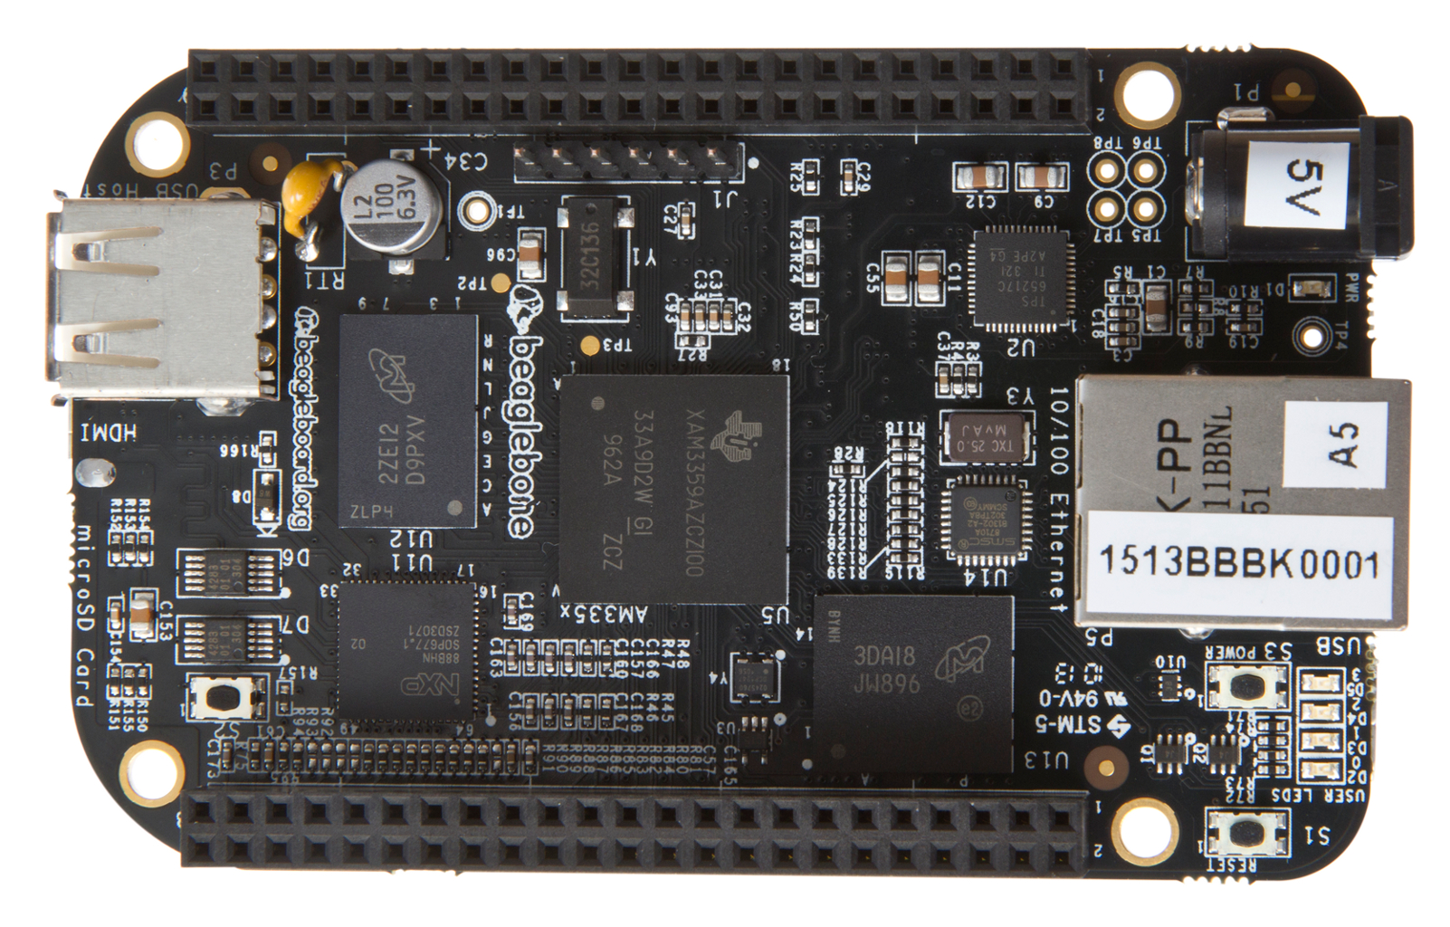

Beaglebone black is a low power open source single-board credit card sized linux computer developed for electronic hobbyist, developer and also keeping engineering students in mind. This open source hardware development is maintained by beagleboard.org. It is not a complete product designed to do any particular function. It is a foundation for experimentation and learning how to program the processor and to access the peripherals by the creation of your own software and hardware. It is also offers access to many interfaces and allows for the use of add-on boards. Even user can develop add-on boards. Large communities are there to support if the user faces any kind problems regarding hardware, software and anything which is related to beaglebone.

## Beaglebone black features and specification:



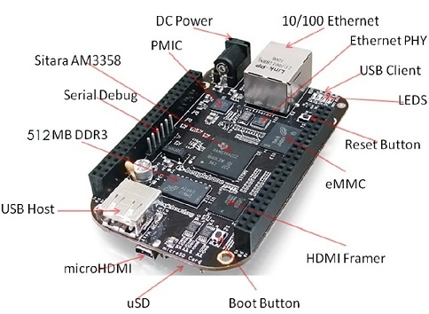

**Beaglebone black high level specification:**

This section provides the high level specification of Beaglebone black.

**Block Diagram:**

**Processor:**

**Sitara AM3358AZCZ we will explain it later.**

**Memory Devices:**

**Memory chip:**

A memory chip is an electronic component in which a program, data or both can be stored. In this context, a program is a series of commands for a microcontroller or microprocessor. Data could consist, for instant temperature values taken by a temperature measurement system. The program/data are stored in the memory chip as a series of number- zeros and ones (binary 0 and 1).A bit can be either a zero or a one. It is difficult for a person to gain an overview over these bits. Therefore they are gathered into group. 16 bits are 'word', 8 bits are 'byte' and 4 bits are 'nibble'.



**512MB DDR3L:**

**RAM:**

Random access memory provides large quantities of temporary storage in a computer system.



Basic capabilities of a memory device:

* It should be able to store a value.
* You should be able to read the value that was saved.
* You should be able to change the stored value.

This block diagram introduces the main interface to RAM:

* A Chip select, CS enable or disable the RAM.
* ADRS specifies the address or location to read from or write to.
* WR selects between reading from or writing to the memory.
* To read from memory, WR should be set to 0. OUT will be the n-bit value to save stored in memory.
* To write to memory, we set WR=1. DATA is the n-bit value to save in memory. Memory for example: a 2^24 X 16 RAM contains 2^24 = 16M words, each bits long.
* The RAM would need 24 address lines.
* The total storage capacity is 2^24 X 16 = 2^28 (2^24 X 2^4) Since memory size are usually specified in number of bytes therefore 2^28 bits / 8 bits per byte = 2^25 bytes ---> 32MB



Consider above diagram of 4X1 RAM:

Where U1 is Decoder and U2, U2, U3, U4 and U5 are RAM cells

* Since there are four RAM cells, ADRS is two bits.
* Each RAM cell is only one bit, so DATA and OUT are one bit each.
* Selection is done with a decoder attached to the CS input of the RAM cells only one cell can be read or written at a time.
* We can create 4X4 RAM by matrix method.

DRAM cells lose their state over time –must be refreshed periodically hence the name Dynamic.

SDRAM is same as DRAM additionally it is synchronous to computer’s clock.

DDR3 SDRAM, an abbreviation for double data rate type three synchronous dynamic random access memory, is a modern type of dynamic random access memory with high bandwidth ("double the rate") interface. It is higher-speed successor to DDR and DD2. DDR3 SDRAM is neither forward nor backward compatible with any earlier type of random access memory due to different signalling voltages, timing and other factors.

A single 256Mbx16 DDR3L 4Gb (512MB) memory device is used. The memory used is the MT41K51M16HA-125 from micron. It will operate at a clock frequency of 303MHz yielding an effective rate of 606MHz on the DDR3L bus allowing for 1.32GB/S of DDR3L memory bandwidth.

**DDR3L memory design:**

**Address Lines**: Provides the row address for ACTIVATE commands and the column address and auto pre-charge bit (A10) for READ/WRITE commands, to select one location out of the memory array in the respective bank. A10 sampled during a PRECHARGE command determines whether the PRECHARGER applies to one bank (A10 LOW, bank selected by BBA [2:0]) or all banks (A10 HIGH). The address input also provides the op-code during a LOAD MODE command. Address inputs are referenced to VREFCA. A12/BC#: When enabled in the mode register (MR), A12 is sampled during READ and WRITE commands to determine whether burst chop (on-the-fly) will be performed (HIGH= BL8 or no burst chop, LOW = BC4 burst chop).

**Bank Address Lines**: BA [2:0] defines the bank to which ACTIVATE, READ, WRITE, or PRECHARGE commands is being applied. BA [2:0] define which mode register (MR0, MR1, MR2, or MR3) is loaded during the LOAD MODE command.

**CK and CK# lines**: are differential clock inputs. All address and control input signals are sampled on the crossing of the positive edge of CK and the negative edge of CK#. Output data strobe (DQS, DQS#) is referenced to the crossing of CK and CK#.

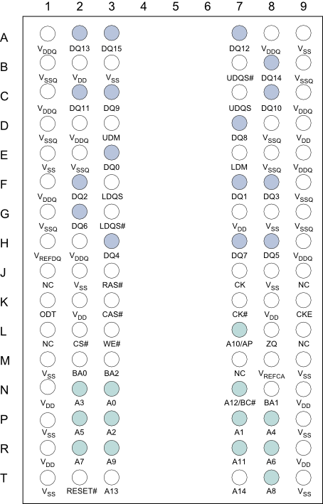

**Clock enable Line**: CKE enable (register HIGH) and disables (registered LOW) internal circuitry and clocks on the DRAM. The specific circuitry that is enabled /disabled is dependent upon the DDR3 SDRAM configurations and operating mode. Taking CKE LOW provides PRECHARGE power-down and SELF REFRESH operation (all banks idle) or active power-down (row active in any bank). CKE is synchronous for self refresh exit. Input buffer (excluding CK, CK# and ODT) are disabled during power-down. Input buffer (excluding CKE and RESET#) are disabled during SELF REFRESH. CKE is referenced to Vrefca.

**Chip Select Line**: CS# enable (register LOW) and disables (register HIGH) the command decoder. All commands are masked when CS# is registering HIGH. CS# provides for external rank selection on system with multiple ranks. CS# is considered part of the command code. CS# is referenced to Vrefca.

**Input Data Mask Line**: DM is an input mask signal for write data. Input data is masked when DM is sampled HIGH along with the input data during a write access. Although the DM ball is input-only, the DM loading is designed to match that of the DQ and DQS balls. DM is referenced to VREFDQ.

**On-die Termination Line**: ODT enables (registered HIGH) and disabled (registered LOW) termination resistance internal to the DDR3L SDRAM. When enabled in normal operation, ODT is only applied to each of the following balls: DQ [7:0], DQS, DQS#, and DM for the x8; DQ[3:0], DQS, DQS# and DM for the x4. The ODT input is ignored if disabled via the LOAD MODE command. ODT is referenced to VREFCA. The DDR3L memory device and the DDR3 rails on the processor are supplied by the TPS65217C. Default voltage is 1.5V but can be scaled down to 1.35 V if desired.



**VREF**: The VVREF signal is generated from a voltage divider on the VDDS_DDR rail that powers the processor DDR rail and the DDR3L devices itself.

**32KB EEPROM**

EEPROM stands for Electrically Erasable Programmable Read Only Memory.

Erasable means that the data on it can be removed. In this usually erasing will carried out by exposing ultraviolet rays on it but in this chip allow the erasing of individual bytes or the entire memory space electrically without UV light. Since individual bytes can be erased without erasing of everything, these individual bytes can be overwritten.

Programmable means that a program or data can be programmed (burned) into this chip. For programming, programming devices like microcontroller required.

Read Only Memory means that this type of memory can be read out but not programmed in the target device.

This memory type can be burned or programmed by a programming device and retains its data until erasing device erase it.

Within the overall EEPROM family of memory devices, there are two main memory types that are available.

* Parallel EEPROM memory: parallel EEPROM devices typically have an 8 bit wide bus which allows it to cover the complete memory of many smaller processor applications. Most devices have chip select and write protect pins and some microcontroller used to have an integrated parallel EEPROM for storage of the software. Parallel programming is faster than serial programming. Disadvantages are more pin outs.
* Serial EEPROM memory: The serial EEPROM are more difficult to operate as a result of the fact that there are fewer pins are operations must be performed in a serial manner. As the data is transferred in a serial fashion, this also makes them much slower than parallel EEPROM counterpart. There are several standard interface types like I2C, SPI, and microwire.

In this board 32KB EEPROM is provided on I2C0 that holds the board information. This information includes boards name, serial number, and revision information. This will be the same as found on the original beaglebone. It has a test point to allow the device to be programmed and otherwise to provide write protection when not ground.

**Memory Cards:**

A memory card (also called flash memory card) is a solid-state electronic data storage device. Memory cards saves data even after memory device is disconnected from its power source. This ability to retained data is the key for flash memory card applications. Memory cards are based on two technologies: NOR technology and NAND technology. NOR technology provides high speed random access capabilities, where data is as small as a single byte can be retrieved. NOR technology-based memory cards are often found in mobile phones and computers. NAND technology invented after NOR technology and it allows sequential access to the data in single pages but cannot retrieve single byte of data like NOR flash. NAND technology-based memory cards are commonly found in digital cameras, mobile phones, audio and video devices and other devices where the data is written and read sequentially.

There are different types of memory cards available some of them are

* Smart Media (SM) cards
* Multimedia card(MMC)
* Compact flash(CF) card
* Memory sticks(MS)card
* microdrive
* xD card
* Secure digital (SD)card

**Multi Media Card:**

MMCs were first developed in late 1970s by Integenix and SanDisk. These cards were initially used in mobile phone and pager devices, but today they are commonly used in many other electronics devices. MMCs operating voltage is 3.3V and the data transfer rate is approximately 2.5 MB/s. MMCs are available with capacities up to 4GB. The older MMCs have been replaced by new multimedia mobile cards. These cards offer higher performance than older MMCs, and they offer lower working voltages (1.8-3.3V) to reduce consumption in portable devices.

**Embedded MMC:**



The term eMMC is short for embedded multimedia controller and refer to package consists of both flash memory and a flash memory controller integrated on the same silicon die. The eMMC solution consists of at least three components -the MMC interface, the flash memory and the flash memory controller and is offered in an industry standard BGA package. BGA is nothing but ball grid array is a type of surface-mount packaging for integrated circuits. The benefits of eMMC its architecture integrating the flash memory controller in the same package simplifies the application interface design and frees the host processor from low-level flash memory management. This benefits product developers by simplifying the non-volatile memory interface design and qualification process- resulting in a reduction in time-to-market as well as facilitating support for future flash device offerings. eMMC eliminates the need to develop interface software for all types of NAND memory by integrating the embedded controller into the memory chip and providing an easy-to-use memory solution package.



In beaglebone a single 2GB eMMC device is on board. The device connects to the MMC1 port of the processor, allowing for 8bit access. Default boot mode for the board will be MMC1 with an option to change it to MMC0 for SD card booting. MMC0 cannot be used in 8bit mode because the lower data pins are locate on the pins used by the Ethernet port. This does not interface with SD card operation but it does make it unsuitable for use an eMMC port if the 8bit feature is needed.

**eMMC Device**:

The device used is micron MTFC2GMTEA-0F_WT 2GB eMMC device. The package is a 153 ball WFBGA device. The footprint o the beaglebone black for this device support 4GB and 8GB devices. As this is a JEDEC standard, there are other suppliers that may work in this design as well. The only device that has



been tested is the MTFC2GMTEA-0F_WT. The eMMC device is connected to the MMC1 port on the processor. Pull-up resistor is used to increase the rise time on the signal to compensate for any capacitor on the board. For eMMC devices the ROM will only support raw mode. The ROM code reads out raw sector from image or the booting file within the file system and boots from it.

Pin used in beaglebone for eMMC connection.



**eMMC Pins:**

The beaglebone black user 10 pins to connect to the processor that also connects to the P8 expansion connector. If using these pins, several things need to be kept in mind when doing so

* On the eMMC device, these signals are input and outputs.
* The eMMC device will add a load onto these pins.
* When used for other function, the eMMC cannot be used. This means you must boot from the uSD slot.
* If using these pins, you need to put the eMMC into reset.

On power up, the eMMC is not reset. If you hold the boot button down, this will force a boot from the uSD. This is not convenient when a cape is plugged into the board. These are two solutions to this issue:

* Wipe the eMMC clean. This will cause the board to default to uSD boot. If you want to use the eMMC later, it can be programmed.
* You can also tie LCD_DATA2 low on the cape during boot. This will be the same as if you were holding the boot button. in order to prevent unforeseen you need to gate this signal with RESET, when the data is sampled. After reset goes high, the signal should be removed from the pin.



**Secure Digital Card (SD card):**

SD cards are probably the most widely used memory cards today. The SD card was originally developed by Matsushita, SanDisk and Toshiba in 2000. SD cards nowadays used in many portable devices, such as digital cameras, mobile phones, PDAs etc...

Standard SD cards are available with capacities from 4MB to $ GB. Recently a new type of SD card called the high-capacity SD card (SDHC) has been developed with capacities ranging from 4 to 32 GB. It has been announced that a new specification called eXtended Capacity (SDXC) will allow capacities to reach 2TB.

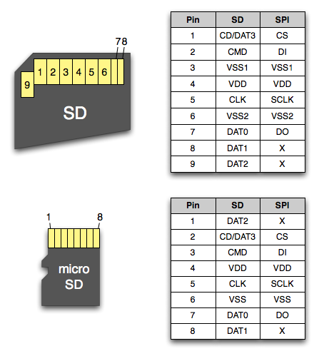

SD cards are based on MMC but they have a number of differences: SD cards are physically thicker than MMCs and would not fit into MMC slots. The MMC on other hand can be easily inserted into SD card slots. In addition SD cards are shaped asymmetrically to prevent them upside down where as MMC would go in either direction although it will not make contact if inserted upside down. In addition the internal register structure of the two types of cards is not the same. Standard SD card can be operated in two modes: the SD Bus mode and SPI Bus mode.SD bus mode is the native operating mode of the card and all the pins are used in this mode. Data is transferred using four pins (D0 - D3), a clock (CLK) pin, and a command line (CMD). Data can be transferred from the card to the host or vice versa.

SD card pins and modes are as follows:



The board is equipped with a single microSD connector to act as the secondary boot source for the board and, if selected as such, can be the primary boot source. The connector will support larger capacity SD card. Booting from MMC0 will be used to flash the eMMC in the production environment or can be used by the user to update SW as needed.

**uSD Design:**

The uSD connector on the board will support a uSD card that can be used for booting or file storage on the beaglebone black. The signal MMC0_3 is the data lines for the transfer off data between the processor and the uSD connector. The MMC0_CLK signal clocks the data in and out of the uSD card. There is no separate card detect pin in uSD specification. It uses MMC0_DAT3 for that function. However most uSD connector still a CD function the connector. In the beaglebone black design, this pin is connected to MMC0_SDCD pin for use by the processor. You can also change the pin to GPIO_6, which is able to wake up the processor from a sleep mode when SD card is inserted into the connector. Pull-up resistor is provided on the signal to increase the rise times of the signal to overcome PCB capacitance. Power is provided from the VDD_3V3B rail and 10uf capacitor is provided for filtering.



**Boot Modes:**

* eMMC Boot: This is a default boot mode and will allow for the fastest boot time and will enable the board to boot out of box using the pre-flashed OS image without having to purchase an SD card writer.
* SD Boot: this mode will boot from the uSD slot. This mode can be used to override what is on the eMMC device and can used to program the eMMC.
* Serial Boot: This mode will use the serial port to allow downloading of the software direct. A separate USB to serial cable is required to use this port.
* USB Boot: This mode support booting over the USB port.

A switch is provided to allow switching between the modes.

* Holding the boot switch down during boot without a SD card inserted will force the boot source to be the USB port and if nothing is detected on the USB client port, it will go to the serial port for download.
* Without holding the switch, the board will boot from eMMC . If it is empty, then it will try booting from uSD, followed by the serial port, and then the USB port.
* If you hold the boot switch down during boot, and you have a uSD card inserted with a bootable image, the board will boot from uSD card.

**Power Management:**

The TPS^%@!&C power management device is used along with a separate LDO to provide power to the system. The TPS65217C version provides for the proper voltage required for the DDR3L. DDR3L requires 1.5V instead of 1.8V, the 1.8V regulator setting has been changed to 1.5V for the DDR3L. The LDO3 3.3V rail has been changed to 1.8V to support those rails on the processor. LDO4 is still 3.3V rail has been changed to 1.8V to support those rails on the processor. An external LDOTLV70233 provides the 3.3V rail for the rest of the board.



**TPS65217C:**

The main power management IC (PMIC) in the system is the TPS65217 which is a single chip power management IC consisting of a linear dual-input power path, three step-down converter, and four LDOs. The system is supplied by a USB port or DC adapter. Three high-efficiency 2.25 MHz step-down converter are targeted at providing the core voltage and memory voltage for the board. LDO1 and LDO2 are intended to support system standby mode. In normal operation, they can support up to 100mA each. LDO3 can support up to 285mA each. By default only LDO1 is always ON but any rail can be configured to remain up in SLEEP state.



A 5VDC supply can be used to provide power to the board. The power supply current depends on how many and what type of add-on boards are connected to the board. For typical use, a 5VDC supply rated at 1A should be sufficient. If heavier use of the expansion header or USB host port is expected, then a higher current supply will be required.

**USB Power**:

The board can also be powered from the USB port. A typical USB port is limited to 500mA max. When powering from the USB port, the VDD_5V rail is not provided to the expansion header. The selection of either the 5VDC or the USB as the power sources is handled internally to the TPS65217C and automatically switches to 5VDC power if both are connected.

**TL5209:**

TL5209 is an efficient PNP low-dropout (LDO) regulator that is well suited for portable applications. It has significantly lower quiescent current than previously was available from traditional PNP regulator and allows for a shutdown current of only 0.05uA (typical). The TL5209 also has very good dropout voltage characteristics, requiring a maximum dropout of 60 mV at light loads and 500mV at full load.

**Power Sources:**

The board can be powered from four different sources:

* A USB port on a PC
* A 5VDC 1A power supply plugged into the DC connector.
* A power supply with a USB connector.
* Expansion connector.

The USB port is limited to 500mA by the power management IC. It is possible to change the settings in the TPPS6517C to increase this current, but only after the initial boot.. And at the point the PC most likely will complain, but you can also use a dual connector USB cable to the PC to get to 1A.

A 1A supply is sufficient to power the board, but if the there is a cape plugged into the board or you have a power hungry device or hub plugged into the host port, then more current may needed from the DC supply. Power routed to the board via the expansion header could be provided from power derived on a cape. The DC supply should be well regulated and 5V+/- .25V.

**Buttons:**

**Reset button**:

When pressed and released, causes a reset of the board.

**Power button**:

A power button is provided near the reset button close to the Ethernet connector. This button takes advantages of the input to the PMIC for power down features. While a lot of the capes have a button, it was decided to add this feature to the board to insure everyone had access to some new features. These features include:

* Interrupt is set to the processor to facilitate an orderly shutdown to save files and to un-mount drives.
* Provides ability to let processor put board into a sleep mode to save power.
* Can alert processor to wake up from sleep mode and restore state before sleep was entered.
* Allows board to enter the sleep mode, preserving the RTC clock.

If you hold button longer than 8 seconds, the board will power off if you release the button when the power LED turns off.

**Indicators:**

There are a total of five blue LEDs on the board.

* One blue power LED indicates that power is applied and the power management IC is up. If means that an excess current was detected and the PMIC has shut down.
* Four blue LEDs that can be controlled via the SW by setting GPIO pins.

In addition, there are two LEDs on the RJ45 to provide Ethernet status indication. One is yellow (100M link up if on) and the other is green (Indicating traffic when flashing).

**CTI JTAG Header:**

A place for an optional 20 pin CTI JTAG header is provided on the board to facilitate the SW development and debugging of the board by taking various JTAG emulators. This header is not supplied standard on the board. To use this, a connector will need to be soldered onto the board.

**HDMI Interface:**

A single HDMI interface is connected to the 16bit LCD interface on the processor. The 16b interface was used to preserve as many expansion pins as possible to allow for use by the user. The NXP TDA1998BHN is used to convert the LCD interface to HDMI and convert audio as well. The signal is still connected to the expansion header to enable the use of LCD expansion boards or access to other function on the board as needed. The HDMI device does not support HDCP copy protection. Support is provided via EDID to allow the SW to identify the compatible resolution. Currently the following resolution is support via the software.

* 1280 x 1024
* 1440 x 900
* 1024 x 768

# Introduction to ARM Processor:

**History:**

The history of ARM started in 1983, when a company named Acorn Computers was looking for a 16bit microprocessor for next desktop machine. They quickly discovered that existing commercial microprocessor did not satisfy their requirement. These processors were slower than standard memory parts available at the time. They had complex instruction sets that included instructions taking hundreds of cycles to execute, leading to high interrupt latencies. The reason for these deficiencies was that early integrated microprocessors were modelled after processors of minicomputers, which consisted of many chips, were driven by microcode and had very complex instruction sets. Therefore, Acorn engineers considered designing their own microprocessors.

However, resources required for such project were well beyond what the company could afford. In early 80's, microprocessor architectures became so complex that it took many years even for large companies with significant expertise in the area to design a new processor. Fortunately, just two years before this, the Berkeley RISC 1 project had shown that it had actually been possible to build very simple processor with performance comparable to the most advanced CISC processors of the time. Acorn decided to pick up the Berkeley approach, and two years later, in 1985, they released their first 26bit Acorn RISC Machine (ARM) processor, which also become the first commercial RISC processor in the world. It used less than 25000 transistors a very small number even for 1985.

In 1990 Apple made a strategic decision to use an ARM processor in their Newton PDA. A joint venture was co-founded by Acorn and Apple to design a new processor. The company called ARM, standing for Advanced RISC Machines. The third version of ARM architecture was developed by this company and featured 32-it addressing, MMU (memory management unit) support and 64bit multiply-accumulate instructions.

**ARM versions with examples:**



**ARM Features:**

* ARM are RISC processor but not 100%
* Larger Register file R0 to R16
* Load and store architecture
* Uniform and fixed length instructions
* 32bit processor
* Good speed and power consumption ratio
* Speed 1Mhz to 1.25Ghz
* ARM support JAVA jezelle DBX (Direct Byte code execution)
* DSP Enhanced Instructions
* Support for TrustZone technology additional security core
* Conditional execution of all instruction
* 32 bit barrel shifter
* In build circuit for debugging
* Reducing system cost.

**Reducing system cost:**

Diagram shows the advantage of combining the functions performed by separate CPUs into a signal, high-performance system-on-chip based on a ARM processor. In the integrated solution, there is no duplication of memory, memory controllers, and pins. Saving can be very high if off-chip memory subsystems can be replaced by a single memory system using commodity DRAM or SDRAM.



**Load/store architecture:**

In register memory architecture no restriction for memory accessing, this allows processor alter, manipulate and process the data directly. Due to mal operation on memory may result in data loss.

Load /store architecture only allows memory to be accessed by load and store operation, and all values for an operation need to be loaded from memory and be present in register. Following the operation, the result needs to be stored back to memory. For instance, in a load/store approach both operands for an ADD operation must be in registers. This differs from register memory architecture in which one of the operands for the ADD operation may be in memory, while the other is in register.

For example in register-memory architecture addition will take place like this

ADD r0, #32H

MOV #34H, r0

Where as in load/store architecture

LOAD r1, #32H

ADD r0, r1

STORE #34H, r0

**Reduced Instruction Set Computer (RISC):**

For example consider we need to multiply two numbers in memory.

Figure represents the storage scheme for a generic computer. The main memory is divided into 5x6 as shown in figure. The executing unit is responsible for carrying out all computations. However, the execution unit can only operate on the data that has been loaded into one of the six register (A, B, C, D, E, or F). Let's say we want to find the product of two numbers one stored in 2:4 and another stored in 3:2 and then store the product back in the location 5:4.



**The CISC (Complex instruction Set Computer):**

The primary goal of CISC architecture is to complete a task in as few lines of assembly as possible. This is achieved by building processor hardware that is capable of understanding and executing a series of operations. For this particular task, a CISC processor would come prepared with a specific instruction (we'll call it "MULT"). When executed, this instruction loads the two values into separate register, multiplies the operands in the entire task of multiplying two numbers can be completed with one instruction:

MULT 2:4, 3:2

MULT is what is known as a "complex instruction." It operates directly on the computer's memory banks and does not require the programmer to explicitly call any loading or storing functions. It closely resembles a command in a higher level language. For instance, if we let "a" represents the value of 2:4 and "b" represents the value of 3:2, then this commands is identical to the C statement "a= a* b." one of the primary advantage of this system is that the complier has to do very little work to translate a high-level language statement into assembly. Because the length of the code is relatively short, very little RAM is required to store instructions. The emphasis is put on building complex instructions directly into the hardware.

**The RISC (Reduced Instruction Set Computer) Approach:**

RISC processors only use simple instructions that can be executes within one clock cycle. Thus, the "MULT" command described above could be divided into three separate commands: "LOAD", which moves the data from the memory bank to register, and "STORE," which moves data from register to memory banks. In order to perform the exact series of steps described in the CISC approach, a programmer would need to code four line of assembly:

LOAD A, 2:4

LOAD B, 3:2

PROD A, B

STORE 3:2, A

At first, this may seem like a much less efficient way of completing the operation. Because there are more lines of code, more RAM is needed to store the assembly level instructions. The complier must also perform more work to convert a high-level language statement into code of this form. However, the RISC strategy also brings some very import advantages. Because each instruction requires only one clock cycle to execute in the entire program will execute in approximately the same amount of time as the multi-cycle "MULT" command. These RISC "reduced instructions" requires less transistors of hardware space than the complex instructions, leaving more room for general purpose register. Because all of the instructions execute in a uniform amount of time, pipelining is possible. Separating the "LOAD" and "STORE" instructions actually reduces the amount of work that the computer must perform. After a CISC-style "MULT" command is executed, the processor automatically erases the register. If one of the operands needs to be used for other computations, the processor must re-load the data from the memory bank into register. In RISC, the operands will be remaining in the register until value is loaded in its place.

**Comparison between RISC and CISC:**



**ARM Nomenclature:**

ARM{x}{y}z{T}{D}{M}{I}{E}{J}{F}{S}

* x: series
* y:MMU
* z:cache
* T:Thumb
* D:debugger
* M:enhanced multiplier
* I:Embedded ICE Macrocel
* J:Java acceleration by Jazelle
* F: Vector floating point
* S:Synthesizable version

**ARM7TDMI**

This is ARM7 family processor, which has T=Thumb instruction set, D=Debug unit, M=MMU, I=trace circuit is inside the core (Embedded Trace Macrocel)

**ARM946E-S**

* ARM9XX core
* Enhanced instruction set for DSP
* Synthesizable

**Memory Management Unit:**

The Memory Management Unit MMU performs two primary functions: it translates virtual addresses into physical addresses, and it controls memory access permissions. The MMU hardware requires to perform these functions consists of a Translation Look-aside buffer (TLB), access control logic, and translation table walking logic.



**Cache:** is a component used to reduce the average time to access memory. The cache is smaller, faster memory which stores copies of the data from frequently used main memory location. Most CPUs have different independent caches, where the data cache is usually organised as a hierarchy of more levels (L1, L2 etc)

If ARM processor supports this then it will indicates in nomenclature.

**Thumb:**

It indicates that processor will support thumb instruction. We will discuss this later.

**Debugger**:

On-chip Debug support, enabling the processor to halt in response to debug request.

**EmbeddedICE macrocell:**

The EmbeddedICE macrocell is integral to ARM processor core. It has two hardware breakpoint/watchpoint units each of which may be configured to monitor either the instruction memory interface or the data memory interface. Each watchpoint units has a value and mask register, with in an address, data and control field.

In ARM9TDMI processor core has Harvard architecture; the user must specify whether the watchpoint register examines the instruction or the data interface. This is specified by bit 3:

* When bit 3 is set, the data interface is examined.
* When bit 3 is clear, the instruction interface is examined.

**Enhanced multiplier:**

Enhanced multiplier, yield a full 64bit result, high performance.

**Java acceleration by Jazelle:**

**Jazelle**:

To execute java bytecode we normally processor follows

* **Direct interpretation**: bytecode translate directly into machine code. This is method will gives efficient memory utilization but low performance.
* **JIT(Just In Time) complier**: complied, profiled into most executed instructions translate into native ARM code problem is that complier requires extra power, memory resources, complier will starts slowly, application will pauses due to profiling.

ARM introduces jazelle technology: Jazelle is an execution mode in ARM architecture which "provides architectural support for hardware acceleration of bytecode by a java virtual machine (JVM)."

Jazelle operates in modes:

* **Jazelle DRX** is an execution to allow processor to directly execute the JVM bytecode ("In addition to the 32-bit ARM and 16-bit Thumb instruction sets, an 8-bit java instruction set has been introduced") There is a single new ARM instruction: 'branch-to-java' for entering java state.
* **Jazelle RCT** is the addition of a few new thumb instructions that are useful for code generation emitting code for compiled java or other similar language. (It adds 12 new instruction to thumb2 and modifies the behaviour of some existing thumb2 instruction and is accessible through entering a new state 'ThumbEE' )

**Vector floating point:**

ARM floating point architecture (VFP) provides hardware support for floating point in half, single, and double precision floating point arithmetic. The floating point capabilities of ARM VFP offer increased performance for floating point arithmetic used in automotive power train and body control applications.

VFP Applications:

* Automotive control applications like ABS
* 3D Graphics.
* Imaging like laser printing.
* Industrial control systems like motion controllers.

**Program status register:**

* hold information about the most recently performed ALU operation
* control the enabling and disabling of interrupts
* set the processor operating mode



**Condition code flags:**

* **N** : **N**egative result from ALU
* **Z** : **Z**ero result from ALU
* **C** : ALU operation **C**arried out
* **V** : ALU operation o**V**erflowed

**T Bit:**

* **T** = 0 : Processor in ARM state
* **T** = 1 : Processor in Thumb state

**Sticky Overflow flag** - **Q** flag

* Architecture 5TE and later only
* Indicates if saturation has occurred

**J bit**

* Architecture 5TEJ and later only
* J = 1 : Processor in Jazelle state

**DNM:** Do not modify bit.

**Interrupt Disable bits**

* I = 1 : Disables IRQ
* I = 0 : Disables FIQ

**New bits in V6**

* **GE[3:0]** used by some SIMD instruction
* **E** bit controls load/store endianness
* **A** bit disables imprecise data aborts
* **IT[abcde]** IF THEN conditional execution of Thumb2 instruction groups

**Processor Mode M [4:0]:**

* 10000 - User mode
* 10001 - FIQ mode
* 10010 - IRQ mode
* 10011 - Supervisor (SWI)
* 10111 - Abort mode
* 11001 - Undefined mode
* 11111 - system mode

# Installing Operating System:

The BeagleBone Black includes a 2GB on-board eMMC flash as we discussed in previous chapter. Beaglebone black comes with the Angstrom distribution factory pre-installed. We can flash new operating systems including Debian, Ubuntu, Android, and others. In addition to the eMMC, you can also boot directly from a microSD card similarly to the original BeagleBone.

All supported images can be downloaded from [www.ARMhf.com](http://www.ARMhf.com) make sure that where you want to flash. If you want to flash to eMMC, download suitable for that.

**Choosing an operating System:**

There are a few operating systems you can choose to use on your beaglebone black.

**Angstrom:**

Angstrom was started by a small group of people who worked on the OpenEmbedded, OpenZaurus and OpenSimpad projects to unify their effort to make a stable and user-friendly distribution for embedded devices like handheld devices, set top boxes and network-attached storage devices and more. Angstrom is the default linux distribution that is pre-installed on eMMC on the beaglebone black. It's a stripped down version of linux specifically designed for embedded devices. You can find the latest version at the beagleboard latest images page.

**Ubuntu:**

Ubuntu which means "humanity to others." Ubuntu also means "I am what I am because of who we all are". The ubuntu operating system brings the spirit of ubuntu to the world of computers.

Linux was already established as an enterprise server platform in 2004, but free software was not a part of everyday life for most computer user. That's why mark shuttle worth gathered a small team of developers from one of the most establish linux project- Debian- and set out to create an easy-to-use linux desktop called ubuntu.

**Ubuntu-saucy-13.10-armhf-3.8.13-bone30.img.xz (November 29, 2013)**

Ubuntu Saucy 13.10 Hard Float Minimal Image uses the ubuntu 13.10 core filesystem from ubuntu with the minimal Meta package applied. The kernel is a Robert Nelson armhf 3.8 kernel. The result is an easy-to-install linux image that works with both the beaglebone and the new beaglebone black boards.

* md5 (message-digital algorithm): 8173diffeaae12421a5542c3578afdd82
* hostname: ubuntu-armhf
* username: ubuntu
* password: ubuntu

**Ubuntu Precise 12.04.3 LTS Hard Float Minimal image**

This image uses the ubuntu 12.04.3 LTS core filesystem from ubuntu with the minimal Meta package applied. The kernel is a Robert Nelson armhf 3.8 kernel. The result is an easy-to-install linux image that works with both the beaglebone and the new beaglebone black boards.

**Ubuntu-precise-12.04.3-armhf-3.8.13-bone30.img.xz (November 29,2013)**

* md5 (message-digital algorithm): 36060e4209389d7d65422a549ede5111
* hostname: ubuntu-armhf
* username: ubuntu
* password: ubuntu

**Debian:**

The Debian project was officially founded by Iran Murdock. Debian was meant to be carefully and conscientiously put together, and to be maintained and supported with similar care. It started as a small, tightly-knit group of free software hackers, and gradually grew to become a large, well-organized community of developer and user.

When it began, Debian was the only distribution that was open for every developer and user to contribute their work. It remains the most significant distributor of linux that is not a commercial entity. To achieve and maintaining high standard of quality, Debian has adopted an extensive set of policies and procedures for packaging and delivering software. These standards are backed up by tools, automation, and documentation implementing all of Debian's key elements in an open and visible way.

**Debian Wheezy 7.2 Hard Float Minimal Image**

This image is based on the Debian Wheezy 7.2 core filesystem from live-build, with packages equivalent to the ubuntu minimal Meta package. The kernel is a Robert Nelson armhf 3.8 kernel. The result is an easy-to-install linux image that works with both beaglebone and the new beaglebone black.

**Debian-wheezy-7.2-armhhf-3.8.13-bone30.img.xz (November 29,2013)**

* md5: 56eb200d1323c5439b218ca8dd1fc981
* hostname: Debian-armhf
* username: debian
* password: debian

**Steps involved in installing operating system:**

* Installing drivers.
* Download the image for example ubuntu-saucy-13.10-armhf-3.8.13-bone30.img.xz
* Install compression utility.
* Install SD card formatter.
* Write the image to your SD card.
* Boot mode selection.

**Installing drivers:**

Follow the following step if you’re using beaglebone first time, you need to install drivers for your beaglebone black.

Visit http://beagleboard.org/Gettinng%20Started

Follow the instruction.

**Install compression utility:**

* Download 7-Zip to unzip your image file.
* Install 7-Zip to your system.
* Right click on your image file which you downloaded.

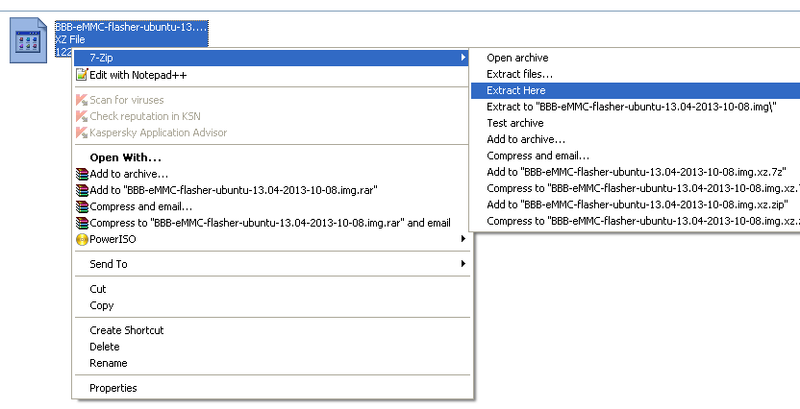

* Click on extract here.
* .image file will be extracted.

**Install SD card formatter:**

For this step you need to have SD card of minimum 2GB capacity.

* Download SD card formatter.
* Install SD card formatter.
* Insert SD card to multi card reader and connect to system as shown in figure.

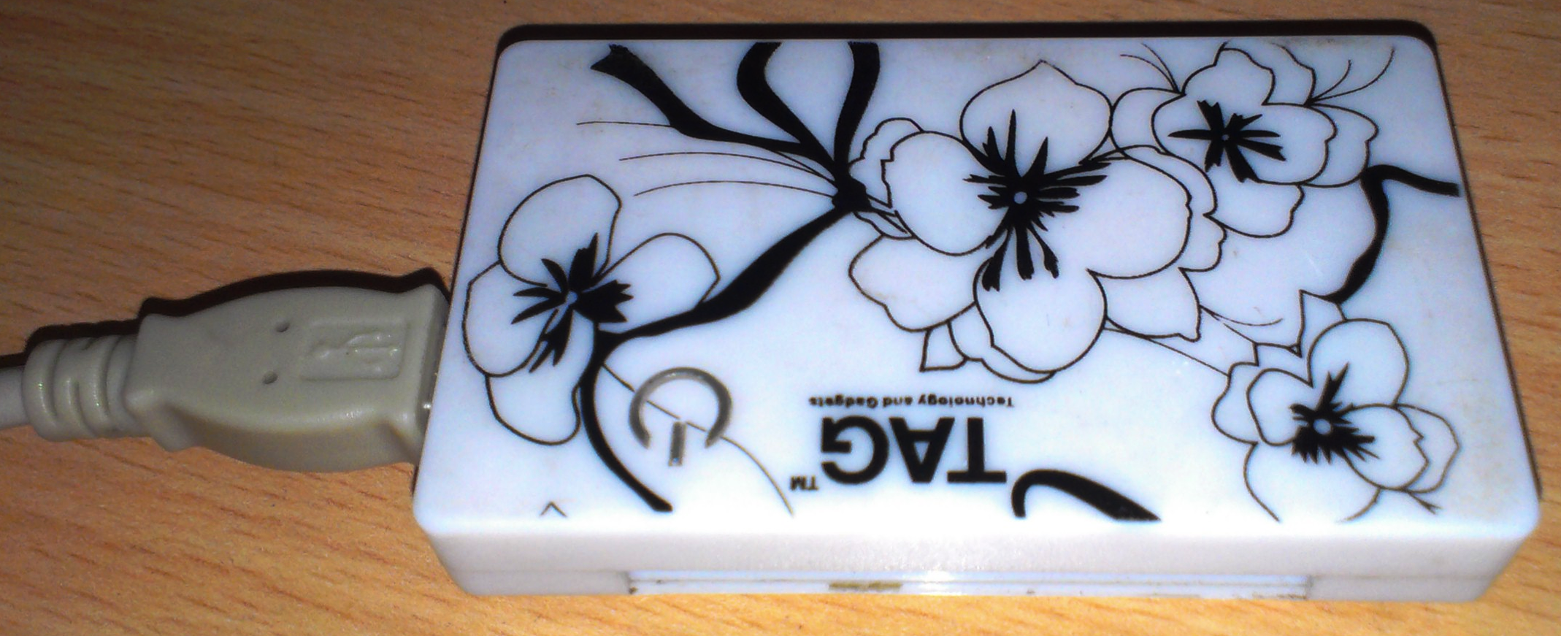

* Open SD card formatter.
* You will drive where SD card is connected, in this figure it is connected to H: drive.

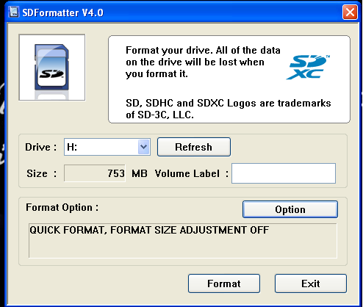

* Click on format button.
* It will ask for conformation click on OK.
* SD card will be formatted.

**Write the image to your SD card:**

* To write image to SD card you need Disk Imager.
* Download Win32 Disk Imager.
* Double click on Win32 Disk Imager.
* You will find following figure. 
* Select device where SD card is connected for example [H:\].
* Browse your .img file (previously you extracted)
* If you’re correct you will get similar as shown in figure.
* Click on write button.
* It will ask for conformation, click on OK.
* Image file will write to your SD card.
* Remove SD card from multi card reader.
* Power off the beaglebone black.
* Insert SD card into beaglebone.
* Don’t power ON.

**Boot mode selection:**

**Boot Mode eMMC:**

Now that you have the latest image of ubuntu onto your microSD card slot, you'll need to flash it onto the on-board flash memory of the beaglebone black. To start, make sure the beaglebone black is powered down and unplugged from the power source. Now, insert the microSD card into the slot on the back of the beaglebone black. It should snap into place.Now, find the "User Boot" button. It’s located on the same side of the beaglebone black as the microSD card slot, and is the only button in the area. 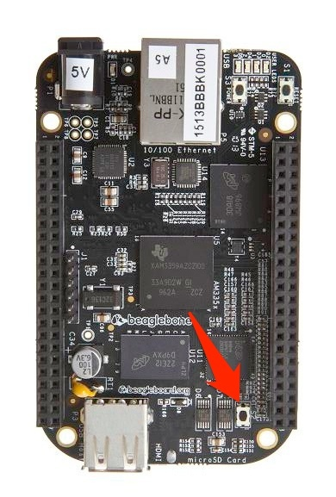

Hold the 'User Boot ' button down, and then plug in the power (USB or 5V adaptor). Keep holding down the button until you see the bank of 4 LED's light up for a few seconds. You can now release the button.It will take anywhere from 30-40 minute to flash the image onto the on-board chip. Once it's done, the bank of 4 LED's to the right of the Ethernet will all stay lit up at the same time. You can then power down your beaglebone black.After this remove SD card repeat the SD card format process since SD card will have bootable image. Insert SD card back to beaglebone black.

**Beagle bone black driver installation:**

* Downloading beaglebone black driver:
* Go Google and search for beagleboneboard.org
* You will find a screen similar to this.

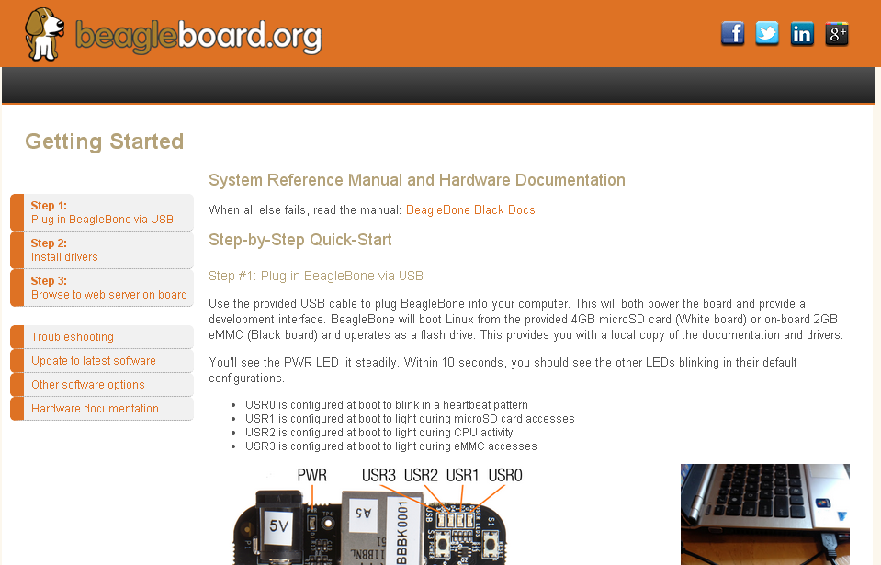

* Click on step2: install drivers.
* Depending upon your OS, download the drivers.
* Installing beaglebone driver
* go to downloaded folder double click on BONE_DRV.exe

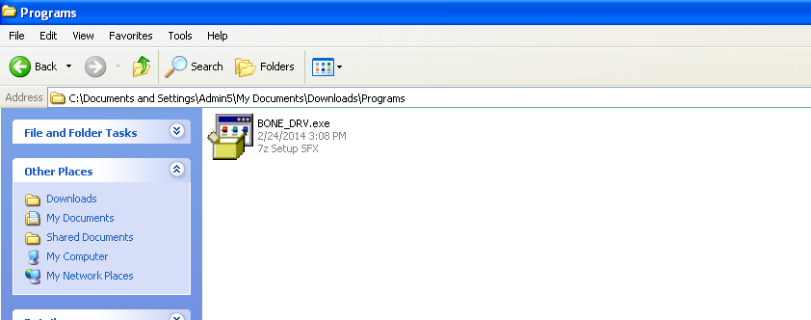

* click on next

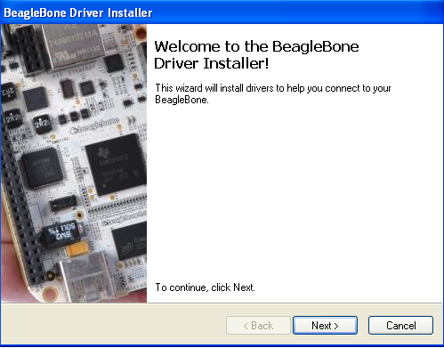

* Please wait while the driver install

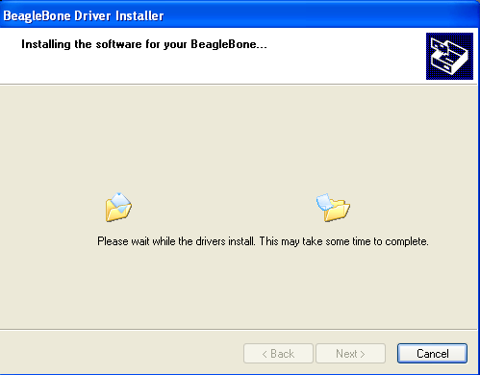

* click on finish

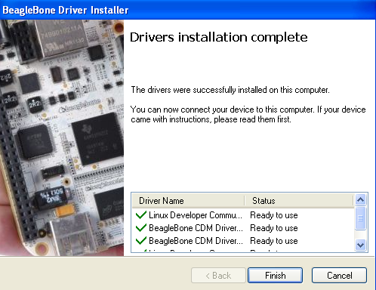

**Getting Beaglebone IP address:**

* Connect beaglebone black to PC through USB cable.
* Open the teraterm, if you don’t have download and install it. If you open it you will as shown below

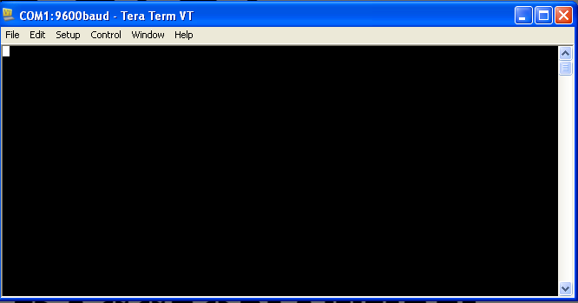

* Click on Setup, click on serial port. you will get an image as shown below

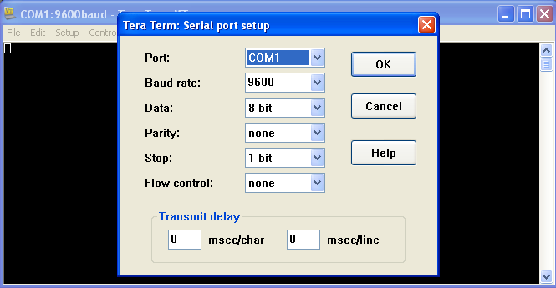

* Click on port you will find out one more com port except **COM1** select that if you’re not finding any port except **COM1** remove USB connection and put it back you will get. Even though you are not finding any port connected to PC than it means you’re not installed driver properly go back to the beaglebone driver installation procedure and install it again and repeat the process.
* select baud rate - 115200, Data- 8bit, Parity- none, Stop- 1bit, Flow control- none

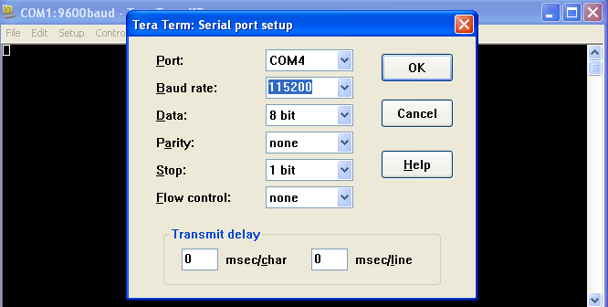

* click on OK
* click on setup again, click on terminal, uncheck local echo click on OK

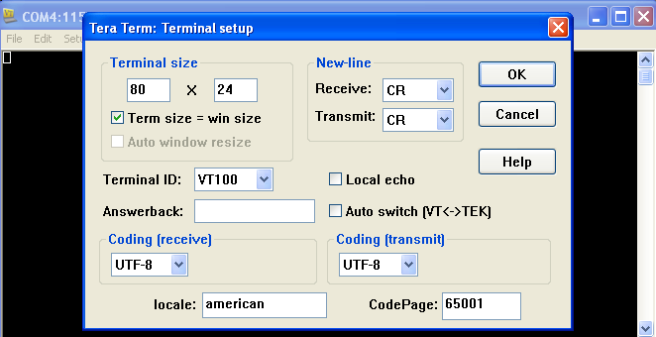

* You may nothing display on teraterm screen don’t worry.

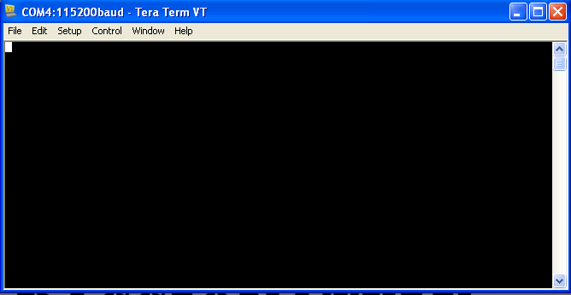

* Click on reset button of beaglebone black.
* Now you will find a screen similar to this indicates that Linux OS is starting in beaglebone black.

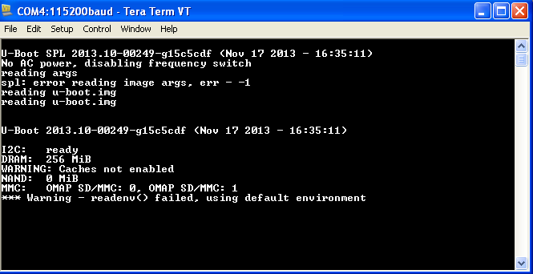

* When OS ready you will get screen like this

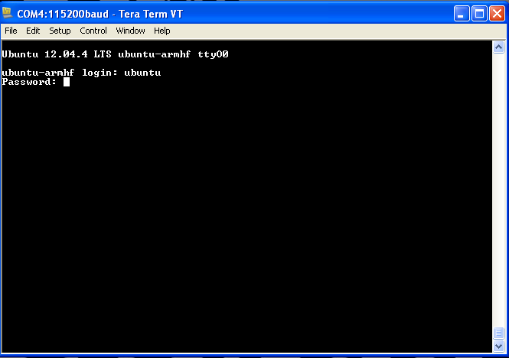

* give user name and password , username: ubuntu password: temppwd
* You will get a screen as shown below.

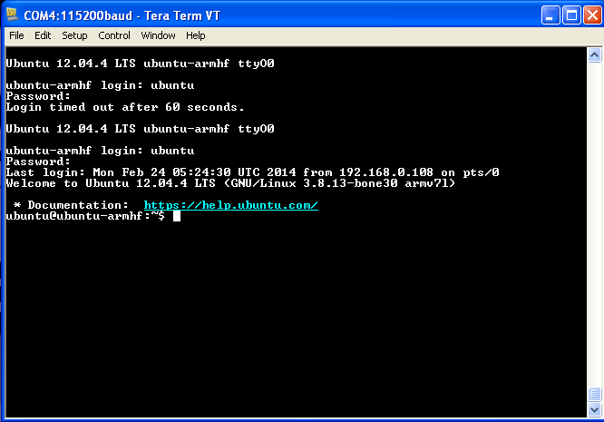

* Connect Ethernet cable to beagle bone remembers this is one of the way to connect to *ssh connection* through putty. Even we can connect to internet through our USB cable itself, I will explain this later when it required.
* Write *ifconfig* click *enter.*

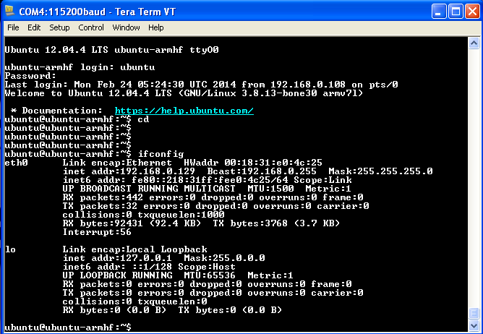

* Now for this connection you can find out our IP address is ***192.168.0.129*** remember this will varies.
* We will use this IP address to connect beaglebone through ***putty***.

**Connecting Beaglebone through putty**

* Open the putty terminal if you don’t have download and install it.

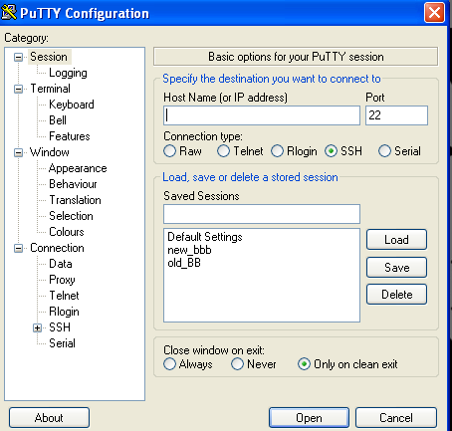

* You will notice as shown in figure. Type your beaglebone black IP address which you got from previous process in Host name, click on SSH connection, give proper name to save and we can use this when we connect beaglebone through putty. Click on open.

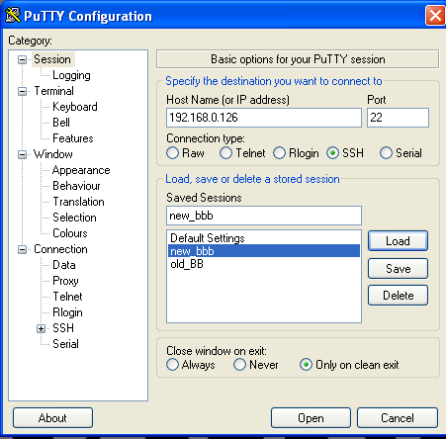

* You will get as shown below

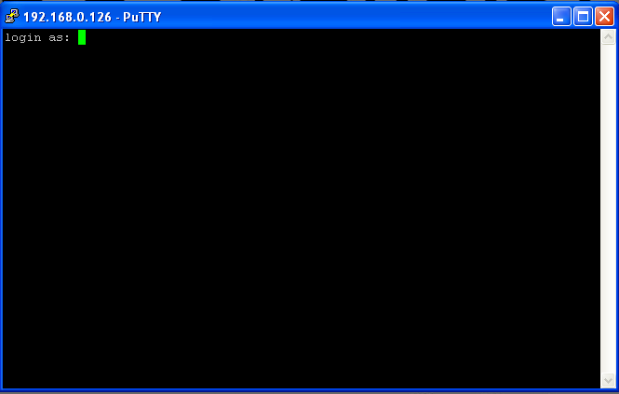

* Give user name and password
* You will get screen like this

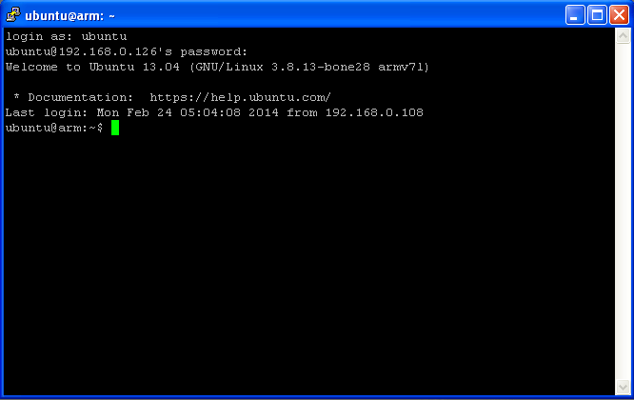

Now you can notice that it is showing ***welcome to ubuntu 13.04 (GNU/Linux 3.8.13-bone28 armv71) latest login: Mon Feb 24 05:04:08 2014 from 192.168.0.108*** which is nothing but information about the OS you’re using and from which IP your login. In this case 192.168.0.108

There are so many way to connect to beaglebone, you can use cloud9 IDE for development, you can use VNC viewer. I will explain those we it required.

In screen you can find out something like this ***ubuntu@arm:~$***

***ubuntu:***

* This indicates the user you’re logged in as, in this case, ubuntu. The user account ubuntu is user. root is superuser.

***arm:***

* This indicates the hostname. This is how other computers on your network refer to your beaglebone.

***~:***

* This indicates the current working directory. It's your current location in the filesystem. If you run a command to create a file without specifying another location, the file will be created to create a file without directory. The tilde is shorthand for the logged in user's home directory. When you're logged in as root on the beaglebone, the tilde indicates the location /home/root

***$:***

This is prompt for input. It also indicates that we're logged in as a user not superuser. If you were logged in as a regular user, the prompt for input would appear as #.

# Introduction to Linux

**“Linux is hard to learn but easy to use”** my definition on linux.

Linux is a free open-source operating system based on UNIX. Linus Torvalds originally created linux with the assistance of developers from around the world. Linux is open source, UNIX like, Network operating system. Linux is a kernel; a kernel provides access to the computer hardware and control access to resources such as:

* Files and data
* Running programs
* Loading programs into memory
* Networks
* Security and firewall

However the linux kernel itself is useless unless you get all the application such as text editor, office application etc therefore someone came up with idea of linux distribution.

A typical linux distribution includes:

* Linux kernel
* GNU application utility such as text editor, browser etc.
* Office application software
* Software development tools and compliers
* Thousand of ready to use application software packages
* Linux installation programs/scripts

Linux kernel: The kernel is the heart of the linux operating system. It manages the resources linux such as:

* File management
* Multitasking
* Memory management
* I/O management
* Process management
* Device management
* Network management
* Virtual memory management

Before starting learning it is very important to know UNIX philosophy

* Do one thing do it well- Write programs that do one thing and do it well.
* Everything is file - ease of use and security is offered by hardware as a file.
* Small is beautiful
* Store data and configuration in flat text file
* Use shell script to increase leverage and portability
* Chain programs together to complete complex task.
* Choose portability over efficiency
* Keep it simple.

**Filesystem:**

Just like in many operating systems, the Linux filesystem is an organized structure of files within folders, or directories. The root of the file system (not to be confused with the root user) is indicated by a forward slash (/). Within the root of the filesystem, there are few main directories, most of which are listed



**Basic commands line editing:**

*CTRL+L*: clear screen

*CTRL+W*: delete the word starting at cursor.

*CTRL+U*: clear the line i.e. deletes all words from command line.

*Up and down arrow keys*: recall the commands

*Tab*: auto complete file, directory, commands name and much more.

*CTRL+R*: search for previous used commands

*CTRL+C*: cancel currently running commands

*CTRL+T*: swap the last two characters before the cursor.

*ESC+T*: Swap the last two words before the cursor.

*CTRL+H*: Delete the letters starting at cursor.

To get familiar with commands in Linux commands type *CTRL+L* and hit *enter*. Now you will find clear screen. Type

date

All ways remember in linux hit enter after command typing.

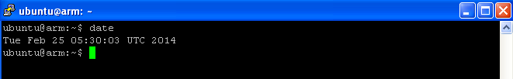

From now on wards what all the commands I written in box indicates you have type execute by hitting enter.

Lets learn some basic commands.

* sudo ('superuser do'): A very common expression which indicates that the taken action must be verified with the admin password.
* cd('change directory'): with this commands you can navigate your way throughout the system. Simply typing 'cd' or 'cd~' will take you to the home folder, which is the folder you are located in by default when starting up a terminal session.
* cd / : Takes you to the root directory
* cd.. : takes you to the one directory level
* cd-- : takes you to the previous level
* pwd ('print working directory'): it displays your location in the system.
* ls (list): list all the files in current directory. Typing 'ls~' will show you the files in your home folder and adding on a folder name shows a list over the files in that specific folder.

cd /

Takes you to the root directory

ls

List all file, directories in specific folder

cd home

Takes you to the home folder

ls

list all the files, folders in home directory

cd ubuntu

Takes you to the ubuntu folder

ls

Nothing displays since no file or folders in that directory.

cd ..

Takes previous directory level ie to home folder

ls

List all files and folders in home directory

cd /

Takes you to the root directory

ls

List all the files and folders in root directory

pwd

Prints the current directory

cd home

Takes you to the home directory

pwd

Prints current directory i.e. home

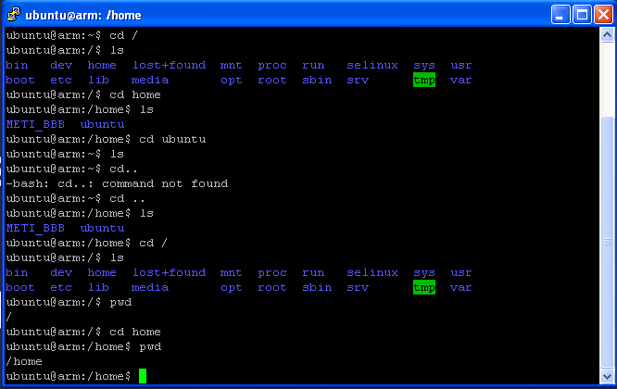

cd /

Takes you to the home directories

ls -l

Lists all files and folder in current directory with more information

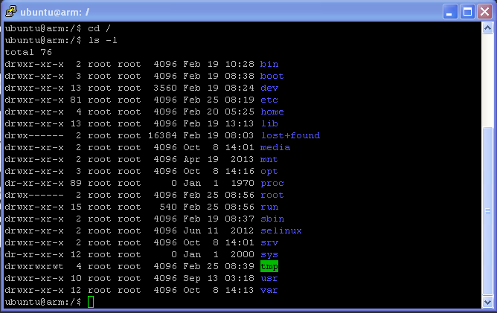

**Changing password:**

* Changing current user password:

passwd

* Now it will ask for "***changing password for ubuntu. (current) UNIX password:"***
* Give current password
* If current password is correct it will ask

***Enter new UNIX password:***

* Give new password.
* Again it will ask for retype new password

***Retype new UNIX password:***

* If you give correct password it will says

***passwd: password updated successfully***

* If password is short it will ask you again.

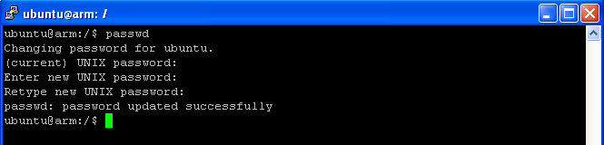

* Changing root password

sudo passwd

* sudo indicates super user password
* now it will ask for ***[sudo] password for ubuntu:***
* give current user password i.e. ubuntu user password
* If the password is correct it will ask ***"Enter new UNIX password:"***
* give new root password
* Again it will ask for ***"Retype new UNIX password:"***
* Give same password again
* If password is correct it will displays

***"passwd: password updated successfully"***

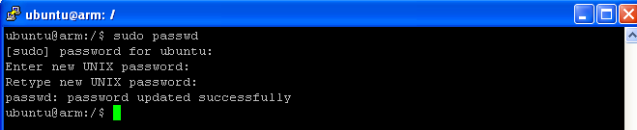

**Creating new directory:**

ctrl+l

Clear the screen

cd /

Takes you to the root directory

ls

List all the files and directories

cd home

takes you to the home directory

ls

list all file and directories

sudo mkdir myprojects

*sudo :* superuser permission

*mkdir*: make new directory

*myprojects*: name of new directory *myprojects*

ls

Lists all the file and folder in that directory

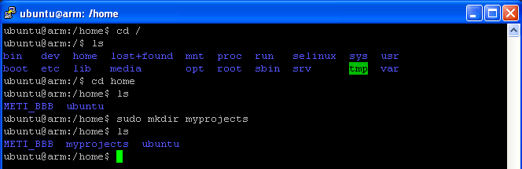

Now you can find out new directory called *myprojects* is created.

**Creating new text file:**

We can create new text in so many methods but I prefer the best and easiest way to do this

* Install text editor called vim

sudo apt-get update

* *sudo*: superuser do
* *apt-get*: advanced packaging tool(apt) performing function as installing of new software packages, upgrading of existing software packages, updating of the package list index, and upgrading the entire ubuntu system
* *update*: it always good practice to update entire ubuntu system before installing any new software.
* It will ask your password, if password is correct it will take few minutes depending upon your internet connection.

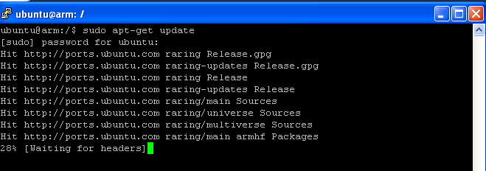

* After successful update we need to upgrade it

sudo apt-get upgrade

Again depending upon network connection it will upgrade your beaglebone.

sudo apt-get install vim

Now it will search new version of vim and dependency tree.

It will ask your permission to install it by asking this much disk space will used. Type ***y*** enters.

ctrl+l

Clear the screen

cd /

Takes you to the root directory

ls

List all the files and directories

cd home

Takes you to the home directory

cd myprojects

Takes you to the myprojects directory

sudo vim hello.txt

It will take you to the screen shown below.

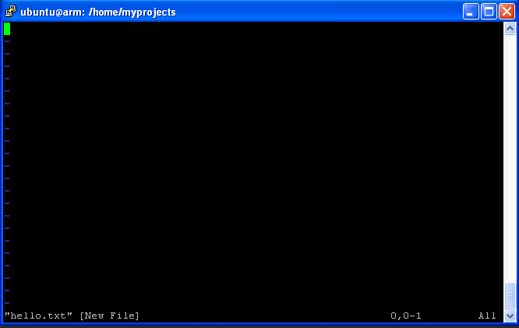

On top of the screen you can root directory, bottom file name “*hello.txt*” to edit this file press ‘***insert***’ on your keyboard. If did it properly you will notice “—insert--” at the bottom of the page.

Type the text you want to type in this example type *hello world*. After finishing typing press “***Esc***” then ***:wq*** to say write quit. Now you will return to the *myprojects* folder.

ls

Now you can find a text file *hello.txt* in folder *myprojects*. To see the content in the file before this we will give permission to access this file.

sudo chmod –x hello.txt

*chmod* : change mode

*-x* : giving permission to access.

*hello.txt*: text file.

cat hello.txt

*cat*: concatenating the files.

You can notice content of the file hello.txt

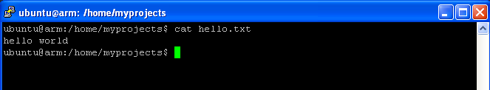

To get more clarification we will create one more text file

sudo vim bye.txt

Repeat the same process as above to create one more file *bye.txt*

Give permission to access

sudo chmod –x bye.txt

To concatenate both one more file and one more thing it always asks for permission so we will jump to superuser by

Su

Superuser permission

It will ask for password type password now you type

cat hello.txt bye.txt > greeting.txt

both file concatenate to file *greeting.txt* type

cat greeting.txt

Now you can see the concatenated output.

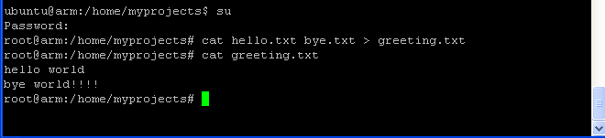

**Copying, Moving and renaming the files:**

mkdir tempp

To do this create one more directory by name ***tempp***

ls

You will notice tempp folder

To copy the text file hello.txt to folder tempp, remember you need to press enter at the end of every line.

cp hello.txt tempp

cd tempp

ls

You will find hello.txt file in the folder tempp.

To move the file bye.txt to tempp folder

cd ..

mv bye.txt tempp

ls

you will notice bye.txt file not in the folder myprojects.

cd tempp

ls

File bye.txt file moved to tempp.

To rename the file greeting.txt to okok.txt

cd ..

mv greeting.txt okok.txt

ls

You can notice greeting.txt file renamed to okok.txt

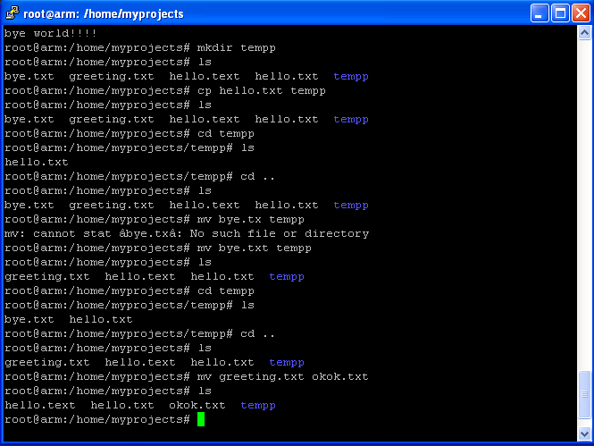

**Deleting files and directories:**

To delete the files and directories use *rm* command.

ls

List all the files in folder myprojects

rm okok.txt

ls

Text file *okok.txt* is deleted.

rm –r tempp

*rm*: remove

*-r* : recursive delete all file and folder of tempp

*tempp*: folder name

ls

You can notice folder tempp is deleted. 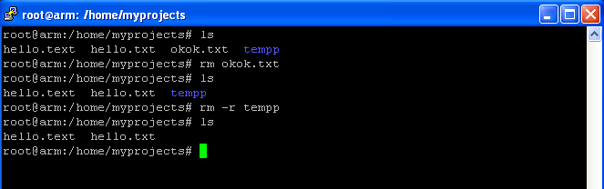

**Date and time:**

Most computers have a real time clock, a piece of hardware that keeps track of the date and time. RTC's frequently have a battery backup so that they can keep time even when there's no power supplied to the computer. Unfortunately beaglebone does not have a real time clock. This means that when you boot up the beaglebone, it will have no idea what the date and time are. To prove it, try the date command:

date

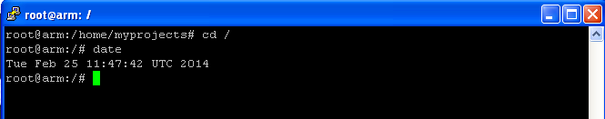

However, the beaglebone can keep track of time as long as it's powered on. The time just needs to be set every time it boots up. Of course, it's possible to set the time manually, but this wouldn't make much sense if you need to this every time you power on the board. Fortunately, we're able to set up the beaglebone so that it can get correct date and time through the internet using Network Time protocol, or NTP

**set time Timezone:** The first thing you'll need to do is set your timezone. There's a built-in data-base of timezones preloaded onto the board and you'll need to make a link to the appropriate timezone file from /etc/localtime. First, backup the old localtime file renaming it localtime.old:

mv /etc/localtime /etc/localtime.old

Change to the directory /usr/share/zoneinfo and list the contents to see the available timezone files, keeping in mind, it might be contained within one of the continent directories such as Asia. I'll be using /usr/share/zoneinfo/Kolkata

cd /usr/share/zoneinfo/

ls

cd Asia

ls

You'll then create a symbolic link from the /etc/localtime file to your desire Timezone file. A symbolic link is like forwarding for a file. You can place one in a directory and most software that wants to read or write the file will be redirected to the file in another location.

ln -s /usr/share/zoneinfo/Asia/Kolkata /etc/localtime

**ntp server time:**

sudo apt-get install ntp

cd /etc/

ls

vim ntp.conf

# C:\Documents and Settings\Admin5\Local Settings\Temporary Internet Files\Content.Word\P113.png

**Useful commands regarding system information:**

* ***df(display filesystem):*** Displays how much disk space on every mounted partition that is occupied. ***df-h*** uses MB and GB instead of blocks, make it more convenient.

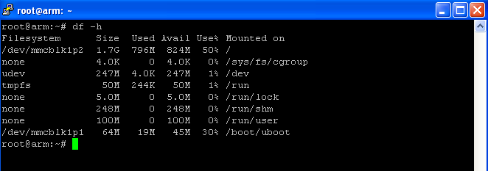

* ***du(directory usage):*** Displays how much space a given directory plus all of its subdirectories uses. ***du -s*** gives you a summary while ***du -h*** translates the information to non-geeks

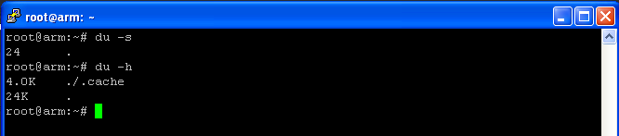

* The ***free*** command tells you how much space which is available for usage. To view the statistics in megabytes, type free –m

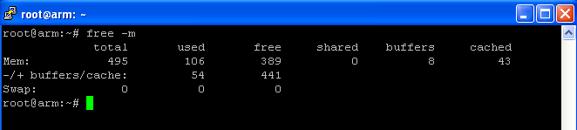

* ***uname -a:*** Prints all information about your system.

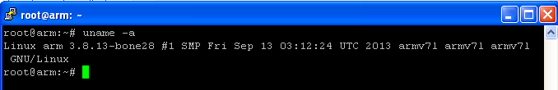

* ***lsb_release -a:*** Prints information about linux distributions.

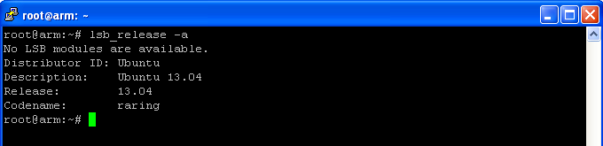

* ***top:*** This commands ignites system monitoring, viewing RAM, CPU, and swap usage plus the total of running process. Press q to shut down the monitor.

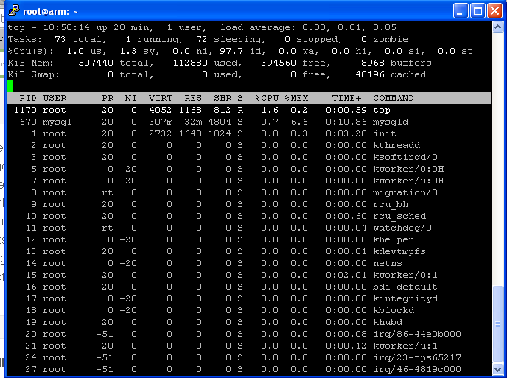

This list provides you some common linux commands but I am not showing all with examples: At this time you may think that this information is not needed but I am when ever your commands and you can come back see this.

* adduser: Add a user to the system
* addgroup: Add a group to the system
* alias: Create an alias
* apropos: Search Help manual pages (man -k)
* apt-get: Search for and install software packages (Debian/Ubuntu)
* aptitude: Search for and install software packages (Debian/Ubuntu)
* aspell: Spell Checker
* awk: Find and Replace text, database sort/validate/index.
* basename: Strip directory and suffix from filenames
* bash: GNU Bourne-Again SHell
* bc: Arbitrary precision calculator language
* bg: Send to background
* break: Exit from a loop
* builtin: Run a shell built in
* bzip2: Compress or decompress named file(s)
* cal: Display a calendar
* case: Conditionally perform a command
* cat: Display the contents of a file
* cd: Change Directory
* cfdisk: Partition table manipulator for Linux
* chgrp: Change group ownership
* chmod: Change access permissions
* chown: Change file owner and group
* chroot: Run a command with a different root directory
* chkconfig: System services (run level)
* cksum: Print CRC checksum and byte counts
* clear: Clear terminal screen
* cmp: Compare two files
* comm: Compare two sorted files line by line
* command: Run a command - ignoring shell functions
* continue: Resume the next iteration of a loop
* cp: Copy one or more files to another location
* cron: Daemon to execute scheduled commands
* crontab: Schedule a command to run at a later time
* csplit: Split a file into context-determined pieces
* cut: Divide a file into several parts
* date: Display or change the date & time
* dc: Desk Calculator
* dd: Convert and copy a file, write disk headers, boot records
* ddrescue: Data recovery tool
* declare: Declare variables and give them attributes
* df: Display free disk space
* diff: Display the differences between two files
* diff3: Show differences among three files
* dig: DNS lookup
* dir: Briefly list directory contents
* dircolors: Colour setup for `ls'
* dirname: Convert a full pathname to just a path
* dirs: Display list of remembered directories
* dmesg: Print kernel & driver messages
* du: Estimate file space usage
* echo: Display message on screen
* egrep: Search file(s) for lines that match an extended expression
* eject: Eject removable media
* enable: Enable and disable builtin shell commands
* env: Environment variables
* ethtool: Ethernet card settings
* eval: Evaluate several commands/arguments
* exec: Execute a command
* exit: Exit the shell
* expect: Automate arbitrary applications accessed over a terminal
* expand: Convert tabs to spaces
* export: Set an environment variable
* expr: Evaluate expressions
* false: Do nothing, unsuccessfully
* fdformat: Low-level format a floppy disk
* fdisk: Partition table manipulator for Linux
* fg: Send job to foreground
* fgrep: Search file(s) for lines that match a fixed string
* file: Determine file type
* find: Search for files that meet a desired criteria
* fmt: Reformat paragraph text
* fold: Wrap text to fit a specified width.
* for: Expand words, and execute commands
* format: Format disks or tapes
* free: Display memory usage
* fsck: File system consistency check and repair
* ftp: File Transfer Protocol
* function: Define Function Macros
* fuser: Identify/kill the process that is accessing a file
* gawk: Find and Replace text within file(s)
* getopts: Parse positional parameters
* grep: Search file(s) for lines that match a given pattern
* groups: Print group names a user is in
* gzip: Compress or decompress named file(s)
* hash: Remember the full pathname of a name argument
* head: Output the first part of file(s)
* help: Display help for a built-in command
* history: Command History
* hostname: Print or set system name
* id: Print user and group id's
* if: Conditionally perform a command
* ifconfig: Configure a network interface
* ifdown: Stop a network interface
* ifup: Start a network interface up
* import: Capture an X server screen and save the image to file
* install: Copy files and set attributes
* jobs: List active jobs
* join: Join lines on a common field
* kill: Stop a process from running
* killall: Kill processes by name
* less: Display output one screen at a time
* let: Perform arithmetic on shell variables
* ln: Make links between files
* local: Create variables
* locate: Find files
* logname: Print current login name
* logout: Exit a login shell
* look: Display lines beginning with a given string
* lpc: Line printer control program
* lpr: Off line print
* lprint: Print a file
* lprintd: Abort a print job
* lprintq: List the print queue
* lprm: Remove jobs from the print queue
* ls: List information about file(s)
* lsof: List open files
* make: Recompile a group of programs
* man: Help manual
* mkdir: Create new folder(s)
* mkfifo: Make FIFOs (named pipes)
* mkisofs: Create an hybrid ISO9660/JOLIET/HFS filesystem
* mknod: Make block or character special files
* more: Display output one screen at a time
* mount: Mount a file system
* mtools: Manipulate MS-DOS files
* mtr: Network diagnostics (trace route/ping)
* mv: Move or rename files or directories
* mmv: Mass Move and rename (files)
* netstat: Networking information
* nice: Set the priority of a command or job
* nl: Number lines and write files
* nohup: Run a command immune to hang ups
* notify-send: Send desktop notifications
* nslookup: Query Internet name servers interactively
* open: Open a file in its default application
* op: Operator access
* passwd: Modify a user password
* paste: Merge lines of files
* pathchk: Check file name portability
* ping: Test a network connection
* pkill: Stop processes from running
* popd: Restore the previous value of the current directory
* pr: Prepare files for printing
* printcap: Printer capability database
* printenv: Print environment variables
* printf: Format and print data
* ps: Process status
* pushd: Save and then change the current directory
* pwd: Print Working Directory
* quota: Display disk usage and limits
* quotacheck: Scan a file system for disk usage
* quotactl: Set disk quota
* ram: ram disk device
* rcp: Copy files between two machines
* read: Read a line from standard input
* readarray: Read from stdin into an array variable
* readonly: Mark variables/functions as readonly
* reboot: Reboot the system
* rename: Rename files
* renice: Alter priority of running processes
* remsync: Synchronize remote files via email
* return: Exit a shell function
* rev: Reverse lines of a file
* rm: Remove files
* rmdir: Remove folder(s)
* rsync: Remote file copy (Synchronize file trees)
* screen: Multiplex terminal, run remote shells via ssh
* scp: Secure copy (remote file copy)
* sdiff: Merge two files interactively
* sed: Stream Editor
* select: Accept keyboard input
* seq: Print numeric sequences
* set: Manipulate shell variables and functions
* sftp: Secure File Transfer Program
* shift: Shift positional parameters
* shopt: Shell Options
* shutdown: Shutdown or restart linux
* sleep: Delay for a specified time
* slocate: Find files
* sort: Sort text files
* source: Run commands from a file `.'
* split: Split a file into fixed-size pieces
* ssh: Secure Shell client (remote login program)
* strace: Trace system calls and signals
* su: Substitute user identity
* sudo: Execute a command as another user
* sum: Print a checksum for a file
* suspend: Suspend execution of this shell
* symlink: Make a new name for a file
* sync: Synchronize data on disk with memory
* tail: Output the last part of files
* tar: Tape Archiver
* tee: Redirect output to multiple files
* test: Evaluate a conditional expression
* time: Measure Program running time
* times: User and system times
* touch: Change file timestamps
* top: List processes running on the system
* traceroute: Trace Route to Host
* trap: Run a command when a signal is set(bourne)
* tr: Translate, squeeze, and/or delete characters
* true: Do nothing, successfully
* tsort: Topological sort
* tty: Print filename of terminal on stdin
* type: Describe a command
* ulimit: Limit user resources
* umask: Users file creation mask
* umount: Unmount a device
* unalias: Remove an alias
* uname: Print system information
* unexpand: Convert spaces to tabs
* uniq: Uniquify files
* units: Convert units from one scale to another
* unset: Remove variable or function names
* unshar: Unpack shell archive scripts
* until: Execute commands (until error)
* useradd: Create new user account
* usermod: Modify user account
* users: List users currently logged in
* uuencode: Encode a binary file
* uudecode: Decode a file created by uuencode
* v: Verbosely list directory contents (`ls -l -b')
* vdir: Verbosely list directory contents (`ls -l -b')
* vi: Text Editor
* vmstat: Report virtual memory statistics
* watch: Execute/display a program periodically
* wc: Print byte, word, and line counts
* whereis: Search the user's $path, man pages and source files for a program
* which: Search the user's $path for a program file
* while: Execute commands
* who: Print all usernames currently logged in
* whoami: Print the current user id and name (`id -un')
* Wget: Retrieve web pages or files via HTTP, HTTPS or FTP
* write: Send a message to another user

# Learning Python for programming

In this competitive age, high productivity, tight deadlines, and short development cycles are the buzzwords in the application development world. These are the reasons why software developer prefers rapid application development (RAD) tools like Python.

Python is a portable, interpreted, object-oriented programming language. It combines remarkable power with very clear syntax. Moreover, its high-level built-in data structure, combined with dynamic typing and dynamic binding, make it very attractive for rapid application development.

*“Python can fulfil an important integration role in the design and large application with a long life expectancy. It allows a fast response to change in user requirement that require adapting the high-level application logic without changing the fundamental underlying components. It also allows quick adaption of the application to change in the underlying components.”*

Guido van Rossum

*“Python is an easy to learn, powerful programming language. It has efficient high-level data structure and a simple but effective approach to object-oriented programming. Python's elegant syntax and dynamic typing, together with its interpreted nature, makes it an idle language for scripting and rapid application development in many areas on most platforms.”*

www.pthon.org

**Overview of python:**

Python is a free, open-source, general-purpose, interpreted, and powerful scripting language for web applications. It is an easy yet powerful programming language that provides structure and support for large applications as well as the power and complexity of traditional high-level language with the features of both an interpreted and a scripting language.

**History of Python:**

Python is directly derived from the scripting language ABC, which was mainly used for teaching purposes in the 1980s by a small number of people. Guido van Rossum is the creator of python. He started work on Python in late 1989 at CWI in Amsterdam. When Guido started work on Python, he was a researcher at CWI. Initially, Python was designed to perform general administration tasks. Later, it became a part of Amoeba project at CWI and was first released for public use in Feb 1991. Since then the team has been involved in python development. Any intellectual property that is added to python is taken care by a nonprofits organization called Python software Foundation.

**Installing Python:**

Before we can start programming, we need some new software. What follows is a short description of how to download and install python.

**Windows:**

**To install python on windows machine, follow these steps:**

* Open a web browser and go to <http://www.python.org>.
* Click the download link
* Download latest python IDE for windows.
* Double click on pthon.msi file

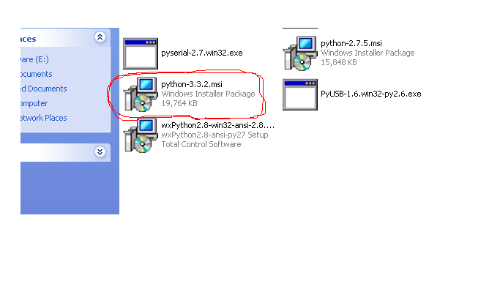

* click on next

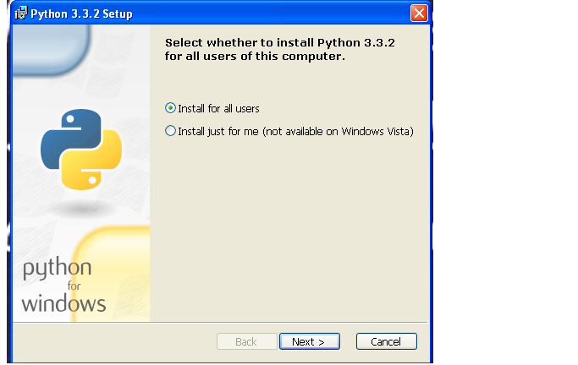

* click on next

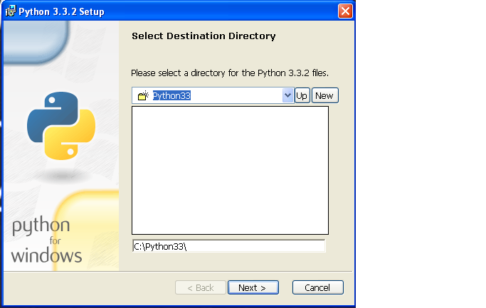

* click on next

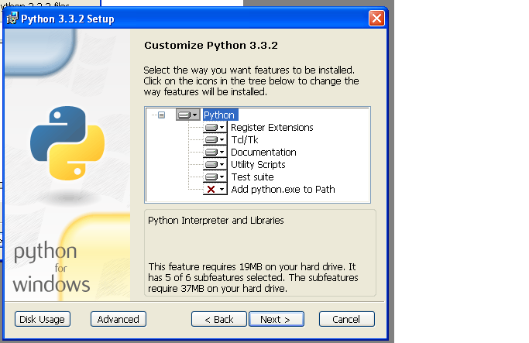

* wait still installation complete

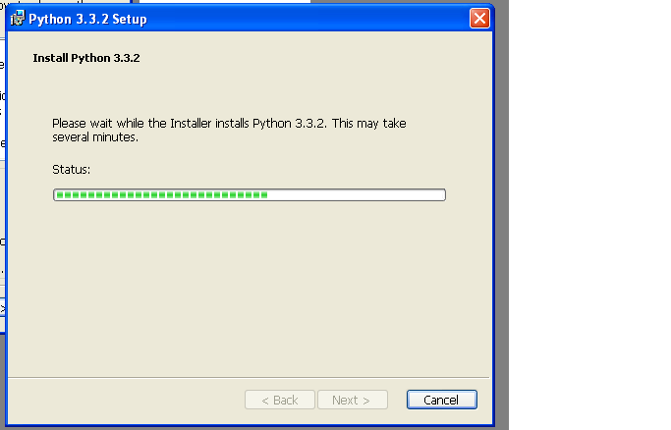

* when installation completed click on finish

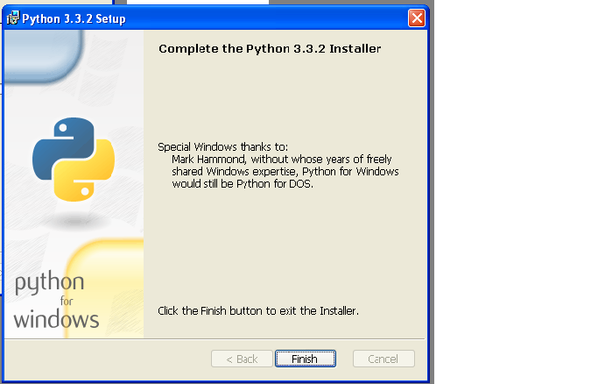

**Who uses Python:**

* Google makes extensive use of python in its web search systems.
* The popular YouTube video sharing service is largely written in Python.
* The Dropbox storage service codes both its server and desktop client software primarily in Python.
* The Raspberry Pi single-board computer promotes Python as its educational language.
* EVE Online, a massively multiplayer online game (MMOG) by CCP Games, uses Python broadly.
* The widespread BitTorrent peer-to-peer file sharing system began its life as a python programmer.
* Industrial Light & Magic, Pixar, and other use python in the production of animated movies.
* ESRI uses Python as an end-user customization tool for its popular GIS mapping products.
* Google's App Engine web development uses Pyhton as an application language.
* The IronPort email server product uses more than 1 million lines of Python code to do its job.
* Maya, a powerful integrated 3D modelling and animation system, provides a python scripting API.
* The NASA uses Python for cryptography and intelligence analysis.
* iRobot uses Python to develop commercial and military robotic devices.
* The Civilization IV game's customizable scripted events are written entirely in Python.
* The One Laptop per Child (OLPC) project built its user interface and activity model in Python.
* Netflix and Yelp have both documented the role of python in their software infrastructures.
* Intel, Cisco, Hewlett-Packard, Seagate, Qualcomm and IBM use python for hardware testing.
* JPMorgan Chase, UBS, Getco and Citadel apply Python to financial market forecasting.
* NASA, Los Alamos, Fermilab, JPL, and others use Python for scientific programming tasks.

**Pyhton Technical Strengths:**

* Its Object-oriented and functional
* It's Free
* It's Portable (no matter any OS)
* It's Powerful: Dynamic typing, Automatic memory management
* Programming-in-the-large support Built-in object types
* Built-in tools
* Library utilities
* Third-party utilities
* It's Mixable
* It's Relatively Easy to Use
* It's Relatively Easy to Learn

**P1.0 Hello Word Program:**

Python comes with a GUI- Integrated Development Environment called 'IDLE' (actually it should be 'IDE' right but "Rossum" gave this name). A development environment is a set of tools that makes writing programs easier, we can think of it as a word processor for your programs. But it's even more than a place to write, save and edit our work. IDLE provides two modes to work:

* An interactive mode
* Script mode.

**Interactive mode:**

To begin your interactive session, from the start menu -> choose programs -> Python IDLE (Python GUI). This window is called Python shell, at the command prompt (>>>), type

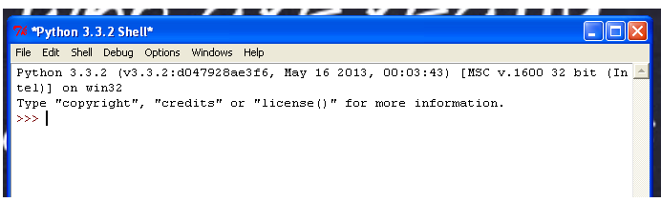

print ("Hello World")

The print statement displays whatever text you type between pair of braces.

The statement that you entered is print ("Hello World"); made up of three parts:

* *print* is a command and its syntax is *print (".....")* or *print ()*, it tells computer to take some action. Python is a case-sensitive and commands are in lowercase.
* *" hello world"*, is an expression or straightforward string.
* "*;*" terminating character which is not required in python but it supports.

**Script mode:**

Using Interactive mode gives you immediate feedback. But it's not design to create programs you can save, edit and run later. So Python offer script mode also. It's just like a word processor for your code. Select file menu, select new window

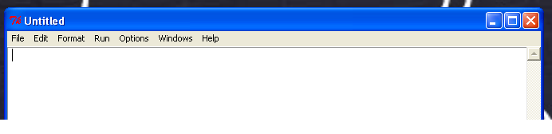

Now type:

print ("hello world");

Save it, run it by pressing F5. You will notice output Hello World will displays on python shell.

Interactive mode is great for trying out a small idea. Script mode is perfect for writing programs you can run later. Using both modes together is a great way to code. The script window is where we craft program. The interactive window is like working sheet where we can think and experiment. Using them together helps me to write better programs more quickly.

**Operators:**

What is an operator?

Simple answer can be given using expression 4+5 is equal to 9. Here 4 and 5 are operands and + is called operator. Python language supports following type of operators.

* Arithmetic operator
* Comparison (relational) operators
* Assignment operators
* Logical operator
* Bitwise operators
* Membership operator
* Identity operator

**Arithmetic operator:**

* “***+***” Addition -> adds values on either side of the operator 2**+**3 is 5.
* “***-***“Subtraction -> Subtracts right hand side operand from left hand operand 3**-**2 is 1.
* “**\***” Multiplication -> Multiplies values on either side of the operands 3**\***2 is 6.
* “**/**” Division -> Divides left hand operand by right hand operand 4**/**2 is 2.
* “**%**” Modulus -> Divides left hand operand by right hand operand and returns remainder 4**%**2 is 0.
* “**\*\***” Exponent -> performs exponential (power) calculation on operands. 2**2 is 4.
* “**//**” Floor Division -> the division of operands where the result is the quotient in which the digits after the decimal point are removed. 9**//**2 is 4 and 9.0**//**2.0 is 4.0

**Example:**

**Program to demonstrate Arithmetic operators:**

* In this program we are writing a code to demonstrate Arithmetic operators.
* Open Pyhton IDLE.
* Select file menu
* Click on New window
* Save the program as *Arithmetic_Operator*
* Add the following code

Number_1 = 4;

Number_2 = 2;

Number_3 = 5;

Sum = Number_1 + Number_2;

Diff = Number_1 - Number_2;

Mul = Number_1 * Number_2;

Div = Number_3 / Number_2;

Div_Floor = Number_3 // Number_2;

Modulus = Number_3 % Number_1;

print (Number_1," + ",Number_2," is ",Sum);

print (Number_1," - ",Number_2," is ",Diff);

print (Number_1," * ",Number_2," is ",Mul);

print (Number_3," / ",Number_2," is ",Div);

print (Number_1," // ",Number_2," is ",Div_Floor);

print (Number_1," % ",Number_2," is ",Modulus);

* Edited code will look like this

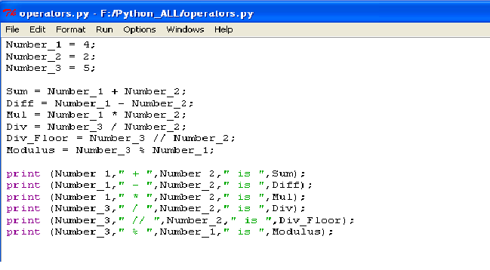

* Save it and run it by pressing *F5.*
* Output of *Arithmetic_Operator*

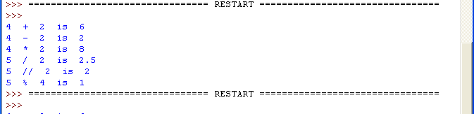

* Code Explanation
* In first 3 line of code we are assigning number 4, 2 and 5 to variables *Number_1*, *Number_2* and *Number_3* respectively.
* In next 5 lines of code we are using above variables to perform arithmetic operation like addition, subtraction, multiplication, division, floor division and modulus. And assigning these result to variables Sum, Diff, Mul, Div, Div_Floor, Modulus respectively.
* Rest of line are written for displaying results.
* “,” operator is used to concatenate the strings.

**Comparison operator**:

* “**==**” checks if the value of two operands are equal or not, if yes then condition becomes true else false (2**==**2) is true (2**==**7) is false.
* “**!=**” checks if the value of two operands are equal or not, if values are not equal then condition becomes true. (2**!=**7) is true and (2**!=**2) is false.
* “**>**” checks if the value of left operand is greater than the value of right operand, if yes then condition becomes true. (4**>**2) is true. (2**>**4) is false.
* “**<**” checks if the value of left operand is less than the value of right operand then condition is true. (**2<4**) is true and (**4<2**) is false.
* “**>=**” checks the value of left operand is greater than or equal to value of right operand, if yes then condition is true. (2**>=**1)is true and (1**>=**2) is false.
* “**<=**” checks the value of left operand is less than or equal to value of right operand, if yes then condition is true. (2**<=**1)is false and (1**<=**2) is true.

**Example:**

**Program to demonstrate comparison operators:**

* In this program we are writing a code to demonstrate comparison operators.
* Open Pyhton IDLE.
* Select file menu
* Click on New window
* Save the program as *Comparator_Operator*
* Add the following code

a = 5;

b = 10;

c = 5;

Equal_Operator_Status = (a == b);

Not_Equal_operator_Status = (a != b);

GreaterThan_Operator_Status = (b > a);

LesserThan_Operator_Status = (b < a);

GreaterThanOrequal_Operator_Status = (c <= a);

LesserThanOrequal_Operator_Status = (c <= a);

print ("Equal_Operator_Status:",Equal_Operator_Status);

print ("Indicates that variable a and b are not equal\n");

print ("Not_Equal_operator_Status:",Not_Equal_operator_Status);

print ("Indicates that variable a and b are not equal\n");

print ("GreaterThan_Operator_Status:",GreaterThan_Operator_Status);

print ("Indicates that variable b is greater than variable a\n");

print ("LesserThan_Operator_Status:",LesserThan_Operator_Status);

print ("Indicates that variable b is not lesser than variable a\n");

print ("GreaterThanOrequal_Operator_Status:",GreaterThanOrequal_Operator_Status);

print ("Indicates that variable c is Greater than or equal to variable a\n");

print ("LesserThanOrequal_Operator_Status:",LesserThanOrequal_Operator_Status);

print ("Indicates that variable c is Lesser than or equal to variable a\n");

* Code will look like this

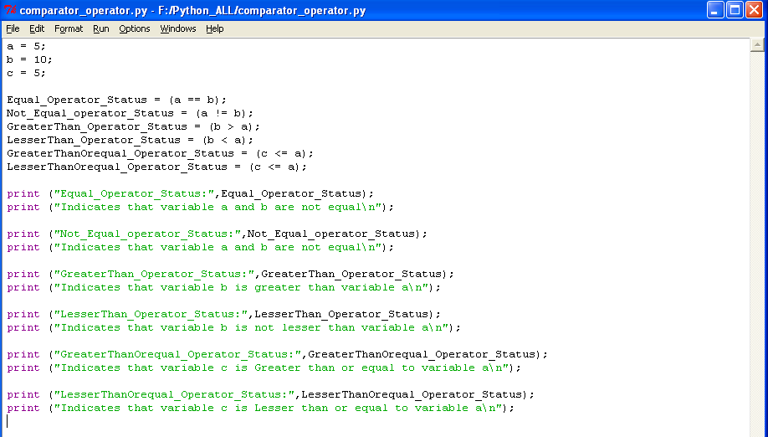

* Save it and run it by pressing F5
* Output of *Comparator_Operator*

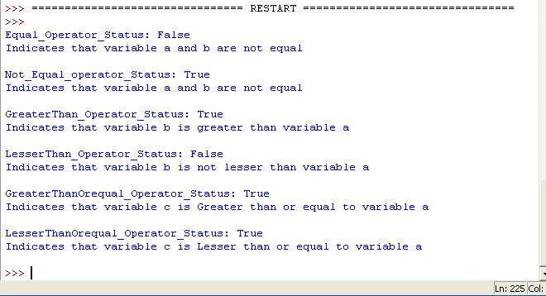

* Code explanation:
* In first 3 lines of code we are declaring variables a, b and c and assigning values 5, 10, 5 respectively.
* Next 6 line of code we checking comparison operators and assigning their result to variables.
* Rest of lines are used to display the results.

**Assignment operator:**

* Simple assignment operator assigns values from right side operands to left side operands. “b**=**a” will assign value of “a” to “b”.
* “**+=**” Add and assignment operator, it adds right operator to the left operand and assign the result to left operand. “b**+=**a” is equivalent to “b = a + b”.
* “**-=**” subtracts and assignment operator, it subtracts right operands from the left operands and assign the result to left operand. “b**-=**a” is equivalent to “b = a - b”.
* “**\*=**” Multiply and assignment operator, it multiplies right operand with left operand and assign the result to left operand. “b**\*=**a” is equivalent to “b = a * b”.
* “**/=**” Divide and assignment operator, it divide left operand with right operand and assign the result to left operand. “b**/=**a” is equivalent to “b = a / b”.
* “**%=**” Modulus and assignment operator, it takes modulus of two operands and assign to left operand. “b**%=**a” is equivalent to “b = a % b”.
* “**//=**” Floor division and assignment operator, it performs floor division and assign the result to left operand. “b**//=**a” is equivalent to “b = a // b”.

**Example:**

**Program to demonstrate Assignment operators:**

* In this program we are writing a code to demonstrate assignment operators.
* Open Pyhton IDLE.
* Select file menu
* Click on New window
* Save the program as *Assignment_Operator*
* Add the following code

a = 10;

b= 20;

print ("value of 'a'before assignement operation",a);

a=b;

print ("value of 'a'after assigning value of b: ",a,);

print ("value of 'b'before add and assignement operation",b);

b+=a;

print ("value of 'b' after add and assignement operation",b);

print ("value of 'b'before subtract and assignement operation",b);

b-=a;

print ("value of 'b' after subtract and assignement operation",b);

print ("value of 'b'before multiply and assignement operation",b);

b*=a;

print ("value of 'b' after multiply and assignement operation",b);

print ("value of 'b'before divide and assignement operation",b);

b/=a;

print ("value of 'b' after divide and assignement operation",b);

print ("value of 'b'before modulus and assignement operation",b);

b%=a;

print ("value of 'b' after modulus and assignement operation",b);

b=25;

a=15;

print ("value of 'b'before floor division and assignement operation",b);

b//=a;

print ("value of 'b' after floor division and assignement operation",b);

* Code will look like this.

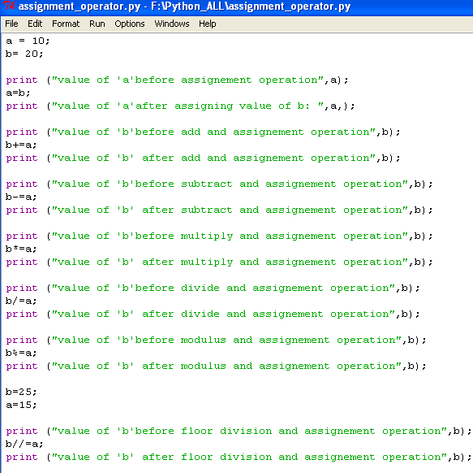

* Save it and run it by pressing F5
* Output of *Assignment_Operator*

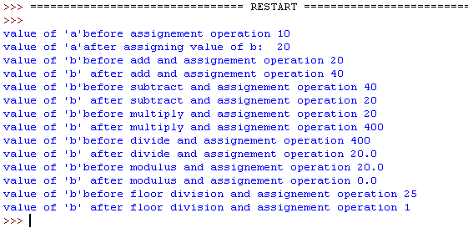

* Code explanation:
* In first 2 line of code we are assigning value 10 and 20 to variable a and b.
* Rest of code will explain value of variable b before and after assignment operations.

**Bitwise operator:**

Bitwise operator works on bits and performs bit by bit operation. Assume if a=60; and b=13; now in binary format they will be as follows:



**Example:**

**Program to demonstrate Bitwise operators:**

* In this program we are writing a code to demonstrate Bitwise operators.
* Open Pyhton IDLE.
* Select file menu
* Click on New window
* Save the program as *Bitwise_Operator*
* Add the following code

a = 60;

b = 13;

print ("value of a:",a);

print ("value of b:",b);

print ("Binary AND operation: a & b :",a&b);

print ("Binary OR operation: a | b :",a|b);

print ("Binary XOR operation: a ^ b :",a^b);

print ("Binary NOT operation: ~a :",~a);

print ("Binary Left shift operation: a << 2 :",a<<2);

print ("Binary Right shift operation: a >> 2 :",a>>2);

* Code will look like this.

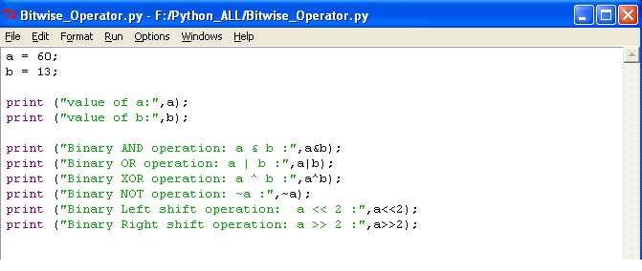

* Save it and run it by pressing F5
* Output of *Assignment_Operator*

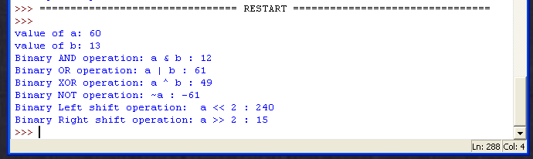

* Code explanation:
* In first 2 line of code assign the value 60 and 13 to variables a and b.
* Rest of code uses different bitwise operator and displays the results.

**Logical operators:**

* “**and**” -> called logical AND operator. If both the operands are true then condition becomes true.
* “**or**” -> called logical OR operator. If any one of operand is nonzero then condition becomes true.
* “**not**” -> called logical NOT operator. Use to reverse the logical state of its operand. If a condition is true then logical NOT operator will make false.

**Membership operators**:

* “**in**” -> Evaluates to true if it finds a variable in the specified sequence and false otherwise. “x **in** y”, here “in” results in a 1 if x is a member of sequence y.
* “**not in**” -> Evaluates to true if it does not finds a variable in the specified sequence and false otherwise. “x **not in** y”, here “not in” results in a 1 if x is a member of sequence y.

**Identity operator**:

Identity operator compares the memory location of two objects.

* “**is**” -> evaluates to true if the variable on either side of the operator point to the same object and false otherwise. “x **is** y”, here “is” results in 1 if id(x) equals id(y).
* “**is not**” -> evaluates to false if the variable on either side of the operator point to the same object and true otherwise. “x **is not** y”, here “is” results in 1 if id(x) is not equals id(y).

Python operator’s presidency:

* **
* ~+-
* */%//
* +-
* >><<
* &
* ^|
* <= <>>=
* <> == !=
* is
* is not
* in not in
* not or and.

**More on Strings:**

**string literals:**

In Python programming language, string can be created with single quotes, double quotes or triple quotes. When we use triple quotes, strings can span several lines without using escape character.

**Example:**

**Program to demonstrate string literals:**

* In this program we are writing a code to demonstrate string literals.
* Open Pyhton IDLE.
* Select file menu
* Click on New window
* Save the program as *Workbench.py*
* Add the following code

print ('single quotes\n');

print ("double quotes\n");

print (""" triple quote example

we can write multiple

lines.....\n """);

print (""" Mysore Embedded Technology Institute ***'METI'***

\"Embedding Engineering Excellence\" """);

* Code will look like this.

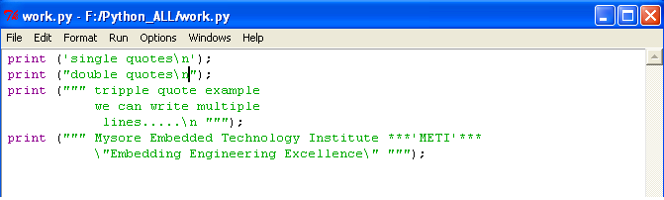

* Save it and run it by pressing F5
* Output of *Workbench.py*

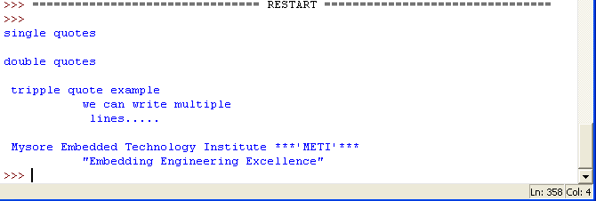

* Code explanation:
* First three lines of code uses different quotes used to print strings.
* Last line of code ‘\’ symbol is used to escape the next character and it prints it as it is.

**String Length:**

The len() method calculates the number of character in string. The white character are also counted.

**Example:**

**Program to demonstrate String Length:**

* In this program we are writing a code to demonstrate String length.
* Open Pyhton IDLE.
* Select file menu
* Click on New window
* Save the program as *String_Length*
* Add the following code

s1 = "METI";

s2 = "METI\n";

s3 = "METI ";

print ("lenght of s1: ",len(s1));

print ("lenght of s2: ",len(s2));

print ("lenght of s3: ",len(s3));

* Code will look like this.

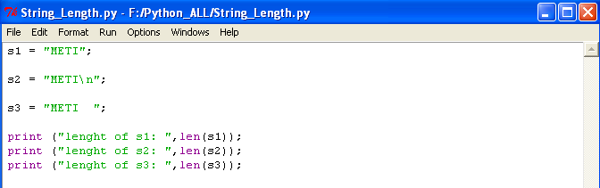

* Save it and run it by pressing F5
* Output of *String_Length*

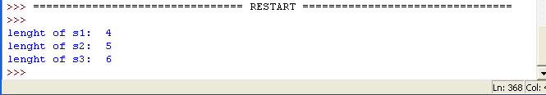

* Code explanation

s2 = "METI\n";

* ‘\n’ escape character adds to length of string.

s3 = "METI ";

* Two whitespace added to the length of string s3.

**Stripping white characters:**

The term white spaces, characters refer to invisible characters like new line, tab, space or other control characters. We have few methods like strip(), lstrip(), rstrip() to remove these characters.

**Example:**

**Program to demonstrate stripping white characters:**

* In this program we are writing a code to demonstrate Bitwise operators.
* Open Pyhton IDLE.
* Select file menu
* Click on New window
* Save the program as *String_Strip.py*
* Add the following code

s = " METI ";

print ("length of string s : ",len(s));

s1 = s.rstrip();

print ("length of string s1: ",len(s1));

s2 = s.lstrip();

print ("length of string s2: ",len(s2));

s3 = s.strip();

print ("length of string s3: ",len(s3));

print ("length of string s : ",len(s));

* Code will look like this.

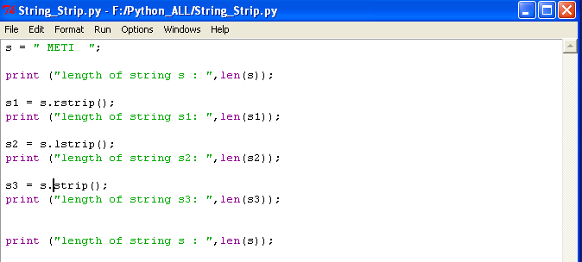

* Save it and run it by pressing F5
* Output of *String_Strip.py*

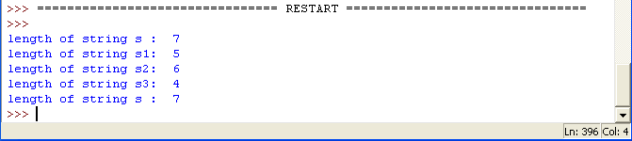

* Code explanation:

s = " METI ";

print ("length of string s : ",len(s));

* We are declaring variable ‘s’ and assigning string value “ METI ” , length of variable ‘s’ will be 7 since we added 1 whitespace at beginning and 2 whitespace at the end.

s1 = s.rstrip();

print ("length of string s1: ",len(s1));

* ‘*rstrip()*’ method or function will remove the tailing whitespaces and return the result to ‘s1’. Length of ‘*s1*’ is 5 since ‘*rstrip()*’ removes 2 whitespace at the tailing of ‘*s*’.

s2 = s.lstrip();

print ("length of string s2: ",len(s2));

* ‘*lstrip()’* method or function will remove the leading whitespace in string ‘*s*’. Length of ‘*s2*’ is 6 since ‘*lstrip()*’ removes 1 whitespace at the begining of string ‘*s*’.

s3 = s.strip();

print ("length of string s3: ",len(s3));

* ‘*strip()*’ method or function will removes all whitespace presents in string ‘*s*’. Length of ‘*s3*’ is 4 since it removes 2 whitespace at tailing and 1 whitespace at leading of string ‘*s*’.
* Remember ‘strip()’ won’t remove any whitespaces between string for example in “METI Mysore” , ‘*strip()*’ function won’t removes whitespace which is between METI and Mysore.

**Accessing string element:**

We can access string element individually as shown below.



In the above figure we can access string “*PYTHON*” with its index as shown.

**Example:**

**Program to demonstrate Accessing string element:**

* In this program we are writing a code to demonstrate Bitwise operators.
* Open Pyhton IDLE.
* Select file menu
* Click on New window
* Save the program as *Accessing_string_element.py*
* Add the following code

s = "PYTHON";

print ("Print string 's':",s);

print ("\n");

print ("print s[0] :",s[0]);

print ("print s[1] :",s[1]);

print ("print s[2] :",s[2]);

print ("print s[3] :",s[3]);

print ("print s[4] :",s[4]);

print ("print s[5] :",s[5]);

print ("\n");

print ("print s[-1] :",s[-1]);

print ("print s[-2] :",s[-2]);

print ("print s[-3] :",s[-3]);

print ("print s[-4] :",s[-4]);

print ("print s[-5] :",s[-5]);

print ("print s[-6] :",s[-6]);

print ("print s[0:4] :",s[0:4]);

print ("print s[0:] :",s[0:]);

print ("print s[:2] :",s[:2]);

print ("print s[0:10] :",s[0:10]);

print ("print s[:] :",s[:]);

print ("print s[-5:-1]:",s[-5:-1]);

print ("print s[-1:] :",s[-1:]);

print ("print s[-6:] :",s[-6:]);

print ("print s[-10:] :",s[-10:]);

print ("print s[0:-3] :",s[0:-3]);

* Code will look like this.

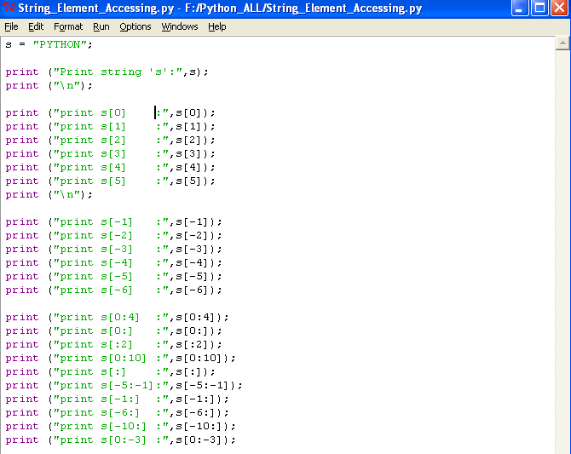

* Save it and run it by pressing F5
* Output of *Accessing_string_element.py*

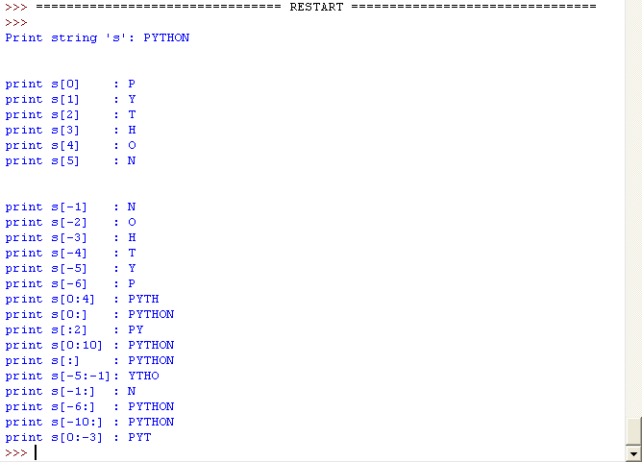

* Code explanation:
* S[:] 🡪 print complete string.
* S[1:4]🡪 prints from index 1 to 4 , except 4.
* S[0:10]🡪 even though string length is less than 10, complete string will print.

**String Formatting operator:**

One of the Python's coolest features is the string format %.



**Example:**

**Program to demonstrate String formatting operators:**

* In this program we are writing a code to demonstrate String formatting operators.
* Open Pyhton IDLE.
* Select file menu
* Click on New window
* Save the program as *String_Formater.py*
* Add the following code

print ("print a character : %c" %'y');

print ("print a string : %s" %'yogi');

print ("print a signed decimal integer : %i" %-10);

print ("print a signed decimal integer : %d" %29);

print ("print a hexadecimal lowercase integer : %x" %10);

print ("print a hexadecimal uppercase integer : %X" %10);

print ("print a lowercase exponential notation : %e" %0.0029);

print ("print a lowercase exponential notation : %E" %0.0029);

print ("print a floating point real : %f" %4.6);

print ("print a floating point real : %f\n" %78);

print ("Name: %s and AGE: %d" %('Yogi',23));

print ("print decimal number %d and its floating point value is %f"%(100,100));

* Code will look like this.

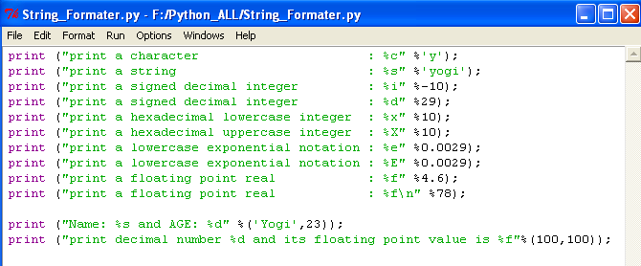

* Save it and run it by pressing F5
* Output of *String_Formater.py*

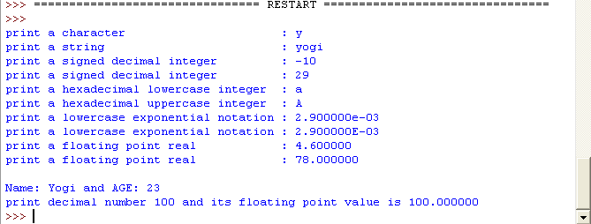

**Escape sequence:**

Escape sequences are special characters that have a specific purpose as shown in figure.



**Built-in string methods:**

**capitalize():**

* The method *capitalize()* returns a copy of the string with only its first character capitalize.
* syntax:
* *str.capitalize()*
* Return value:
* This method returns a copy of the string with only its first character capitalized.

**center():**

* The method *center()* returns centred in a string of length *width*. Padding is done using the specified *fillchar*. Default is space.
* syntax:
* *str.center(width[, fillchar)]);*
* parameters:
* *width* -- This is the total width of the string
* *fillchar* -- This is character to be filled.
* return value:
* This method returns centred in a string of length *width*
* other factors:
* If width is less or equal to *len(str)* then no padding will done.

**count():**

* The method *count()* returns the number of occurrences of substring sub in the range *[start, end]*. Optional argument start and end are interpreted as in slice notation.
* Syntax
* *str.count (substring, start=0, end=len(string))*
* parameters:
* *substring* -- This is the substring to be searched.
* *start* -- Search starts from this index. By default search starts from 0th index.
* return:

This method returns centred in a string of length width

* other factors:

Search is case sensitive "This" and "this" are different.

**endswith():**

* The method *endswith()* returns true if the strings ends with the specified suffix, otherwise return false optionally restricting matching with the given indices *start* and *end*.
* Syntax
* *str.endswith(suffix[,start[,end]])*
* parameter:
* *suffix* -- This could be a string.
* *start* -- The slice begins from here
* *end* -- The slice ends here
* Return value:

This method returns true if the string ends with the specified *suffix*, otherwise returns false.

**expandtabs():**

* The method *expandtabs()* returns a copy of the string in which tab character *\t* have been expanded using spaces, optionally using the given tabsize (default 8).
* syntax:
* *str.expandtabs(tabsize=8)*
* parameters
* *tabsize* -- This specifies the number of character to be replaced for a tab character \t
* return value:

This method returns a copy of the string in which tab character \t have been expanded using spaces.

**find():**

* The method *find()* determines if string *str* occurs in string, or in a substring if starting index *beg* and ending index *end* are given.
* syntax:
* *str.find(str, beg=0 end =len(string))*
* parameters
* *str* -- This specifies the string to be searched..
* *beg* -- This is the starting, by default its 0.
* *end* -- This is the ending index, by default its equal to the length of the string.
* return value:

this method returns if found and -1 otherwise..

**index():**

* The method *index()* determines if string *str* occurs in string or in a substring of string index *beg* and ending index *end* are given. This method is same as *find()*, but raises an exception if sub string is not found.
* syntax:
* *str.index(str, beg=0 end=len(string))*
* parameters:
* *str* -- This specifies the string to be searched.
* *beg* -- This is the starting index, default its 0.
* *end* -- This is the ending index, by default it is equal to the length of the string.
* return value:
* This method returns index if found otherwise raises an exception if str is not found.

**Example:**

**Program to demonstrate Built-in string methods 1:**

* In this program we are writing a code to demonstrate Built-in string methods.
* Open Pyhton IDLE.
* Select file menu
* Click on New window
* Save the program as *Built-in_string_methods1.py*
* Add the following code

s = "yogesh";

print ("print string s:",s);

print ("print capitalize of string s:",s.capitalize());

print ("printing centered string s with a:",s.center(10,'a'));

print ("printing centered string s with a:",s.center(5,'a'));

s = "this is not correct but this is example";

print ("print number of times 'this' occurs in s:",s.count('this',0,len(s)));

s = "hello world wow";

print ("is suffix 'wow' in string s???:",s.endswith("wow"));

print ("is suffix 'wow' in string s???:",s.endswith("wow",0,5));

s = "hello\tworld";

print ("original string:",s);

print ("tabed string 's':",s.expandtabs());

print ("tabed string 's':",s.expandtabs(16));

s = "I saw a wolf in the forest. A lone wolf."

print ("index of word 'wolf'in string 's':",s.find("wolf"));

print ("word 'wolf' between index 10 and 20:",s.find("wolf",10,20));

* Code will look like this.

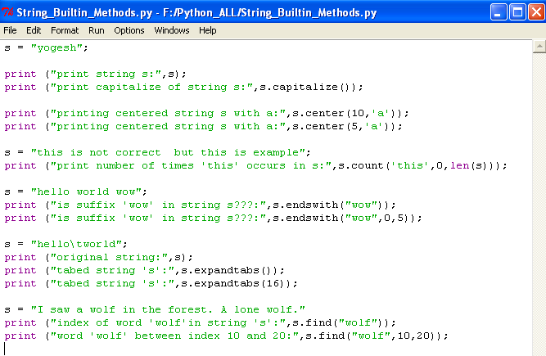

* Save it and run it by pressing F5
* Output of *Built-in_string_methods1.py*

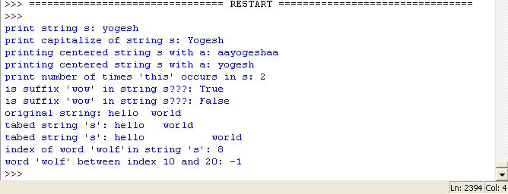

**isalnum():**

* The method *isalnum()* checks whether the string consists of alphanumeric character.
* syntax:
* *str.isalnum()*
* returns value:
* This method returns true if all character in the string is alphanumeric and there is at least one character, false otherwise.

**isalpha():**

* The method *isalpha()* checks whether the string consists of alphabetic characters only.
* syntax:
* *str.isalpha()*
* return value
* This method returns true if all character in the string is alphabetic and there is at least one character, false otherwise.

**isdecimal():**

* The method *isdecimal()* checks whether the string consists of only decimal character.
* syntax:
* *str.isdecimal()*
* return value:
* This method returns true if all character in the string are decimal, false otherwise.

**isdigits():**

* The method *isdigits()* checks whether the string consists of digits only.
* syntax:
* *str.isdigits()*
* return value:
* This method returns true if all character in the string is digits and there is at least one character, false otherwise.

**islower()**

* The method *islower()* checks whether all the case-based character(letter) of the string are lowercase.
* syntax:
* *str.islower()*
* Return value:
* This method returns true if all cased characters in the string are lowercase, false otherwise.

**Example:**

**Program to demonstrate Built-in string methods 2:**

* In this program we are writing a code to demonstrate Built-in string methods 2.
* Open Pyhton IDLE.
* Select file menu
* Click on New window
* Save the program as *Built-in_string_methods_2.py*
* Add the following code

s = "new year 2014";

print ("is string 's' containes alphanumeric character?:",s.isalnum());

s= "Yogesh"; #no space and digit in string

print ("is only alpha in string s?? :",s.isalpha());

s = "this is what this is"; # string has space

print ("is only alpha in string s??:",s.isalpha());

s = "yogi245"

print ("is only decimal in string s??:",s.isdecimal());

s = "5677";

print ("is only decimal in string s??:",s.isdecimal());

s = "yogi245"

print ("is only digits in string s??:",s.isdigit());

s = "5677";

print ("is only digits in string s??:",s.isdigit());

s = "yogesh"

print ("is lowercase in string s??:",s.islower());

s = "Yogesh"

print ("is lowercase in string s??:",s.islower());

* Code will look like this.

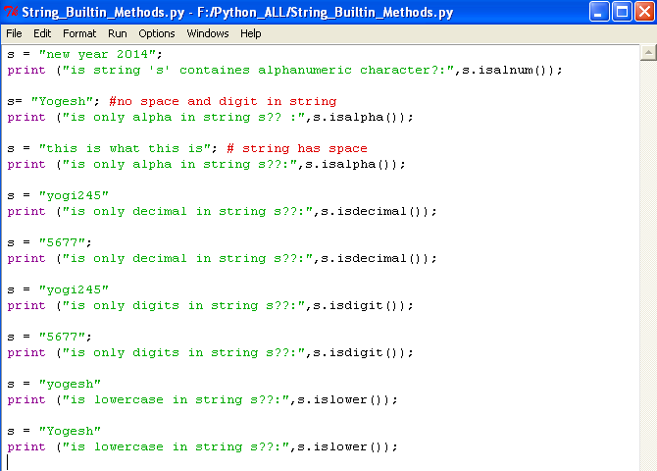

* Save it and run it by pressing F5
* Output of *Built-in_string_methods_2.py*

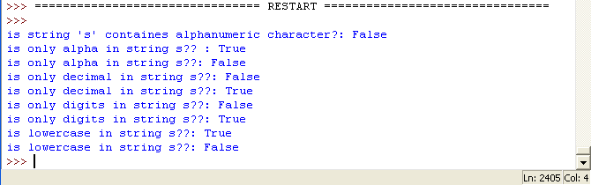

**isnumeric()**

* The method *isnumeric()* checks whether the string consists of only numeric character.
* syntax:
* *str.isnumeric()*
* return value:
* This method returns true if all characters in the string are numeric, false otherwise.

**isspace():**

* The method *isspace()* checks whether the string consists of whitespace.
* syntax:
* str.isspace();
* return value:
* This method returns true if there are only whitesace character in the string, false otherwise.

**istitle():**

* The method *istitle()* checks whether all the strings following non-case based letters are uppercase and all other case-based character are lowercase.
* syntax:
* *str.istitle()*
* return value:
* This method returns true if the string is titlecased string and there is at least one character, false otherwise

**isupper():**

* The method *isupper()* checks whether all the case-based character of the string are uppercase.
* syntax:
* *str.isupper()*
* return value:
* This method return true if all cased character in the strings are uppercase, false otherwise.

**Example:**

**Program to demonstrate Built-in string methods 3:**

* In this program we are writing a code to demonstrate Built-in string methods 3.
* Open Pyhton IDLE.
* Select file menu
* Click on New window
* Save the program as *Built-in_string_methods_3.py*
* Add the following code

s = "yogi245"

print ("is only digits in string s??:",s.isnumeric());

s = "5677";

print ("is only digits in string s??:",s.isnumeric());

s = " " #only spaces

print ("is only spaces in string s???: ",s.isspace());

s = "hello world!!"

print ("is only spaces in string s???: ",s.isspace());

s = "Yogesh";

print ("is string s is title??: ",s.istitle());

s = "yogesh";

print ("is string s is title??: ",s.istitle());

s = "YOgesh";

print ("is string s is title??: ",s.istitle());

s = "YOGESH";

print ("is string s is uppercased??: ",s.isupper());

s = "yogesh";

print ("is string s is uppercased??: ",s.isupper());

s = "YOGesh";

print ("is string s is uppercased??: ",s.isupper());

* Code will look like this.

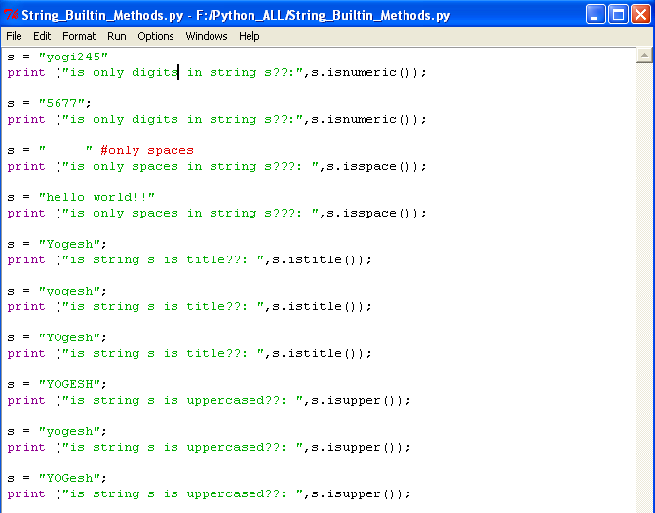

* Save it and run it by pressing F5
* Output of *Built-in_string_methods_3.py*

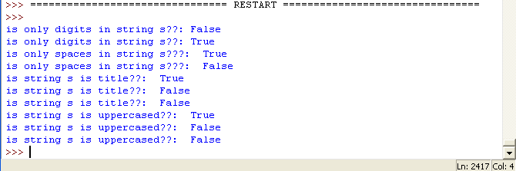

**join():**

* The method *join()* returns a string in which the string elements of sequences have been joined by *str* separator.
* syntax:
* *str,join(sequences)*
* parameter:
* sequences -- This is a sequences of the elements to be joined.
* Return value:
* This method returns a string, which is the concatenation of the string in the sequences seq. the separator between elements is the string providing this method.

**ljust():**

* The method *ljust()* returns the string left justified in string of length width. Padding is done using the specified fillchar (default is a space). The original string is returned if width is less than len(s)
* Syntax
* *str.ljust(width[,fillchar])*
* parameter
* *width* -- this is string length in total after padding
* *fillchar* -- this is filler character, default is a space
* Return value:
* This method returns the string left justified in string of length width. Padding is done using the specified fillchar. The original string will return if width is less than len(s).

**lower():**

* The method *lower()* returns a copy of the string which all case-based character have been lowercased.
* Syntax:
* *str.lower()*
* Return value:
* This method returns a copy of the string in which all character have been lowercased.

**upper():**

* The method *upper()* returns a copy of the string which all case-based character have been uppercased.
* Syntax:
* *str.upper()*
* Return value:
* This method returns a copy of the string in which all character have been uppercased.

**title():**

* The method *title()* returns a copy of the string which returns first character uppercase and remain character are lower cased.
* Syntax:
* *str.title()*
* Return value:
* The method *title()* returns a copy of the string which returns first character uppercase and remain character are lower cased.

**swapcase():**

* The method *swapcase()* returns a copy of the string in which all the case-based character have had their case swapped.
* Syntax:
* *str.swapcase()*
* Return value:
* This method returns a copy of the string in which all case-based character have had their case swapped.

**max():**

* The method *max()* returns the max alphabetical character from the string str.
* Syntax:
* *max(str)*
* Parameter:
* *str* -- this is the string from which max alphabetical character needs to be returned
* Return value:
* This method returns the max alphabetical character from the string *str*.

**Example:**

**Program to demonstrate Built-in string methods 4:**

* In this program we are writing a code to demonstrate Built-in string methods 4.
* Open Pyhton IDLE.
* Select file menu
* Click on New window
* Save the program as *Built-in_string_methods_4.py*
* Add the following code

s1 = "METI";

s2 = "%%%%"

print ("join s2 to s1:",s1.join(s2));

s = "METI";

print ("left justified charcter 'Y' 10 times:",s.ljust(14,'Y'));

print ("left justified charcter 'Y' 10 times:",s.ljust(4,'Y'));

s = "METI";

print ("lowercased string of 's':",s.lower());

s = "yogi";

print ("uppercased string of 's':",s.upper());

s = "yogesh";

print ("titlecased string of 's':",s.title());

s = "YOGesh";

print ("swaping case string of 's':",s.swapcase());

s = "yogesh"

print ("max alphabetical character in string 'yogesh':",max(s));

s = "abcdef"

print ("max alphabetical character in string 'abcdef':",max(s));

* Code will look like this.

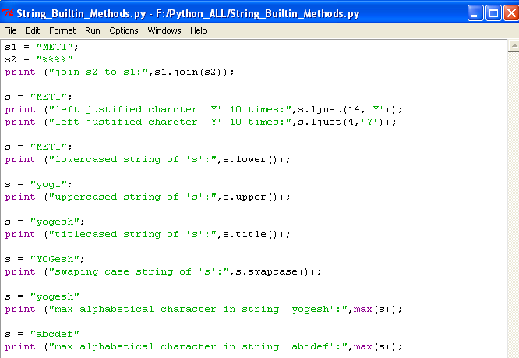

* Save it and run it by pressing F5
* Output of *Built-in_string_methods_4.py*

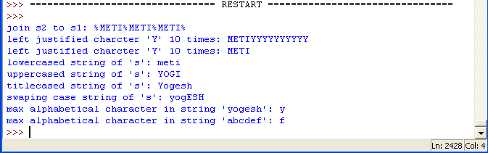

**min():**

* The method *min()* returns the *min* alphabetical character from the string str.
* Syntax:
* *min(str)*
* Parameter:
* *str* -- this is the string from which min alphabetical character needs to be returned
* Return value:
* This method returns the *min* alphabetical character from the string *str*.

**replace():**

* The method *replace()* returns a copy of the string in which the occurrences of old have been replaced with new, optionally restricting the number of replacement to max.
* Syntax
* *str.replace(old, new[,max])*
* Parameters
* *old* -- this is old substring to be replaced
* *new* -- This is new substring, which would replace old substring
* *max* -- If this optional arguments max is given, only the first count occurrences are replaced
* Return value:
* This method returns a copy of the string with all occurrences of substring old replaced by new. if the optional argument max is given, only the first count occurrences are replaced.

**zfill():**

* The method *zfill()* pads string on the left with zero to fill width
* Syntax:
* *str.zfill()*
* Parameter:
* *width* -- This is final width of the string.
* Return value:
* This method returns padded string.

**Example:**

**Program to demonstrate Built-in string methods 5 :**

* In this program we are writing a code to demonstrate Built-in string methods 5.
* Open Pyhton IDLE.
* Select file menu
* Click on New window
* Save the program as *Built-in_string_methods_5.py*
* Add the following code

s = "yogesh"

print ("min alphabetical character in string 'yogesh':",min(s));

s = "abcdef"

print ("min alphabetical character in string 'abcdef':",min(s));

s = "I saw a wolf in the forest. A lonely wolf."

print (s);

print ("replace 'wolf' by 'fox' :",s.replace('wolf','fox'));

print ("replace 'wolf' by 'fox' only once:",s.replace('wolf','fox',1));

s = "METI";

print ("padding '0' to the string 'METI'",s.zfill(10));

s = "I saw a wolf in the forest. A lone wolf."

print ("index of word 'wolf'in string 's':",s.index("wolf"));

print ("word 'wolf' between index 10 and 20:",s.index("wolf",10,20));

* Code will look like this.

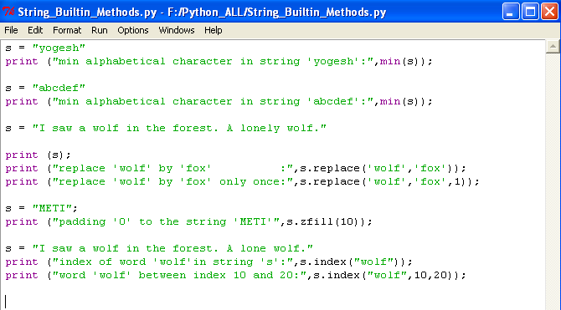

* Save it and run it by pressing F5
* Output of *Built-in_string_methods_5.py*

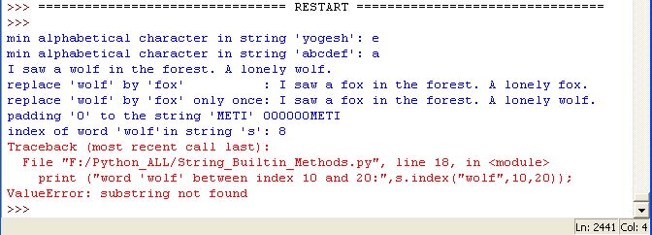

**Decision making:**

Some time we need to execute block of code based on few condition. A decision is when a program has more than one choice of actions depending on variable’s value. Pyhton provides if, if-else, if-elif-else, switch statement to execute them.

**If:**

* In this block of code will execute only when condition satisfied.



* Syntax:

statement a;

if<condition>:

Statement 1;

Statement 2;

.

.

.

Statement n;

Statement b;

Statement c;

* *If* – key word.
* *<Condition>* -- specifies the condition to be executed.
* *Statement 1*, *statement 2*, *statement n*, are the statement executes only when condition is true.
* *Indentation is important in python.*

**Example:**

**Program to demonstrate if statements:**

* In this program we are writing a code to demonstrate if statements.
* Open Pyhton IDLE.
* Select file menu
* Click on New window
* Save the program as *if_statement.py*
* Add the following code

a = 10;

b = 20;

if (b>a):

print ("b is greater than a");

* Code will look like this.

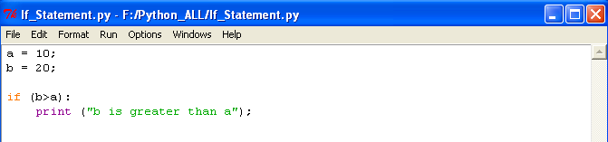

* Save it and run it by pressing F5
* Output of *if_statement.py*

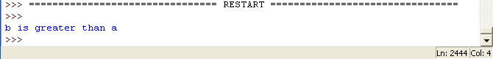

**If-else:**

* In this block of code will execute only when condition satisfied else one more block of code.



* Syntax:

statement a;

if<condition>:

Statement 1;

Statement 2;

.

.

.

Statement n;

else:

Statement 11;

Statement 22;

.

.

.

Statement nn;

Statement b;

Statement c;

* *If* – key word.
* *<Condition>* -- specifies the condition to be executed.
* *Statement 1*, *statement 2*, *statement n*, are the statement executes only when condition is true.
* *Statement 11*, *statement 22*, *statement nn*, are executes only when condition is fails.
* *Indentation is important in python.*

**Example:**

**Program to demonstrate if-else statements:**

* In this program we are writing a code to demonstrate if-else statements.
* Open Pyhton IDLE.
* Select file menu
* Click on New window
* Save the program as *if_else_statement.py*
* Add the following code

a = 10;

b = 20;

if (a>b):

print ("a is greater than b");

else:

print ("b is greater than a");

* Code will look like this.

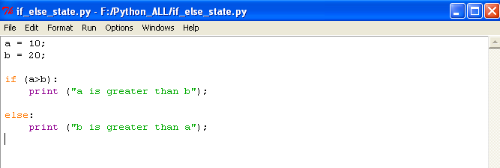

* Save it and run it by pressing F5
* Output of *if_else_statement.py*

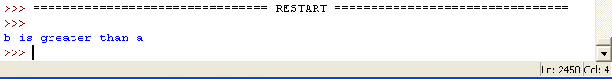

**If-elif-else:**

* In this block condition will check sequentially which ever condition satisfied that code block will executes.



* Syntax:

statement a;

if<condition>:

Block 1;

elif<condition>:

Block 2;

elif<condition>:

Block 3;

.

.

.

else:

Block n;

Statement b;

Statement c;

* *If* – key word.
* *elif* – key word.
* *else –* key word.
* *<Condition>* -- specifies the condition to be executed.
* *Block 1, Block 2 ... Block n* are block of code will executes if corresponding condition satisfied.
* *Indentation is important in python.*

**Example:**

**Program to demonstrate if-elif-else:**

* In this program we are writing a code to demonstrate if-elif-else.
* Open Pyhton IDLE.
* Select file menu
* Click on New window
* Save the program as *if-elif-else_stat.py*
* Add the following code

marks = 53;

if (marks > 90):

print ("A grade\n");

elif (marks > 80):

print ("B grade\n");

elif (marks > 70):

print ("c grade\n");

elif (marks > 60):

print ("D grade\n");

elif (marks > 50):

print ("E grade\n");

elif (marks > 40):

print ("F grade\n");

else:

print ("No grade\n")

* Code will look like this.

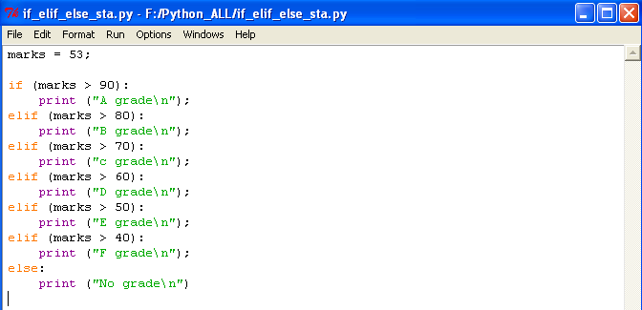

* Save it and run it by pressing F5
* Output of *if-elif-else_stat.py*

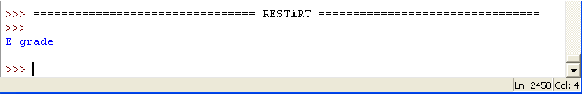

There no *switch* statement in Python if we want then we have to use *if-elif-else* statements only.

**Tuples:**

* Tuples construct simple groups of objects. They work exactly list, except that tuples can't be changed in place (they are immutable) and are usually written as a series of items in parentheses.
* Syntax:
* *str = ( ‘element1’, ’element2 ’, ’ element3 ’);*

**Example:**

**Program to demonstrate Tuples:**

* In this program we are writing a code to demonstrate Tuples.
* Open Pyhton IDLE.
* Select file menu
* Click on New window
* Save the program as *Tuples.py*
* Add the following code

# empty tuple example

s = ();

print ("empty tuple s:",s);

# one element in tuple

s = ('a');

print ("One element in tuple s:",s);

# tuple example

s = ('a',1,1.5,"yogi");

print ("tuple example:",s);

# indexing,slicing tuple

print ("s[0] :",s[0]);

print ("s[0:3]:",s[0:3]);

print ("s[-1] :",s[-1]);

# nested tuple

s = ('a',1,1.5,"yogi",('b','c'));

print ("print nested tuple s:",s);

# indexing nested tuple elements.

print ("accesing nested tuple element s[4][1]:",s[4][1]);

# concating two tuple.

s1 = ('a','b','c');

s2 = ('d','e','f');

print ("concating two tuple s1 and s2:",s1+s2);

# repeting tuple.

s = ('a','b',123);

print ("repeting tuple s 3 times:",s*3);

#membership

s = ('a','b',123);

print ("is 'a' is a member in tuple s:",'a' in s);

# tuple are immutable

s[0] = 'xyz';

* Code will look like this.

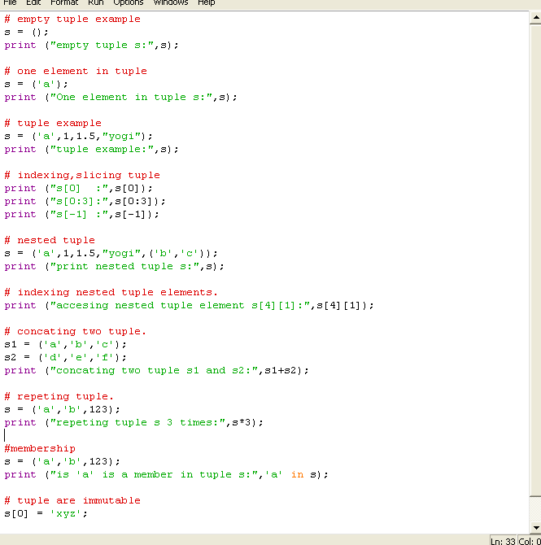

* Save it and run it by pressing F5
* Output of *Tuples.py*

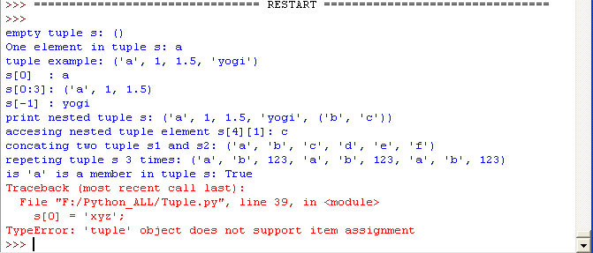

**Lists:**

* Lists are Python's most flexible ordered collection object type. Unlike strings, list can contains any sort of object: number, string, and even other lists. Also, unlike strings, list may be changed in place by assignment to offsets and slices, list method calls, deletion statements, and more- they are mutable.
* Syntax:
* *str = [ ‘element1’, ’element2 ’, ’ element3 ’];*

**Example:**

**Program to demonstrate Lists basics:**

* In this program we are writing a code to demonstrate List basics.
* Open Pyhton IDLE.
* Select file menu
* Click on New window
* Save the program as *List_basics.py*
* Add the following code

# empty list example

s = [];

print ("empty list s:",s);

# one element in list

s = ['a'];

print ("one element in list s:",s);

# list example

s = ['a',1,1.5,"yogi"];

print ("list example:",s);

# indexing,slicing list

print ("s[0] :",s[0]);

print ("s[0:3]:",s[0:3]);

print ("s[-1] :",s[-1]);

# nested list

s = ['a',1,1.5,"yogi",['b','c']];

print ("print nested list s:",s);

# indexing nested list elements.

print ("accesing nested list element s[4][1]:",s[4][1]);

# concating two list.

s1 = ['a','b','c'];

s2 = ['d','e','f'];

print ("concating two list s1 and s2:",s1+s2);

# repeting tuple.

s = ['a','b',123];

print ("repeting list s 3 times:",s*3);

#membership

s = ['a','b',123];

print ("is 'a' is a member in list s:",'a' in s);

* Code will look like this.

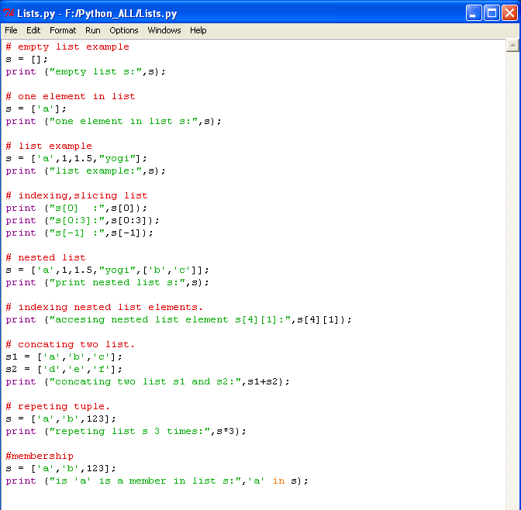

* Save it and run it by pressing F5
* Output of *List_basics.py*

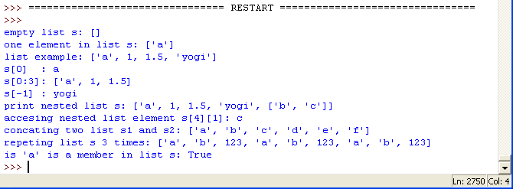

**Example:**

**Program to demonstrate List advanced:**

* In this program we are writing a code to demonstrate List Advanced.
* Open Pyhton IDLE.
* Select file menu
* Click on New window
* Save the program as *List_Advanced.py*
* Add the following code

s = ['a','b','c','d'];

s.append([5,6,7]);

print ("appending '['5','6','7']' to list s:",s);

s = ['a','b','c','d'];

s.extend([5,6,7]);

print ("expanding '['5','6','7']'to list s:",s);

print ("notice the difference between append and extend.");

s.insert(0,'123');

print ("inserting '123' to s[0]:",s);

print ("index of 'c' in list s is:",s.index('c'));

s = ['a','d','c','d','d','e','d'];

print ("counting 'd' in list s:",s.count('d'));

s.sort();

print ("sorting list s:",s);

s.reverse();

print ("reversing list s:",s);

print ("copying list s:",s.copy());

print ("clearing the list s:",s.clear());

s = ['a','d','c','d','d','e','d'];

print ("pop value in position 0:",s.pop(0));

print ("list s after pop:",s)

s.remove('c');

print ("removing 'c' from list s:",s);

del s[3];

print ("deleting 'e':",s);

del s[0:2];

print ("deleting value from 0 to 2:",s);

del s;

print ("deleting complete list s:",);

* Code will look like this.

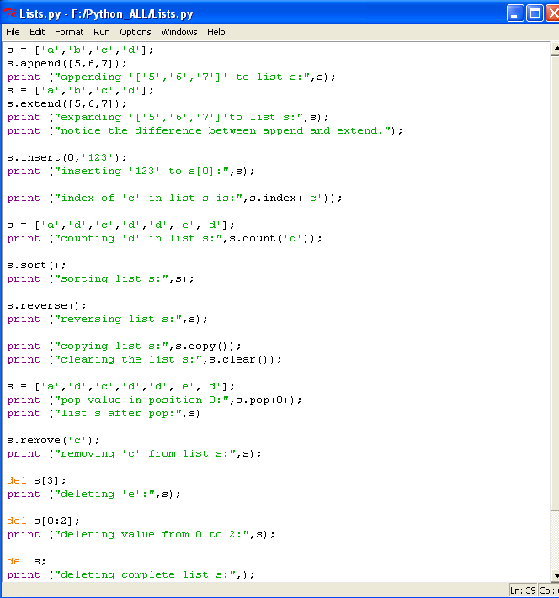

* Save it and run it by pressing F5
* Output of *List_Advanced.py*

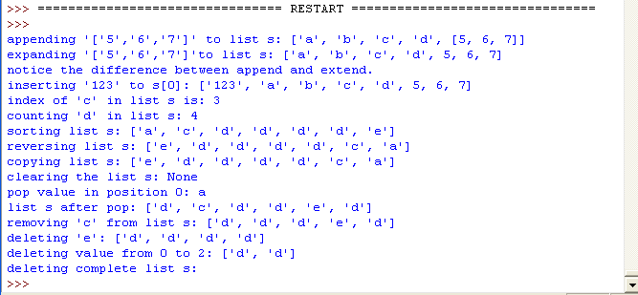

**Dictionaries:**

* Along with lists, dictionaries are one of the most flexible built-in data types in python. If you think of lists as ordered collections of objects, you can think of dictionaries as unordered collections. The chief destination is that in dictionaries, items are stored and fetched by key, instead of by positional offset.
* features:
* accessed by key, not offset position
* Unordered collections of arbitrary objects.
* Variable-length, heterogeneous, and arbitrarily nestable.
* of the category mutable mapping
* tables of object reference (hash table)
* Syntax:
* *str = { 'key1' : 'value1', 'key2' : 'value2', 'key3' : 'value3' };*



**Example:**

**Program to demonstrate Dictionaries:**

* In this program we are writing a code to demonstrate Dictionaries.
* Open Pyhton IDLE.
* Select file menu
* Click on New window
* Save the program as *Dictionaries_Basics.py*
* Add the following code

# empty dictionary

s = {};

print ("empty dictionary s:",s);

s = {'name' : 'yogesh','age':23,'company':'METI'};

print ("print Dictionary s:",s);

s = {'state': {'one':'karnataka','two':'tamil nadu'},'city':'mysore'};

print ("nested dictionary s:",s);

print ("one more way :",s);

s = dict( name ='yogi', age = 23,company = 'METI');

print ("alternative declaring dict s:",s);

s = dict([('name','yogi'),('age',23),('company','METI')]);

print ("one more way :",s);

# accessing dictionary

s = {'state': {'one':'karnataka','two':'tamil nadu'},'city':'mysore','name': 'yogi'};

print ("printing value in key 'city'of dict s:",s['city']);

print ("accessing s['state']['one']:",s['state']['one']);

print ("print all keys in s:",s.keys());

print ("print all keys in s['state']:",s['state'].keys());

print ("print all values in s:",s.values());

print ("print all values in s['state']:",s['state'].values());

print ("print all items in s:",s.items());

print ("print all items in s['state']:",s['state'].items());

* Code will look like this.

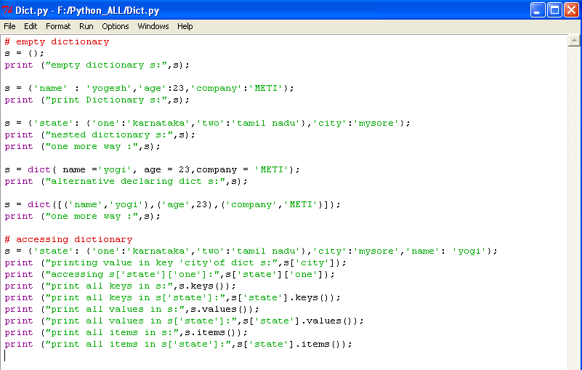

* Save it and run it by pressing F5
* Output of *Dictionaries_Basics.py*

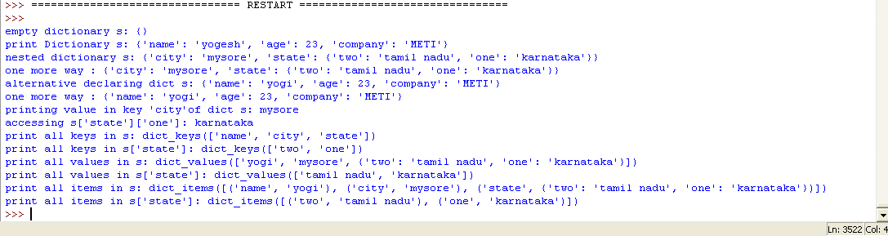

**Example:**

**Program to demonstrate Dictionaries Advance:**

* In this program we are writing a code to demonstrate Dictionaries Advance.
* Open Pyhton IDLE.
* Select file menu
* Click on New window
* Save the program as *Dictionaries_Adv.py*
* Add the following code

s = {'name' : 'yogesh','age':23,'company':'METI'};

print ("copying dict s:",s.copy());

print ("clearing dict s:",s.clear());

print ("dict s after clear function:",s);

s = {'name' : 'yogesh','age':23,'company':'METI'};

s1 = {'city':'mysore','state':'karnataka'};

s.update(s1);

print ("updating dict s:",s);

print ("get 'city' in dict s:",s.get('city'));

print ("pop 'city' in dict s:",s.pop('city'));

print ("dict s after pop:",s);

print (s.setdefault('name'));

* Code will look like this.

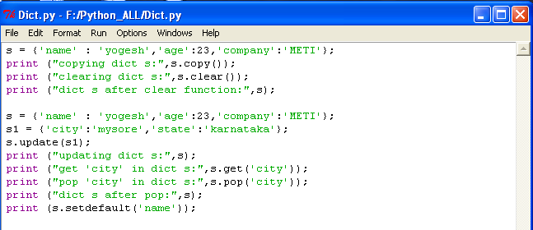

* Save it and run it by pressing F5
* Output of *Dictionaries_Adv.py*

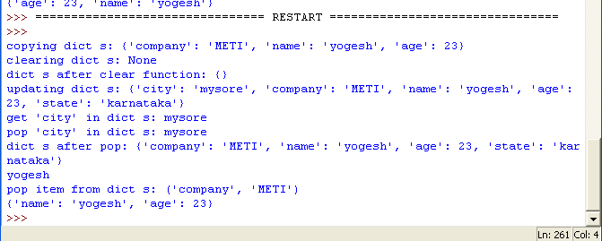

**Loops in python:**

**for loop:**

* A *for* loop is a Python statement which repeats a group of statements a specified number of times. We can use any object (such as *string, list, tuples, dict* and so on) in *for* loop in python.



* Syntax:

for var in <looping_condition>:

stat 1;

stat 2;

.

.

stat n;

**range():**

* range(): is a function which iterate over a sequence of number, for example range(10) [0,1,2,3,4,5,6,7,8,9] but look at it won’t print 10.
* range(1,10)— [1,2,3,4,5,6,7,8,9]
* range(1,10,2)— [1,3,5,7,9]
* range(10,0,-2)---[10,8,6,4,2]

**Example:**

**Program to demonstrate for loop:**

* In this program we are writing a code to demonstrate for loop.
* Open Pyhton IDLE.
* Select file menu
* Click on New window
* Save the program as *For_Loop.py*
* Add the following code

print ("print count from 2 to 10:");

for count in (2,4,6,8,10):

print (count);

# using range function

print ("using range function in for loop:")

print ("print number from 0 to 4");

for count in range(5):

print (count);

print ("range(1,10,2):");

for count in range(1,10,2):

print (count);

print ("range(10,0,-2):");

for count in range(10,0,-2):

print (count);

s = "Python";

print (s);

for letter in s:

print (letter);

* Code will look like this.

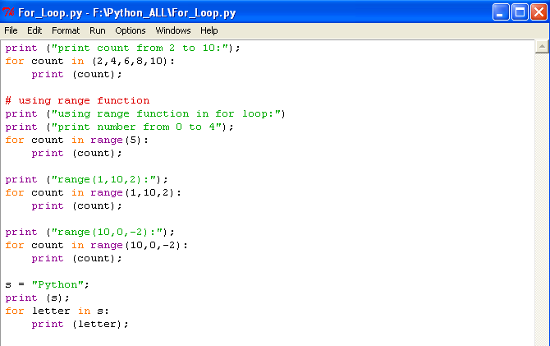

* Save it and run it by pressing F5
* Output of *For_Loop.py*

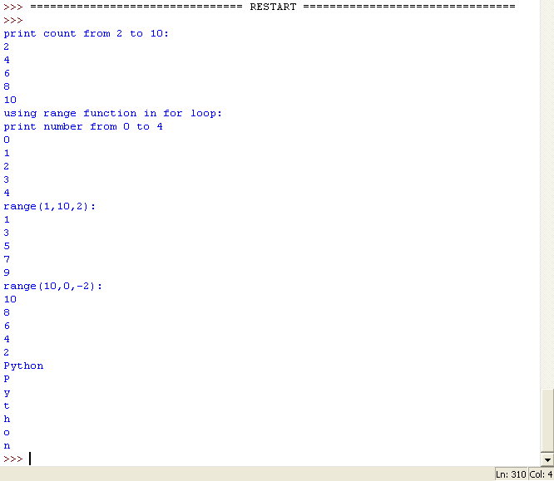

while loops:

* Python's while statement is the most general iteration construct in the language. In simple terms, it repeatedly executes block of statements as long as a test at the top keeps evaluating to true value. When the test becomes false, control passes to the statement that while block.



* Syntax:

Statement a;

while (condition):

statement 1;

statement 2;

.

.

statement n;

statement b;

**Example:**

**Program to demonstrate while loop:**

* In this program we are writing a code to demonstrate while loop.
* Open Pyhton IDLE.
* Select file menu
* Click on New window
* Save the program as *while_loop.py*
* Add the following code

a = 0;

b = 5;

while (a<b):

print (a);

a +=1;

print ("string example")

s = "Python ";

index = 0;

while (s[index]!=' '):

print (s[index]);

index+=1;

* Code will look like this.

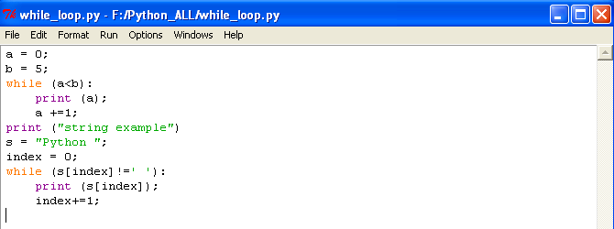

* Save it and run it by pressing F5
* Output of *while_loop.py*

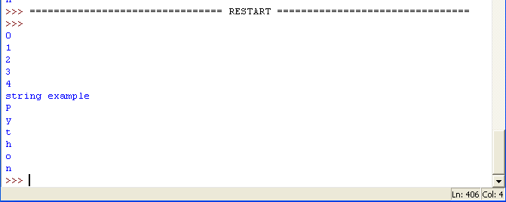

**functions:**

* Functions are alternative to programming by cutting and pasting rather than having multiple redundant copies of an operation's code, we can factor into a single function. In doing so, we reduce our future work radically. If the operation must be changed later, we have only one copy to update in the function, not many scattered throughout the program.
* Maximizing code reuse and minimizing redundancy.
* Procedural decomposition.



* Syntax:

def fun_name(arg1,arg2,...):

fun_body;

return va1;

* *def --*  key word.
* *fun_name –* function name.
* *arg1,arg2,... –* passing parameter to function.
* *fun_body –* block of code when function calls.
* *return –* key word.
* *Val1 –* return value*.*

**Example:**

**Program to demonstrate functions:**

* In this program we are writing a code to demonstrate functions.
* Open Pyhton IDLE.
* Select file menu
* Click on New window
* Save the program as *function.py*
* Add the following code

a = 5;

b = 10;

def Normal_fun():

if(b>a):

print ("'b' is greater than 'a'\n");

else:

print ("'a' is greater than 'b'\n");

def Para_fun(a,b):

if(b>a):

print ("'b' is greater than 'a'\n");

else:

print ("'a' is greater than 'b'\n");

def Para_ret_fun(a,b):

if(b>a):

return 1;

else:

return 0;

print ("normal function:");

Normal_fun();

print ("using parameter passing:");

Para_fun(5,10);

print ("return value from function:");

c = Para_ret_fun(5,10);

if(c):

print ("'b' is greater than 'a'\n");

else:

print ("'a' is greater than 'b'\n");

* Code will look like this.

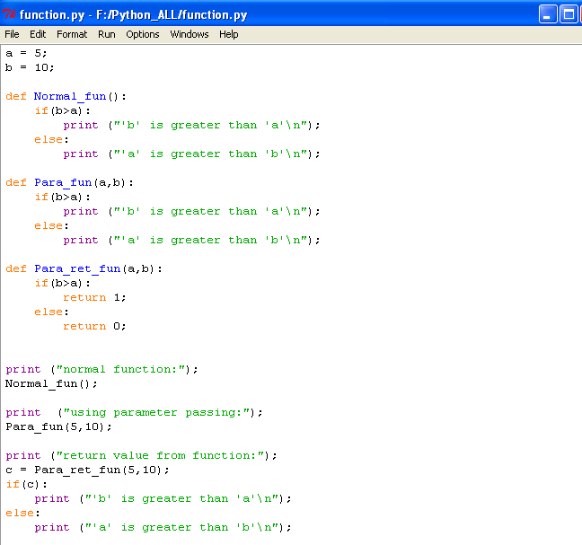

* Save it and run it by pressing F5
* Output of *function.py*

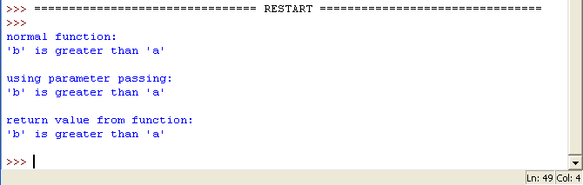

**Exception handling**:

* exception:
* An exception is an error that happens during execution of a program. When that error occurs, Python generate an exception that can be handled, which avoids your program to crash.
* exception are convenient in many ways for handling errors and special conditions in a program. when you think you have a code which can produce an error then you can use exception handling.
* you can raise an exception in your own program by using the raise exception statement, raising an exception breaks current code execution and returns the exception back untill it is handled.
* Exceptions errors in python:
* IOError: If the file cannot be opened.
* ImportError: If python cannot find the module
* ValueError: Rises when a built-in operator or function receives arguments that have the right type but an inappropriate value.
* KeyboardInterrupt: Rises when the user hits the interrupt (ctrl+C or Delete).
* EOFError: Rises when one of the built-in functions hits an end-of-file condition without reading any data.
* try and except are python keyword and are used to catch exceptions.

try:

some statements here.

except:

exception handling

**Example:**

**Program to demonstrate exception handling:**

* In this program we are writing a code to demonstrate exception handling.
* Open Pyhton IDLE.
* Select file menu
* Click on New window
* Save the program as *exception_handling.py*
* Add the following code

a = 10;

b = 0;

try:

print ("a /b is ",a/b);

except:

print ("you cant divide a number by zero.");

* Code will look like this.

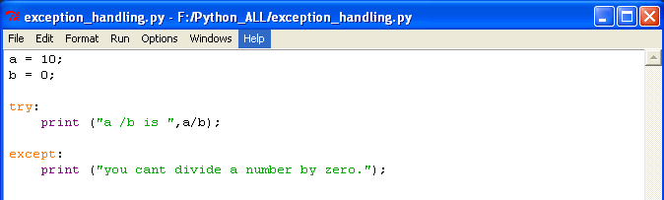

* Save it and run it by pressing F5
* Output of *exception_handling.py*

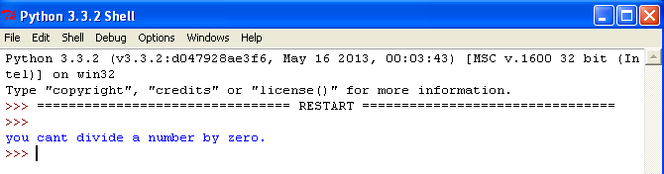

**Time, date, calendar:**

A python can handle date and time in several ways. Converting between date formats is a common thing for computers. Python's time and calendar module helps date and times.

**Example:**

**Program to demonstrate Bitwise operators:**

* In this program we are writing a code to demonstrate time module.
* Open Pyhton IDLE.
* Select file menu
* Click on New window
* Save the program as *time.py*
* Add the following code

print ("Time is: ",time.ctime(),'\n');

for i in range(0,5,1):

print ("Time is: ",time.ctime());

print ("sleep %d seconds"%i);

time.sleep(i);

def show_time_struct(s):

print ("\ntm_year :",s.tm_year);

print ("tm_mon :",s.tm_mon);

print ("tm_mday :",s.tm_mday);

print ("tm_hour :",s.tm_hour);

print ("tm_min :",s.tm_min);

print ("tm_sec :",s.tm_sec);

print ("tm_wday :",s.tm_wday);

print ("tm_wday :",s.tm_yday);

print ("tm_isdst :",s.tm_isdst);

print ("\ngmtime:",show_time_struct(time.gmtime()));

* Code will look like this.

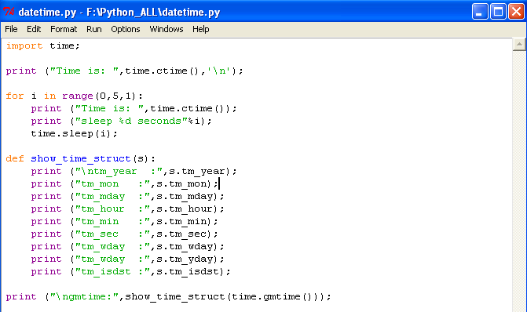

* Save it and run it by pressing F5
* Output of *time.py*

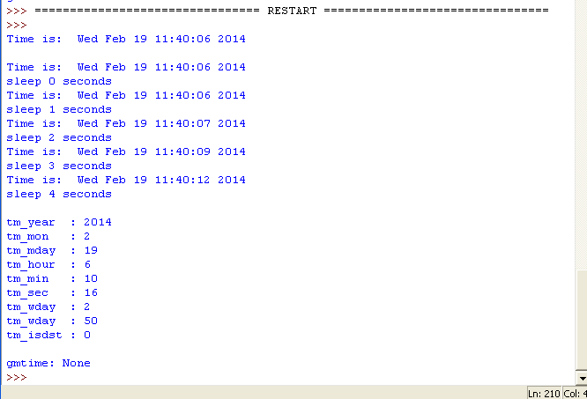

**Example:**

**Program to demonstrate datetime module:**

* In this program we are writing a code to demonstrate datetime module.
* Open Pyhton IDLE.
* Select file menu
* Click on New window
* Save the program as *datetime1.py*
* Add the following code

import datetime;

Today = datetime.datetime.today();

print ("Time :",Today.ctime());

print ("year :",Today.year);

print ("Month :",Today.month);

print ("Day :",Today.day);

print ("Hour :",Today.hour);

print ("Minute:",Today.minute);

print ("Second:",Today.second);

* Code will look like this.

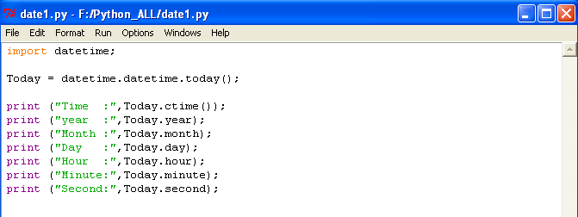

* Save it and run it by pressing F5
* Output of *datetime1.py*

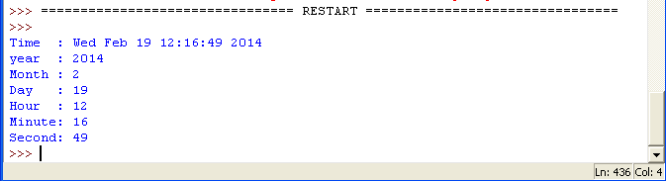

**Example:**

**Program to demonstrate calendar module:**

* In this program we are writing a code to demonstrate calendar module.
* Open Pyhton IDLE.
* Select file menu
* Click on New window
* Save the program as *calendar1s.py*
* Add the following code

import calendar;

cal = calendar.TextCalendar(calendar.MONDAY);

print ("2014 calender:")

cal.pryear(2014);

##you can print month of year

##print ("2014 feb calender:");

##cal.prmonth(2014,2);

* Code will look like this.

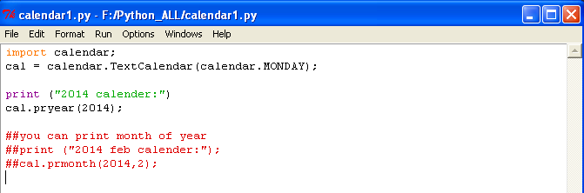

* Save it and run it by pressing F5
* Output of *calendar1.py*

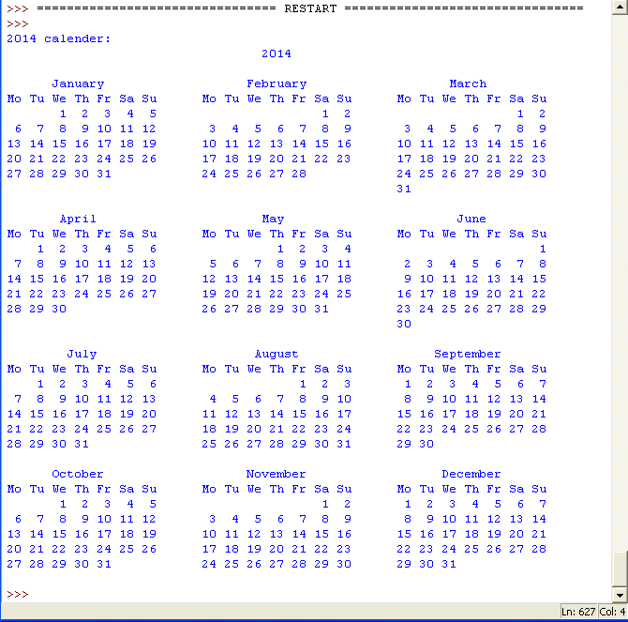

**Example:**

**Program to demonstrate Bitwise operators:**

* In this program we are writing a code to demonstrate Bitwise operators.
* Open Pyhton IDLE.
* Select file menu
* Click on New window
* Save the program as *Bitwise_Operator*
* Add the following code
* Code will look like this.
* Save it and run it by pressing F5
* Output of *Assignment_Operator*
* Code explanation:

# Beaglebone basic projects

We're going to use a few of the pins of beaglebone in GPIO mode. GPIO pins have two statuses: high and low. When a pin is high, that means it's connected to 3.3 volts. When a pin is low, it means that it's connected to ground. It's important to remember that digital pins must be either high or low. Reading the state of a pin that's not connected to anything will return unpredictable results. We say such a pin is floating. 3.3 volt is the specified logic level of the beaglebone. Use only 3.3 volt logic components with the beaglebone. Otherwise you will permanently damage the board.

**Digital pin control from the Linux command line:**

Before we get into writing any software, let's take a look at how to do some basic digital pin control from the linux command line. Once you get to know how the linux virtual filesystem to read and write pins, it makes programming the beaglebone much easier. It also means that you can then use any programming languages like python which you're comfortable with to read and write to the pins. As long as you can read and write files, you can work with GPIO. Unfortunately, the way that you'll refer to each pin within the linux filesystem is not the pin number printed on the board.

For pin outs P8, you can see the default signal name for hardware pin 12 is "*GPIO_12*". The signal names takes format of "*GPIO [chip]_[pin]*". To determine the pin number that you'll use within linux, multiply the chip number by 32 and add the pin number. So for signal *GPIO_12*, you'd refer to it as GPIO signal 44 within linux. (32x1+12=44). You may have noticed that we've only labelled a few pins in figure and here's why: many pins can be assigned different functions, not just digital input and output. This feature is known as pin multiplexing or "pin muxing" and it can make things a little tricky.



You know to use GPIO signal 44 within Linux for pin 12 on header P8 and you know that it's set to work in GPIO mode by default.

**System block diagram:**



cd /

cd /sys/class/gpio

ls

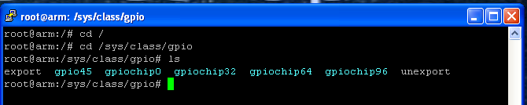

When you list the content of the directory with the commands ls you'll notice there's no folder for gpio signal 44. That's because we need to export the pin to userspace so that we can control it. To do that, use the echo command to write the number 44 to the export file:

echo 44 > export

These pins can be used by many different possible functions and you don’t want them to conflict with each other. For example, if you attach a beagle bone expansion board, or cape, it may request access to a few of these pins for itself. Exporting the pins to the userspace is a way of saying to the linux kernel, "I, the user, want to use this pin." The kernel will then warn you if it's already in use. If it's not in use, it will create the appropriate directory so that you can control the pin and it will then warn others that you have control of it.

ls

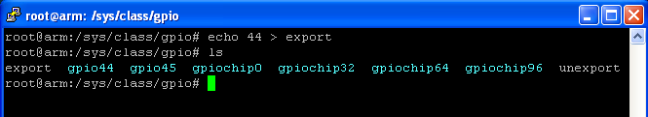

You'll see the newly created gpio44 directory.

cd gpio44

Since you want to control an led, you need to set the pin as an output by writing the word "out" to the pin 44's direction file:

echo out > direction

Now we are ready to set the pin high to illuminate the LED. Write 1 to the value file:

echo 1 > value

We can set the pin low and turn off LED by writing a 0 to the value file :

echo 0 > value

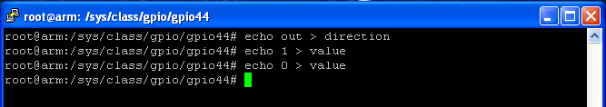

This method is not so good to control GPIO’s of beaglebone.

**GPIO programming using Python:**

When you write code for a microcontroller like PSoC3, Most of the time you will write the code on your computer, compile it, and then upload the complied binary file to the microcontroller. However, on an embedded linux system like beaglebone, the complier or interpreter exits on the board itself. This chapter will show you how to use the python interpreter on beaglebone to program the pins to behave the way we want.

Python is a powerful programming language that's still very accessible for beginners. The code is relatively easy to understand and there are many libraries that help with complex tasks. For example Adafruit's Beaglebone IO python library to help with reading and writing the GPIO pins.

**Installing Adafruit's Beaglebone IO python library:**

Out of box, the beaglebone doesn't have much support for using python to access the input and output pins on the board. Just like we did previously, it is possible to write python code to manually read and write the GPIO file in the linux virtual filesystem. Before you do anything else, you'll need to install some python tools using *apt-get*. From the command line, update packages listing. Make sure that you are working as root user

apt-get update

apt-get upgrade

apt-get install build-essential python-dev python-setuptools python-pip python-smbus -y

easy_install -U distribute

pip install Adafruit_BBIO

If we install everything perfectly then we ready to code.

Create a new folder in home directory and name it as *METI_BBB*

Before starting your project go to the directory *METI_BBB*.

cd /

ls

cd home

ls

cd METI_BBB

ls

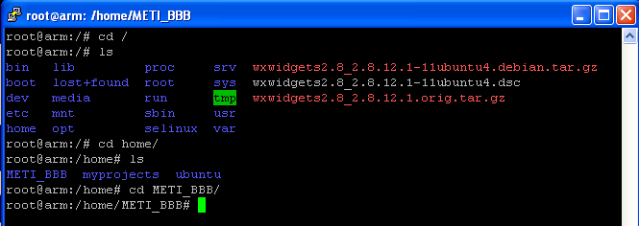

Make sure that your entire beaglebone projects will store in this folder itself.

**Project B1- Blink an LED (with firmware delay)**

Objective:

* Simple LED blinking with firmware delay

System block diagram:



Wiring:

* Connect 1Kohm resistor to pin P8_12 and one more end of resistor to LED positive.
* Connect Led negative to GND pin of beaglebone black i.e. pin 2 of port 8.

Create a new project

vim Blink_Led_1.py

You will get a screen like this

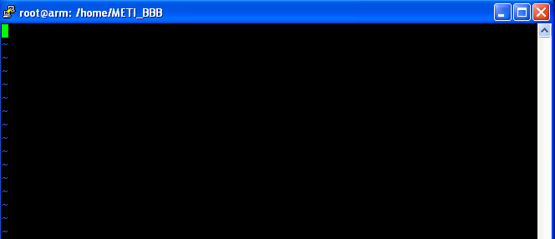

Press *Insert* key to write following code

import Adafruit_BBIO.GPIO as GPIO;

import time;

GPIO.setup(“P8_12”,GPIO.OUT);

While True:

GPIO.output("P8_12",GPIO.HIGH);

print ("ON");

time.sleep(1);

GPIO.output("P8_12",GPIO.LOW);

print ("OFF");

time.sleep(1);

Code will look like this

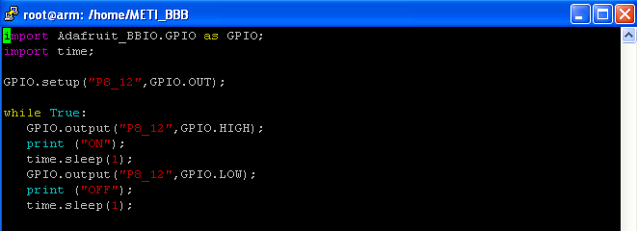

Press ***esc*** type ***:wq*** press enter which is nothing but write and quit

Now you will back to METI_BBB directory

Write command

python Blink_Led_1.py

Now you can see Led which is connected to *P8_12* on/off every 1 second.

Code explanation:

* *import Adafruit_BBIO.GPIO as GPIO;*
* imports the Adafruit's GPIO library and allows you to use functions from Adafruit's GPIO library and refer to them with prefix GPIO
* *import time;*
* Imports the time module and allows you to use functions like sleep.
* *GPIO.setup(“P8_12”,GPIO.OUT);*
* Set the pin 12 of port P8 as output
* *While True:*
* infinite loop
* *GPIO.output("P8_12",GPIO.HIGH);*
* Drive Pin 12 of port 8 to high i.e. 3.3V
* *print ("ON");*
* prints message *ON* on screen
* *time.sleep(1);*
* Gives time delay of 1 second.
* *GPIO.output("P8_12",GPIO.LOW);*
* Drive pin 12 of port 8 to low i.e. 0V
* *print ("OFF");*
* prints message OFF on screen
* *time.sleep(1);*
* Give time delay of 1 second.

**Project B2- Reading switch input and writing to LED with firmware**

Objective:

* Reading the Digital input pin through firmware.
* Simple switch to LED control.

System block diagram:



Wiring:

* Connect 1Kohm resistor to pin P8_12 and one more end of resistor to LED positive.
* Connect Led negative to GND pin of beaglebone black i.e. pin 2 of port 8.
* Connect one end of switch lead to 3.3v and one more lead to P8_11.

Create a new project

vim Switch_Read.py

Press *Insert* key to write following code

import Adafruit_BBIO.GPIO as GPIO;

import time;

GPIO.setup(“P8_12”,GPIO.OUT);

GPIO.setup(“P8_11”,GPIO.IN)

While True:

if GPIO.input("P8_11"):

if (Counter_Press < 10):

Counter_Press += 1;

Counter_Rel = 0;

if (Counter_Press == 1):

print ("Switch pressed!!!!");

time.sleep(.1);

GPIO.output("P8_12",GPIO.HIGH);

else:

Counter_Press = 0;

if (Counter_Rel < 10):

Counter_Rel += 1;

if (Counter_Rel == 1):

GPIO.output("P8_12",GPIO.LOW);

time.sleep(.1);

print ("Switch Released!!!");

Code will look like this

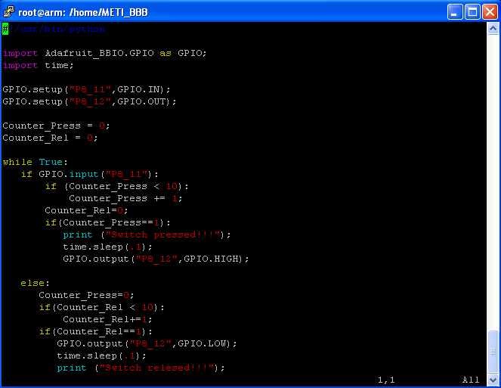

Press ***esc*** write ***:wq*** which is nothing but write and quit

Now you will back to METI_BBB directory

Write command

python Switch_Read.py

Now you can see when switch pressed LED will switch ON and message displayed as *switch pressed!!!*. When switch realised LED will switch OFF and message displayed as *switch realised!!!* .

Code explanation:

* *import Adafruit_BBIO.GPIO as GPIO;*
* Imports the Adafruit's GPIO library and allows you to use functions from Adafruit's GPIO library and refer to them with prefix GPIO
* *import time;*
* Imports the time module and allows you to use functions like sleep.
* *GPIO.setup(“P8_12”,GPIO.OUT);*
* Set the pin 12 of port P8 as output
* *GPIO.setup(“P8_11”,GPIO.IN)*
* Set the pin 11 of port P8 as input
* *While True:*
* Infinite loop
* *if GPIO.input("P8_11"):*
* if pin P8_11 read as high

if (Counter_Press < 10):

Counter_Press += 1;

Counter_Rel = 0;

This logic is to avoid repetitive message display when switch pressed continuously. Variable Counter_Press will increment only 9 if not over flow will occurs if switch pressed for long time

if (Counter_Press == 1):

print ("Switch pressed!!!!");

time.sleep(.1);

GPIO.output("P8_12",GPIO.HIGH);

To display the message *Switch pressed!!!!* Only once and turn on the LED and simple delay to avoid bouncing effect of switch

else:

Counter_Press = 0;

if (Counter_Rel < 10):

Counter_Rel += 1;

This logic is to avoid repetitive message display when switch pressed continuously. Variable *Counter_Rel* will increment only 9 if not over flow will occurs if switch pressed for long time

if (Counter_Rel == 1):

GPIO.output("P8_12",GPIO.LOW);

time.sleep(.1);

print ("Switch Released!!!");

To display the message *Switch Released!!!!* Only once and turn off the LED and simple delay to avoid bouncing effect of switch.

**Project B3- Using interrupt to reading switch input and writing to LED with firmware**

Objective:

* Reading the Digital input pin through interrupt method.
* Simple switch to LED control.

System block diagram:



Wiring:

* Connect 1Kohm resistor to pin P8_12 and one more end of resistor to LED positive.
* Connect Led negative to GND pin of beaglebone black i.e. pin 2 of port 8.
* Connect one end of switch lead to 3.3v and one more lead to P8_11.

Create a new project

vim Switch_ISR.py

Press *Insert* key in your keyboard and write following code

import Adafruit_BBIO.GPIO as GPIO;

import time;

GPIO.setup ("P8_11",GPIO.IN);

GPIO.setup ("P8_12",GPIO.OUT);

while True:

GPIO.wait_for_edge("P8_11",GPIO.RISING);

print ("Switch pressed!!!");

GPIO.output("P8_12",GPIO.HIGH);

GPIO.wait_for_edge("P8_11",GPIO.FALLING);

print ("Switch pressed!!!");

GPIO.output("P8_12",GPIO.LOW);

Code will look like this

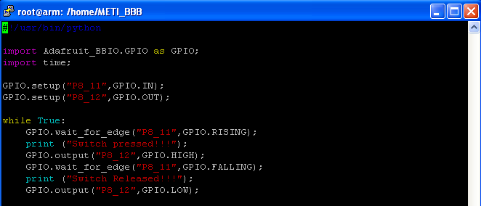

Press ***esc*** write ***:wq*** which is nothing but write and quit

Now you will back to METI_BBB directory

Write command

python Switch_ISR.py

Now you can see when switch pressed LED will switch ON and message displayed as *switch pressed!!!*. When switch realised LED will switch OFF and message displayed as *switch realised!!!* .

**Code explanation**:

* *import Adafruit_BBIO.GPIO as GPIO;*
* Imports the Adafruit's GPIO library and allows you to use functions from Adafruit's GPIO library and refer to them with prefix GPIO
* *import time;*
* Imports the time module and allows you to use functions like sleep.
* *GPIO.setup(“P8_12”,GPIO.OUT);*
* Set the pin 12 of port P8 as output
* *GPIO.setup(“P8_11”,GPIO.IN)*
* Set the pin 11 of port P8 as input
* *While True:*
* Infinite loop
* *GPIO.wait_for_edge("P8_11",GPIO.RISING);*
* Wait until the button changes from low to high.
* *print ("Switch pressed!!!");*
* displays the message Switch pressed
* *GPIO.output("P8_12",GPIO.HIGH);*
* Drive pin 12 of port 8 to high i.e. 3.3V
* *GPIO.wait_for_edge("P8_11",GPIO.FALLING);*
* Wait until the button changes from low to high.
* *print ("Switch pressed!!!");*
* displays the message Switch pressed
* *GPIO.output("P8_12",GPIO.LOW);*
* Drive pin 12 of port 8 to low i.e. 0V

**Project B4- Reading Analog input**

Objective:

* Reading the Analog input.

System block diagram:



Wiring:

* Connect 10Kohm pot to 5V pin and one more end of pot to voltage divider as shown in figure.
* Connect voltage divider as shown in figure.
* Connect *Vout* to pin 33 of port P9 and ground pin to GND.

Create a new project

vim Analog_Volt_Read.py

Press *Insert* key in your keyboard and write following code

import Adafruit_BBIO.ADC as ADC;

import time;

import math;

ADC.setup();

Analog_Volt = 0;

while True:

Analog_Volt = ADC.read("P9_33") * 3.136763 * 1.8 ;

Analog_Volt = math.ceil(Analog_Volt * 100)/100;

print "Analog Read: ", Analog_Volt,"volt";

time.sleep(.5);

Code will look like this

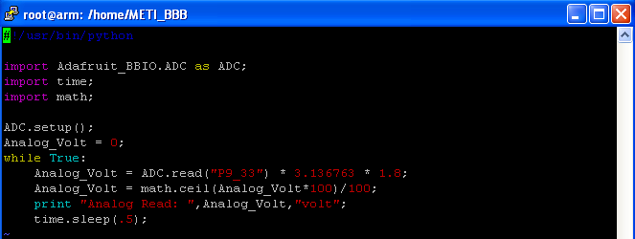

Press ***esc*** write ***:wq*** which is nothing but write and quit

Now you will back to METI_BBB directory

Write command

python Analog_Volt_Read.py

Now you can see analog voltage reading, when pot connected to beaglebone is turned, the actual voltage from the pot is read by the ADC and value displayed on screen.

**Code explanation**:

* *import Adafruit_BBIO.ADC as ADC;*
* Imports the Adafruit's ADC library and allows you to use functions from Adafruit's ADC library and refer to them with prefix ADC
* *import time;*
* Imports the time module and allows you to use functions like sleep.
* *import math;*
* Imports the math function to project.
* *ADC.setup();*
* Sets the pins to be used as analog inputs.
* *Analog_Volt = 0;*
* Variable to store ADC read value.
* *While True:*
* Infinite loop
* *Analog_Volt = ADC.read("P9_33") * 3.136763 * 1.8 ;*
* *ADC.read ("P9_33")* will returns the voltage value from pin 33 on a scale of 0 to 1 so to actual voltage we are multiply this value by 1.8. Since ADC in beagle can read max value of 1.8 not more than that if we try to give more than 1.8 Volt beaglebone damage complete. Most of the time analog voltage range will be 0 to 5V so to get this we are using voltage divider concept. Here we are using 3.3Kohm resistor and 4.7kohm resistor to divide the input voltage and voltage range will be 0 to 1.6 V which good for beaglebone. In coding we are remapping this back to 0 to 5V range by multiplying 3.136763.
* *Analog_Volt = math.ceil(Analog_Volt * 100)/100;*
* To get decimal point adjustment we are using math function ceil, where *Analog_Volt* is multiply by 100 and divide this value by 100 to 2 decimal point adjustment.
* *print "Analog Read: ", Analog_Volt,"volt";*
* prints this read analog value.
* *time.sleep(.5);*
* Delay of 0.5 seconds.

**Project B5- Ambient temperature measurement using LM35**

Objective:

* Measuring ambient temperature using LM35 precision centigrade temperature sensor.

System block diagram:



Wiring:

* Connect *vcc* pin of LM35 to 5V pin of beaglebone, *out* pin of LM35 to voltage divider circuit as shown in figure and *GND* pin of LM35 to *GND* pin of beaglebone.
* Connect voltage divider as shown in figure.
* Connect *Vout* to pin 33 of port P9 and ground pin to GND.

Create a new project

vim Ambient_temp.py

Press *Insert* key in your keyboard and write following code

import Adafruit_BBIO.ADC as ADC;

import time;

import math;

ADC.setup();

Amb_Temp_Volt = 0;

Amb_Temp = 0;

while True:

Amb_Temp_volt = ADC.read("P9_33") * 3.136763 * 1.8 ;

Amb_temp = Amb_Temp_Volt / 0.01 ;

Amb_Temp = math.ceil(Amb_Temp * 100)/100 ;

print "Ambient Tempreture: ",Amb_Temp," Degree celsius" ;

time.sleep(.5);

Code will look like this

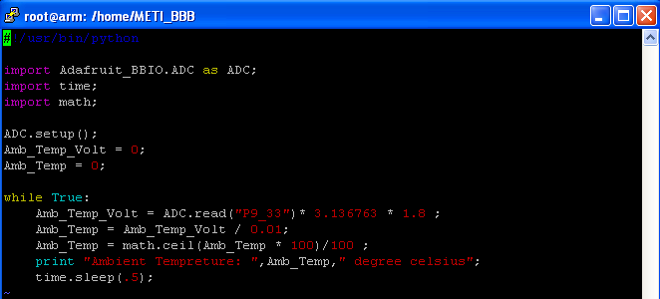

Press ***esc*** write ***:wq*** which is nothing but write and quit

Now you will back to METI_BBB directory

Write command

python Ambient_temp.py

Now you can see ambient temperature on screen, Hold the LM35 IC, see increase temperature on screen.

**Code explanation**:

* *import Adafruit_BBIO.ADC as ADC;*
* Imports the Adafruit's ADC library and allows you to use functions from Adafruit's ADC library and refer to them with prefix ADC
* *import time;*
* Imports the time module and allows you to use functions like sleep.
* *import math;*
* Imports the math function to project.
* *ADC.setup();*
* Sets the pins to be used as analog inputs.
* *Amb_Temp_Volt = 0;*
* Variable to store voltage read by ADC.
* *Amb_Temp = 0;*
* Variable to display temperature
* *While True:*
* Infinite loop
* *Amb_Temp_volt = ADC.read("P9_33") * 3.136763 * 1.8 ;*
* *ADC.read ("P9_33")* will returns the voltage value from pin 33 on a scale of 0 to 1 so to actual voltage we are multiply this value by 1.8. Since ADC in beagle can read max value of 1.8 not more than that if we try to give more than 1.8 Volt beaglebone damage complete. Most of the time analog voltage range will be 0 to 5V so to get this we are using voltage divider concept. Here we are using 3.3Kohm resistor and 4.7kohm resistor to divide the input voltage and voltage range will be 0 to 1.6 V which good for beaglebone. In coding we are remapping this back to 0 to 5V range by multiplying 3.136763.
* *Amb_temp = Amb_Temp_Volt / 0.01 ;*
* LM35 give 10mV change for every 1 degree change in temperature. For example if LM35 gives output of 300mV means temperature is 30 degree.
* *Amb_Temp = math.ceil(Amb_Temp * 100)/100 ;*
* To get decimal point adjustment we are using math function ceil, where *Amb_Temp* is multiply by 100 and divide this value by 100 to 2 decimal point adjustment.
* *print "Ambient Temperature: ",Amb_Temp," Degree Celsius" ;*
* Displays the Ambient temperature on screen.
* *LM35 Temperature Sensor:*
* The LM35 series are precision integrated-circuit temperature sensors, whose output voltage is linearly proportional to the Celsius (Centigrade) temperature. The LM35 thus has an advantage over linear temperature sensors calibrated in ° Kelvin, as the user is not required to subtract a large constant voltage from its output to obtain convenient Centigrade scaling. The LM35 does not require any external calibration or trimming to provide typical accuracies of ±¼°C at room temperature and ±¾°C over a full -55 to +150°C temperature range. Low cost is assured by trimming and calibration at the wafer level. The LM35's low output impedance, linear output, and precise inherent calibration make interfacing to readout or control circuitry especially easy. It has very low self-heating, less than 0.1°C in still air. The LM35 is rated to operate over a -55° to +150°C temperature range. A digital thermometer can be easily created by using LM35 temperature sensor and can be interfaced any microcontrollers. The LM 35 IC generates a 10mV variation to its output voltage for every degree Celsius change in temperature.

**Project B5- LED Brightness control using PWM**

Objective:

* Controlling the brightness of an LED by varying the duty cycle of a PWM.

System block diagram:



Wiring:

* Connect 1Kohm resistor to pin P8_13 and one more end of resistor to LED positive.
* Connect Led negative to GND pin of beaglebone black i.e. pin 2 of port 8.
* Connect one end of switch lead to 3.3v and one more lead to P8_13.

Create a new project

vim PWM_Led.py

Press *Insert* key to write following code

import Adafruit_BBIO.PWM as PWM;

import time;

PWM.start("P8_13",0);

while True:

for Counter in range (0,100,1):

PWM.set_duty_cycle("P8_13",float(Counter));

time.sleep(.1);

for Counter in range (100,0,-1):

PWM.set_duty_cycle("P8_13",float(Counter));

time.sleep(.1);

PWM.stop("P8_13");

PWM.cleanup();

PWM.start("P8_13",0);

Code will look like this

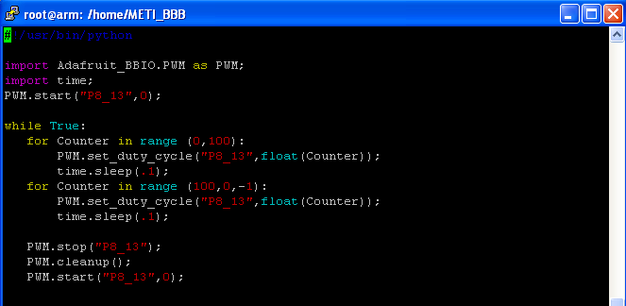

Press ***esc*** write ***:wq*** which is nothing but write and quit

Now you will back to METI_BBB directory

Write command

python PWM_Led.py

Now you can see fade in and fade out at LED connected at P8_13 of beaglebone black.

**Code explanation**:

* *import Adafruit_BBIO.PWM as PWM;*
* Imports the Adafruit's PWM library and allows you to use functions from Adafruit's PWM library and refer to them with prefix PWM
* *import time;*
* Imports the time module and allows you to use functions like sleep.
* *PWM.start("P8_13",0);*
* Start using PWM on pin13 of header P8 and set its duty cycle to 0.
* *While True:*
* Infinite loop
* *for Counter in range (0,100,1):*
* Loop the code, counting up from 0 to 100 and stores that value in variable counter.
* *PWM.set_duty_cycle("P8_13",float(Counter));*
* Set the duty cycle of pin 13 on header P8 to be value of counter, which increments with each iteration of this loop.
* *time.sleep(.1);*
* Delay of 100 ms second.
* Above block of code used for fade in.
* *for Counter in range (100,0,-1):*
* Loop the code, counting up from 0 to 100 and stores that value in variable counter.
* *PWM.set_duty_cycle("P8_13",float(Counter));*
* Set the duty cycle of pin 13 on header P8 to be value of counter, which increments with each iteration of this loop.
* *time.sleep(.1);*
* Delay of 100 ms second.
* Above block of code used for fade in.
* *PWM.stop("P8_13");*
* Stop pulsing pin 13 of header P8.
* *PWM.cleanup();*
* Disable the PWM on any remaining pins.
* *PWM.start("P8_13",0);*
* Restart the PWM
* Beaglebone black PWM pins. Pins marked with an asterisk are used for HDMI output on the beaglebone black.



* Simply to know about PWM consider the figure as shown below in which the saw tooth line indicates the period value of PWM, dots indicates compare value, Till compare value output of PWM will be high and after the compare value output value of PWM will be Low. By this you clearly see that pulse width is varying.



**Project B6- SEVEN SEGMENT Interfacing**

Objective:

* Interfacing 7 segment to beaglebone and display number from 0 to 9 with 1 second delay.

System block diagram:



Wiring:

* Connect pin of 7 segments to beaglebone as shown below.



Create a new project

vim SevenSegment_Basic.py

Press *Insert* key to write following code

import Adafruit_BBIO.GPIO as GPIO;

import time;

Segment_Display_value = [0x3F,0x06,0x5B,0x4F,0x66,0x6D,0x7D,0x07,0x7E,0x6F];

Segment_Pins = ["P9_14","P8_12","P8_13","P8_14","P8_15","P8_16","P8_17","P8_18"];

def Segment_Pins_Start():

Counter_Pins = 7;

while Counter_Pins >=0:

GPIO.setup(Segment_Pins[Counter_Pins],GPIO.OUT);

Counter_Pins -=1;

def Segment_BBB_Decode(Display_Value):

Segment_Value = Segment_Display_Value[Display_Value];

Segment_Value_Bin = bin (Segment_Value);

Segment_Value_Bin_Length = len(Segment_Value_Bin);

Seg_Count = 1;

Seg_Pin_Count = 0;

while Segment_Value_Bin[-Seg_Count] != 'b':

if Segment_Value_Bin[-Seg_Count] == '1':

GPIO.output(Segment_Pins[Seg_Pin_Count],GPIO.HIGH);

else:

GPIO.output(Segment_Pins[Seg_Pin_Count],GPIO.LOW);

Seg_Pin_Count +=1;

Seg_Count +=1;

Seg_Left_Pins = 11 - (Segment_Value_Bin_Length + 1);

while Seg_Left_Pins:

GPIO.output(segment_Pins[Seg_pin_Count],GPIO.LOW);

Seg_Pin_Count +=1;

Seg_Left_Pins -=1;

Segment_Pins_Start();

Counter = 0;

while True:

Segment_BBB_Decode(Counter);

print "Segment Display",Counter;

Counter +=1;

if Counter > 9:

Counter = 0;

time.sleep(1);

Code will look like this

Press ***esc*** write ***:wq*** which is nothing but write and quit

Now you will back to METI_BBB directory

Write command

python SevenSegment_Basic.py

You can see that seven segment will displays values from 0 to 9 with 1 second delay.

**Code explanation**:

* *import Adafruit_BBIO.GPIO as GPIO;*
* Imports the Adafruit's GPIO library and allows you to use functions from Adafruit's GPIO library and refer to them with prefix GPIO
* *import time;*
* Imports the time module and allows you to use functions like sleep.
* *Segment_Display_value = [0x3F,0x06,0x5B,0x4F,0x66,0x6D,0x7D,0x07,0x7E,0x6F];*
* Variable *Segment_Display_value* stores the seven segment values. For example value 0 represents as 0x3F.
* *Segment_Pins = ["P9_14","P8_12","P8_13","P8_14","P8_15","P8_16","P8_17","P8_18"];*
* Seven segment pins which connected to beaglebone. Order of arrangement is a, b, c, d, e, f, g and dot
* *Function for GPIO setting as output:*
* *def Segment_Pins_Start():*
* function name: *Segment_Pins_Start*
* *def* : function key word
* *Function for Segment display:*
* *def Segment_BBB_Decode(Display_Value):*
* function name: *Segment_BBB_Decode*
* def : function key word
* Arguments: *Display_Value*
* This function will take decimal and makes segment pins high or low based on decimal value.
* *Segment_Pins_Start();*
* Calling function *Segment_Pins_Start.*
* *Counter = 0;*
* Initialize the variable *Counter* to 0.
* *while True:*
* Infinite loop.
* *Segment_BBB_Decode(Counter);*
* Calling the function *Segment_BBB_Decode* and passing the value of variable *Counter*.
* *print "Segment Display", Counter;*
* Displaying the message *Segment Display* and *Counter*
* *Counter +=1;*
* Incrementing the value of variable *Counter.*
* *if Counter > 9:*

*Counter = 0;*

* If it is reaches 9 reload 0 to variable *Counter*.
* *time.sleep(1);*
* Delay of 1 second.

**Project B7- Buzzer Interfacing**

Objective:

* Interfacing buzzer to beaglebone as raise in temperature indicator.

System block diagram:



Wiring:

* Connect *vcc* pin of LM35 to 5V pin of beaglebone, *out* pin of LM35 to voltage divider circuit as shown in figure and *GND* pin of LM35 to *GND* pin of beaglebone.
* Connect voltage divider as shown in figure.
* Connect *Vout* to pin 33 of port P9 and ground pin to GND.

Create a new project

vim Temp_Buzzer.py

Press *Insert* key in your keyboard and write following code

import Adafruit_BBIO.ADC as ADC;

import Adafruit_BBIO.GPIO as GPIO;

import time;

ADC.setup();

GPIO.setup("P8_12",GPIO.OUT);

Amb_Temp_Volt = 0;

Amb_Temp = 0;

Amb_Temp_Init = 0;

time.sleep(5);

Amb_Temp_Init = ADC.read("P9_33")*3.136763*1.8;

Amb_Temp_Init = Amb_Temp_Init/0.01;

Amb_Temp_Init = round(Amb_Temp_Init,2);

Amb_Diff = 0;

while True:

Amb_Temp_Volt = ADC.read("P9_33") * 3.136763 * 1.8;

Amb_Temp = Amb_Temp_Volt / 0.01;

Amb_Temp = round(Amb_Temp,2);

print "Ambient Tempreture: ",Amb_Temp," Deg C";

if Amb_Temp > Amb_Temp_Init:

Temp_Diff = Amb_Temp - Amb_Temp_Init;

if Temp_Diff > 2.00:

GPIO.output("P8_12",GPIO.HIGH);

else:

GPIO.output("P8_12",GPIO.LOW);

time.sleep(5);

Press ***esc*** write ***:wq*** which is nothing but write and quit

Now you will back to METI_BBB directory

Write command

python Temp_Buzzer.py

First 5 second Beaglebone will read ambient temperature and stored in a variable. After this time out beaglebone enter into infinite loop. It will read the temperature and stored in one more variable. Every time loop executes it will read LM35 value and compare with Initial temp value if the difference is more than 2 buzzer will ON else buzzer will OFF.

**Project B8- email the beaglebone temperature**

Objective:

* Reading temperature value from LM35 and sending that value email address specified.

System block diagram:



Wiring:

* Connect *vcc* pin of LM35 to 5V pin of beaglebone, *out* pin of LM35 to voltage divider circuit as shown in figure and *GND* pin of LM35 to *GND* pin of beaglebone.
* Connect voltage divider as shown in figure.
* Connect *Vout* to pin 33 of port P9 and ground pin to GND.

Create a new project

vim Ambient_temp_email.py

Press *Insert* key in your keyboard and write following code

import Adafruit_BBIO.ADC as ADC;

import time;

import smtplib;

from email.mime.text import MIMEText

def emailAlert(subject,body):

From_emailID = "metibeaglebone@gmail.com"

To_emailID="yogesh.ineclat@gmail.com"

msg = MIMEText(body);

msg['subject']= subject;

msg['From']= From_emailID;

msg['To']=To_emailID;

msg['Reply-To']=From_emailID;

server = smtplib.SMTP('smtp.gmail.com',587);

server.starttls();

server.login(FromemailID,'metibeaglebone1');

server.sendmail(From_emailID,ToemailID,msg.as_string());

server.quit();

ADC.setup();

Amb_Temp_Volt = 0;

Amb_Temp = 0;

while True:

Amb_Temp_Volt = ADC.read("P9_33")*3.136763*1.8;

Amb_Temp = Amb_Temp_Volt / 0.01;

Amb_Temp = round(Amb_Temp,2);

print "Ambient Tempreture: ",Amb_Temp," Degree celsius";

message = "Time is : " + time.ctime() + "\n" + "Temperature: "+ str(Amb_Temp)+ " degree celsius";

emailAlert("METI Office Tempreture",message);

time.sleep(60);

Press ***esc*** write ***:wq*** which is nothing but write and quit

Now you will back to METI_BBB directory

Write command

python Ambient_temp_email.py

In this program beaglebone will read temperature from LM35 and email to given email ID. Now you open your email ID and see the message. Remember in this code I given my email ID.

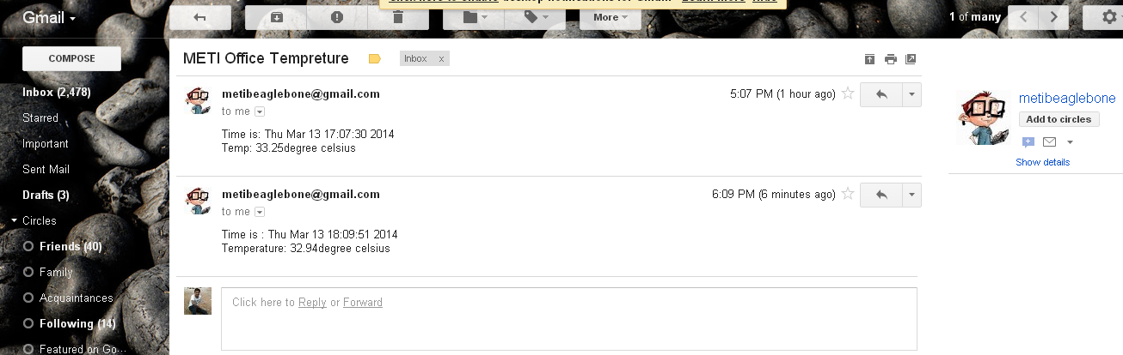 The default sending ID will a dummy created [metibeaglebone@gmail.com](mailto:metibeaglebone@gmail.com) if we give our ID then we need to give our password.

**Code explanation**:

* *import Adafruit_BBIO.ADC as ADC;*
* Imports the Adafruit's ADC library and allows you to use functions from Adafruit's ADC library and refer to them with prefix ADC
* *import time;*
* Imports the time module and allows you to use functions like sleep.
* *import smtplib;*
* importing simple mail tranfer protocol library to send mail
* *from email.mime.text import MIMEText*
* Importing Multipurpose Internet Mail Extension (MIME) a standard that extends the format of email to support.
* *Function to send email with two parameter subject which indicates* *subject of mail to be send and body is message to be send.*
* def emailAlert(subject,body):
* *server = smtplib.SMTP('smtp.gmail.com',587);*
* server to send gmail
* *server.starttls();*
* starting the server
* *server.login(FromemailID,'metibeaglebone1');*
* login to email id with user name and password
* *server.sendmail(From_emailID,ToemailID,msg.as_string());*
* Sending email from whom to whom with what message to be send.
* *server.quit();*
* Logout after sending message.
* *emailAlert("METI Office Tempreture",message);*
* Calling the function *emailAlert("METI Office Tempreture",message);*

**Project B9- Beaglebone temperature Online.**

Objective:

* Reading temperature value from LM35 and sending that value web page

System block diagram:



Wiring:

* Connect *vcc* pin of LM35 to 5V pin of beaglebone, *out* pin of LM35 to voltage divider circuit as shown in figure and *GND* pin of LM35 to *GND* pin of beaglebone.
* Connect voltage divider as shown in figure.
* Connect *Vout* to pin 33 of port P9 and ground pin to GND.

Create a new project

vim Online_temp.py

Press *Insert* key in your keyboard and write following code

from flask import Flask,render_template;

app = Flask(__name__);

import Adafruit_BBIO.ADC as ADC;

import time;

import datetime;

thermometer=["thermometer0.jpg","thermometer1.jpg","thermometer2.jpg ","thermometer3.jpg","thermometer4.jpg","thermometer5.jpg",

"thermometer6.jpg","thermometer7.jpg","thermometer8.jpg","thermometer9.jpg"];

ADC.setup();

Amb_Temp = 0;

Temp_Thermo = 0;

@app.route("/")

def Temp():

now = datetime.datetime.now();

timeString = now.strftime("%Y-%m-%d %H:%M:%S");

Amb_Temp_Volt = ADC.read("P9_33")* 3.136763 * 1.8;

Amb_Temp = Amb_Temp_Volt / 0.01;

Amb_Temp = round(Amb_Temp,2);

Amb_Thermo = int (Amb_Temp/4);

time.sleep(1);

templateData = {

'title':"METI miniSCADA",

'time':timeString,

'Temp':Amb_Temp,

'thermo':"http://192.168.0.126:80/"+thermometer[Temp_Thermo]

}

return render_template('index.html',**templateData)

def get_resource_as_string(name,charset='utf-8'):

with app.open_resource(name) as f:

return f.read().decode(charset)

app.jinja_env.globals['get_resource_as_string']= get_resource_as_string

if __name__ == "__main__":

app.run(host = '0.0.0.0',post=81,debug=True);

Press ***esc*** write ***:wq*** which is nothing but write and quit

Now you will back to METI_BBB directory

Create a directory templates

mkdir templates

cd templates

vim index.html

Add the following code:

<!DOCTYPE HTML>

<!-- Website template by freewebsitetemplates.com -->

<html>

<head>

<style type =text/css>{{get_resource_as_string(‘templates/style.css’)}}</style>

<meta charset="UTF-8">

<meta http-equiv=”refresh” content=”5”>

<title>METI Beaglebone</title>

<link rel="stylesheet" href="css/style.css" type="text/css">

</head>

<body>

<div id="header">

<div>

<img src="http://192.168.0.126:80/logo.png">

</div>

<ul id="navigation">

<li class="active">

<a href="index.html">Beaglebone</a>

</li>

<li>

<a href="http://192.168.0.126:80/python_code.html">Python Code</a>

</li>

<li>

<a href="html_code.html">HTML code</a>

</li>

<li>

<a href="explination.html">Explanation</a>

</li>

<li>

<a href="reference.html">Reference</a>

</li>

</ul>

</div>

</div>

<div align="center">

<table>

<tr>

<td>

<img src={{thermo}}>

</td>

<td>

<h2>Temperature Reading</h2>

<h2>Time:{{time}}</h2>

<h2>Temp:{{Temp}}</h2>

</td>

<td><img src="http://192.168.0.126:80/Temp_img.png" width="400" height="400"></td>

<td><p>Wiring:</br>1.Connect GND pin of L35 to Beaglebone GND pin</br>2.Connect VCC pin of LM35 to 5V of beaglebone</br>3.Connect out of LM35 to voltage divider as shown in figure.<br>4.Connect Vout to P9_33 of Beaglebone</br> </p></td>

</tr>

</table>

</div>

<div align="center"><h2>Note:</h2>

</div>

<div align="center">

<p>In this project we are measuring ambient temperature using LM35 precision centigrade temperature sensor.</br>Beaglebone read the analog voltage from LM35 sensor and converted into Celsius and displayed on page.</br>notice every 5 second html page is refreshing and new temperature value and current time displayed on page</p>

</div>

</body>

</html>

Go to :

cd /

cd var/www

vim python_code.html

Add following code:

<html>

<head>

<title>METI Beaglebone</title>

</head>

<body>

<img src=<http://192.168.0.126:80/pycode.PNG> width=”700”height=”700”>

</body>

</html>

Open cygwin if you don’t have install it.

Open Online_Temp folder open images , copy all the images to C:\cygwin

Double click on cygwin.bat file

Cygwin will open as shown below

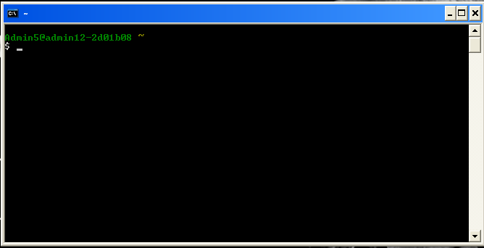

Give command

cd /

Give command

ls

you will get all files in that folder, you will find similar image.

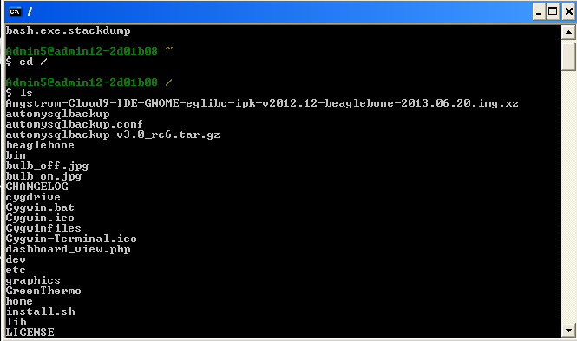

To move your images to beaglebone, give command

scp logo.png [root@192.168.0.126:/var/www](mailto:root@192.168.0.126:/var/www)

Where *scp* is command to send files from PC to beaglebone through secure connection, *logo.png* is an image file to be transferred. *root* is user, 192.168.0.126 is user beaglebone address make sure that this address when I written the document it will be different or it may be same. */var/www* is the destination folder where we are going to store our images. Move all the images one by one. For example

scp logo.png [root@192.168.0.126:/var/www](mailto:root@192.168.0.126:/var/www)

Then it will ask password of beaglebone give it, if things are ok then you will get a result like this.

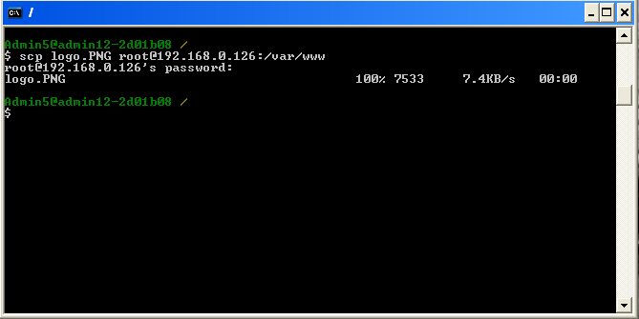

Come back to beaglebone.

cd /

cd var/www

ls

Now you will see all the images in this folder if repeat the process from cygwin.

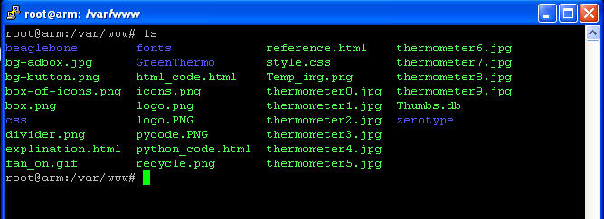

Move to METI_BBB folder

cd /

cd home/METI_BBB

ls

python Online_Temp.py

When you give these commands you can see like this

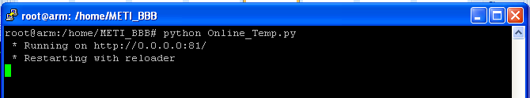

This indicates that local host started. Go to chrome or any browser give 192.168.0.126:81 and enter make sure that this is my beaglebone address, gve your IP address



Now you will see

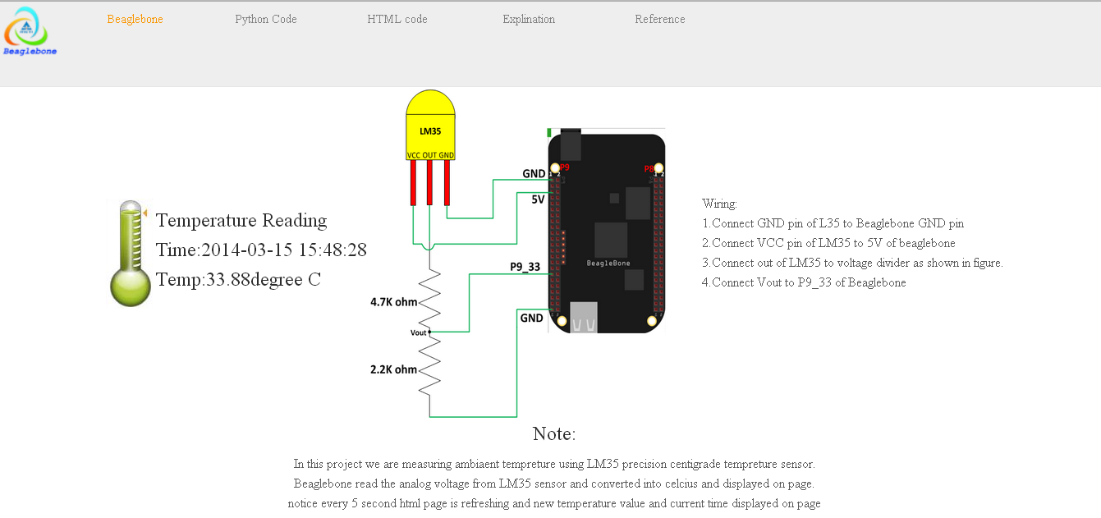

Here you can notice beaglebone circuit image, thermo meter image along with time and temperature value. Wring description and notes are also displayed. HTML page will refresh for every 5 seconds. To see the python code click on python code text you will see like this.

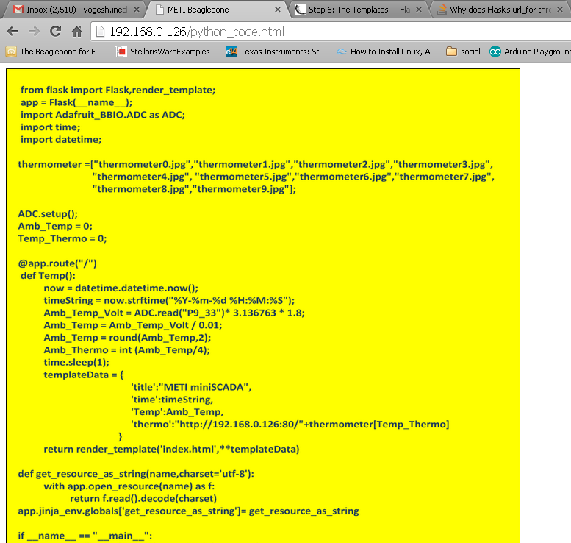

**Project B10- Online Potentiometer reading**

Objective:

* Reading the Analog input.

System block diagram:



Wiring:

* Connect 10Kohm pot to 5V pin and one more end of pot to voltage divider as shown in figure.
* Connect voltage divider as shown in figure.
* Connect *Vout* to pin 33 of port P9 and ground pin to GND.

Create a new project

vim Online_Pot.py

Press *Insert* key in your keyboard and write following code

from flask import Flask,render_template;

app = Flask(__name__);

import Adafruit_BBIO.ADC as ADC;

import time;

import datetime;

voltmeter=["tank-large-00.png","tank-large-01.png","tank-large-02.png","tank-large-03.png","tank-large-04.png","tank-large-05.png","tank-large-06.png","tank-large-07.png","tank-large-08.png","tank-large-09.png","tank-large-10.png",];

ADC.setup();

Volt_Read = 0;

Volt_Thermo = 0;

@app.route("/")

def Volt_Read():

now = datetime.datetime.now();

timeString = now.strftime("%Y-%m-%d %H:%M:%S");

Volt_Read = ADC.read("P9_33")* 3.136763 * 1.8;

Volt_Read = round(Volt_Read,2);

Volt_Thermo = int (Volt_Read/10);

time.sleep(1);

templateData = {

'title':"METI miniSCADA",

'time':timeString,

'Volt':Volt_Read,

'meter':"http://192.168.0.126:80/"+voltmeter[Volt_Thermo]

}

return render_template('index_pot.html',**templateData)

def get_resource_as_string(name,charset='utf-8'):

with app.open_resource(name) as f:

return f.read().decode(charset)

app.jinja_env.globals['get_resource_as_string']= get_resource_as_string

if __name__ == "__main__":

app.run(host = '0.0.0.0',port=81,debug=True);

Press ***esc*** write ***:wq*** which is nothing but write and quit

Now you will back to METI_BBB directory

cd templates

vim index_pot.html

Add following code:

<!DOCTYPE HTML>

<html>

<head>

<style type =text/css>{{get_resource_as_string(‘templates/style.css’)}}</style>

<meta charset="UTF-8">

<meta http-equiv=”refresh” content=”5”>

<title>METI Beaglebone</title>

<link rel="stylesheet" href="css/style.css" type="text/css">

</head>

<body>

<div id="header">

<div>

<img src="http://192.168.0.126:80/logo.png">

</div>

<ul id="navigation">

<li class="active">

<a href="index.html">Beaglebone</a>

</li>

<li>

<a href="http://192.168.0.126:80/python_code_pot.html">Python Code</a>

</li>

<li>

<a href="html_code.html">HTML code</a>

</li>

<li>

<a href="explination.html">Explination</a>

</li>

<li>

<a href="reference.html">Reference</a>

</li>

</ul>

</div>

</div>

<div align="center">

<table>

<tr>

<td><img src={{meter}}></td>

<td>

<h2>Potentiometer Reading</h2>

<h2>Time:{{time}}</h2>

<h2>Voltage:{{Volt}}V</h2>

</td>

<td><img src="http://192.168.0.126:80/pot_img.png" width="400" height="400"></td>

<td><p>Wiring:</br>1.Connect 10Kohm pot to 5V pin and one more end of pot to voltage divider as shown in figure.</br>2.Connect voltage divider as shown in figure.</br>3.Connect Vout to pin 33 of port P9 and ground pin to GND.<br></p></td>

</tr>

</table>

</div>

<div align="center"><h2>Note:</h2>

</div>

<div align="center">

<p>you can see analog voltage reading, when pot connected to beaglebone is turned, the actual voltage from the pot is read by the ADC and value displayed on screen</p>

</div>

</body>

</html>

Go to :

cd /

cd var/www

vim python_code.html

Add following code:

<html>

<head>

<title>METI Beaglebone</title>

</head>

<body>

<img src=<http://192.168.0.126:80/pycode_pot.PNG> width=”700”height=”700”>

</body>

</html>

Open cygwin

Open Online_Pot folder open images , copy all the images to C:\cygwin

Double click on cygwin.bat file

Cygwin will open as shown below



Give command

cd /

Give command

ls

you will get all files in that folder, you will find similar image.



To move your images to beaglebone, give command similar to this with file name

scp logo.png [root@192.168.0.126:/var/www](mailto:root@192.168.0.126:/var/www)



Come back to beaglebone.

cd /

cd var/www

ls

Now you will see all the images in this folder if repeat the process from cygwin.

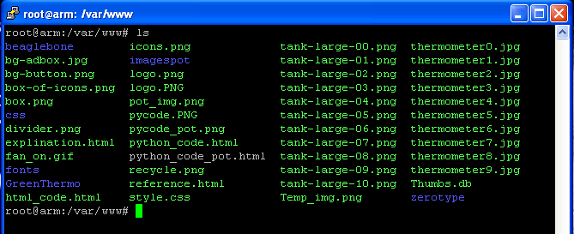

Move to METI_BBB folder

cd /

cd home/METI_BBB

ls

python Online_Pot.py

When you give these commands you can see like this



This indicates that local host started. Go to chrome or any browser give 192.168.0.126:81 and enter make sure that this is my beaglebone address, give your IP address



Now you will see

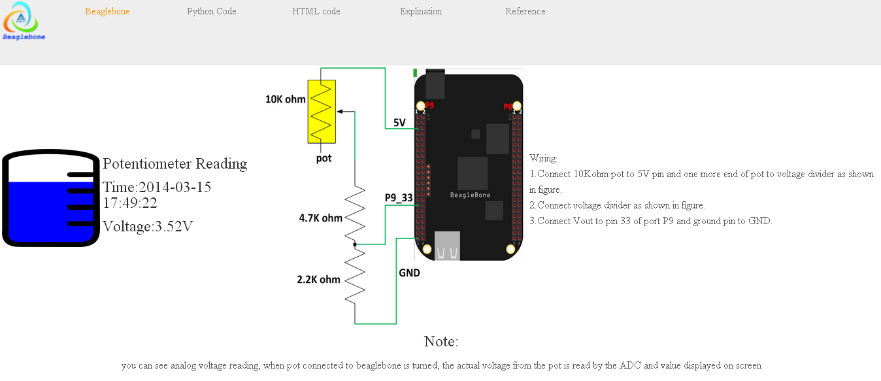

To see python code:

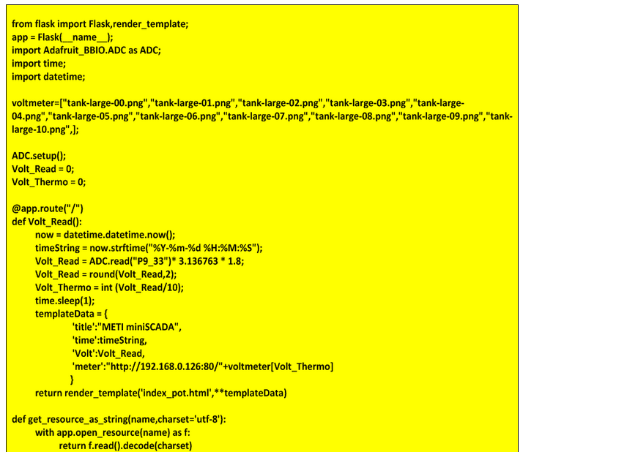

**Project B11- Beaglebone web based home-automation**

Objective:

* Controlling home appliances through web.

System block diagram:



Wiring:

* Connect 10Kohm pot to 5V pin and one more end of pot to voltage divider as shown in figure.
* Connect voltage divider as shown in figure.
* Connect *Vout* to pin 33 of port P9 and ground pin to GND.

Create a new project

vim Home_Test.py

Press *Insert* key in your keyboard and write following code

from flask import Flask

from flask import request

from flask import render_template

import Adafruit_BBIO.GPIO as GPIO

import time

GPIO.setup ("P8_12",GPIO.OUT)

GPIO.setup ("P8_13",GPIO.OUT)

app = Flask(__name__)

@app.route('/')

def my_form():

templateData={'fan1':"http://192.168.0.114:80/fan_off.gif",

'bulb1':"http://192.168.0.114:80/bulb_off.jpg"}

return render_template("Home_Test.html",**templateData)

@app.route('/',methods=['POST'])

def my_form_post():

fan1_button = remder.form['fan1']

if fan1_button == "0":

GPIO.output("P8_12",GPIO.HIGH)

fan1image="http://192.168.0.114:80/fan_on.gif"

print "fan on"

else:

GPIO.output("p8_12",GPIO.LOW)

fan1image="http://192.168.0.114:80/fan_off.gif"

print "fan off"

bulb1_button = request.form['bulbf1']

if bulb1_button == "0":

GPIO.output("P8_13",GPIO.HIGH)

bulb1image="http://192.168.0.114:80/bulb_on.jpg"

print "bulb on"

else:

GPIO.output("p8_13",GPIO.LOW)

bulb1image="http://192.168.0.114:80/bulb_off.jpg"

print "bulb off"

templateData1= {'fan1':fan1image,

'bulb1':bulb1image}

time.sleep(2)

return render_template("Home_Test.html",**templateData1)

if __name__ == '__main__':

app.run(host = '0.0.0.0',post=81,debug=True)

Press ***esc*** write ***:wq*** which is nothing but write and quit

Now you will back to METI_BBB directory

cd templates

vim index_pot.html

Add following code:

<html>

<head>

<link rel="icon" href="http://192.168.0.114:80/images.ico" type="image/x-icon"/>

<title>METI Beaglebone</title>

</head>

<body>

<table>

<tr>

<td>

<img src="http://192.168.0.114:80/logo.png"height="80"width="80">

</td>

<td>

<div>

<h2 style="font-family:Iceland;font-size:40px;line-height:45px;color:#643e08;">METI Beaglebone</h2>

</div>

</td>

</tr>

</table>

<div align ="left">

<table>

<td>

<table>

<tr>

<td>

<img src="{{fan1}}"id="fan1">

</td>

<td>

<img src="{{bulb1}}"id="bulb1">

</td>

</tr>

<tr>

<form method="POST">

<td>

<select name="fanf1">

<option type="button" value="2">select</option>

<option type="button" value="1">OFF</option>

<option type="button" value="0">ON</option>

</select>

</td>

<td>

<select name="bulb1">

<option type="button" value="2">select</option>

<option type="button" value="1">OFF</option>

<option type="button" value="0">ON</option>

</select>

</td>

</tr>

</table>

<input style = "color:red;"type="submit">

</td>

<td>

<table>

<td>

<img src="http://192.168.0.114:80/homeauto.png" height="400"width="400">

</td>

</table>

</td>

<td>

<p><h3 style="color:blue;">Wiring:</h3><b>1.Connect GND 12V power supply to Beaglebone GND pin<b></br>2.Connect P8_12 pin of beaglebone to relay1 of relay board</br>3.Connect P8_13 pin of beaglebone to relay2 of relay board.<br>4.Connect 12V power supply to relay board</br>5.Connect fan and bulb devices to relay board as shown in figure and to 230V AC source.</p><p style="color:red;"><b>Becarefull you are playing with 230V AC.</b></p>

</td>

</table>

<div>

<div align="center"><h2 style="color:blue;">Note:</h2>

</div>

<div align="center">

<p><b>In this project we are controlling home appliances using beaglebone black.When user change </br>state of home appliances for example submit the value of fan by selecting ON from select</br> tag, Beaglebone will read this change and switch on relay of fan.here you can notice changes in html </br> page will happen after 2 seconds since delay is giving to avoid sudden change of relay state.</p>

</div>

</body>

</html>

Open cygwin

Open Home_Auto, copy all the images to C:\cygwin

Double click on cygwin.bat file

Transfer all images to beaglebone. Folder destination will /var/www.

Move to METI_BBB folder

cd /

cd home/METI_BBB

ls

python Online_Pot.py

When you give these commands you can see like this



This indicates that local host started. Go to chrome or any browser give 192.168.0.114:81 and enter make sure that this is my beaglebone address, give your IP address

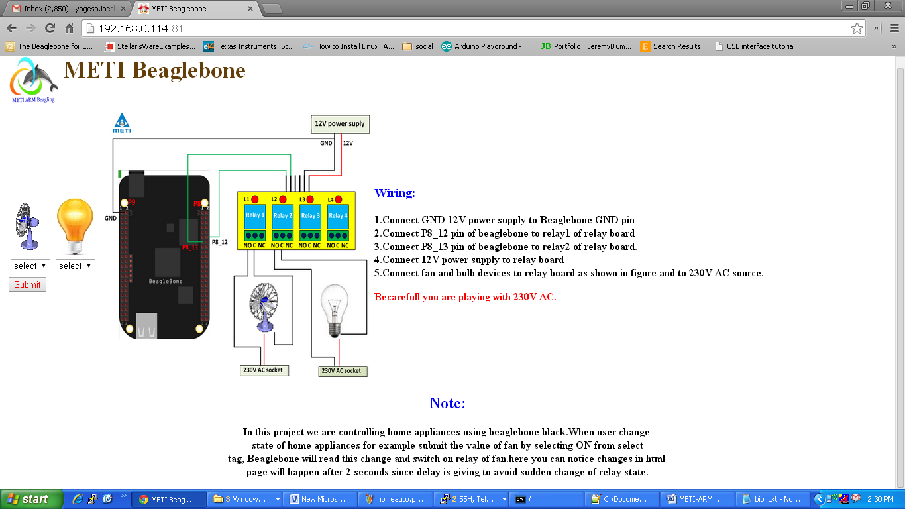

To control the home appliances for example fan here. In web page select ON, click on submit you will see fan turn on and web page animation of fan running. To turn off select ‘OFF’ click on submit fan will turn off.

**Project B12- Interfacing 2x16 Liquid crystal display**

Objective:

* Interfacing 2x16 liquid crystal display to beaglebone black.

System block diagram:

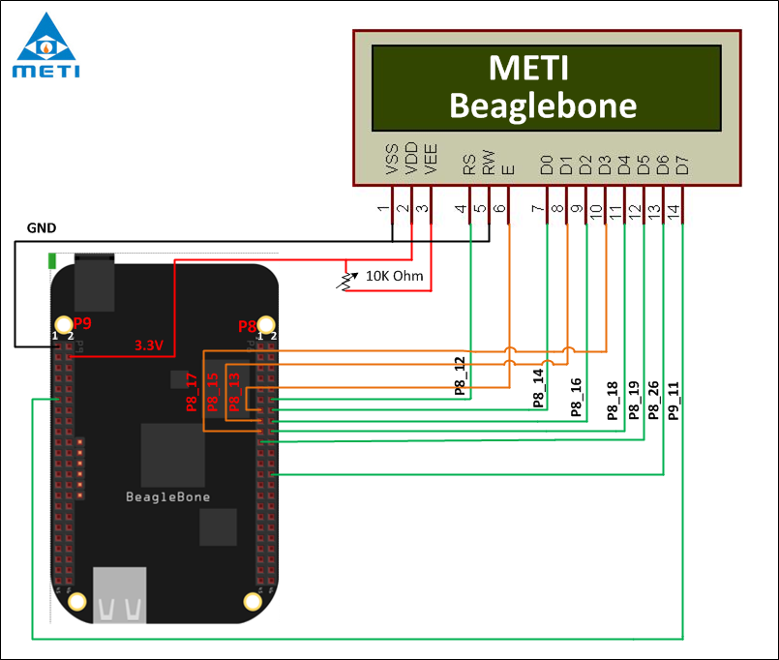

Wiring:

* Connect GND pin of beaglebone to VSS of LCD.
* Connect 3.3V power supply to LCD.
* Connect 3.3V power supply to VEE through 10 K POT.
* Connect R/W pin of LCD to ground.
* Connect remaining pins of LCD to beaglebone as shown in figure.

Create a new project:

vim LCD.py

Press *Insert* key in your keyboard and write following code

import Adafruit_BBIO.GPIO as GPIO

import time

Pins = ["P8_12","P8_13","P8_14","P8_15","P8_16","P8_17","P8_18","P8_19","P8_26","P9_11"]

Char_Set = [' ','!','"','~','#','$','%','&','\'','(',')','*','+',',','-','.','/','0','1','2','3','4','5','6','7','8','9', ':',';','<','=','>','?','@','A','B','C','D','E','F','G','H','I', 'J','K','L','M','N','O','P','Q','R','S','T','U','V','W','X','Y','Z', '[','\\',']','^','_','`','a','b','c','d','e','f','g','h','i','j','k', 'l','m','n','o','p','q','r','s','t','u','v','w','x','y','z','{','|','}']

def LCD_Pins_Setup():

Counter_Pins = 9

while Counter_Pins >=0:

GPIO.setup(Pins[Counter_Pins],"GPIO.OUT)"

Counter_Pins -=1

def RS_Write(LCD_RS_Value):

if LCD_RS_Value == 1:

GPIO.output("P8_12",GPIO.HIGH)'

else:

GPIO.output("P8_12",GPIO.LOW)'

def Enable_Write(LCD_En_Value):

if LCD_En_Value:

GPIO.output("P8_13",GPIO.HIGH)

else:

GPIO.output("P8_13",GPIO.LOW)

def Pins_Write(LCD_Pins_Value):

Counter_Pins = 7

Mask_Value = 128

while Counter_Pins >= 0:

Test_Bit = LCD_Pins_Value & Mask_Value

Mask_Value >>=1

if Test_Bit:

GPIO.output(Pins[Counter_Pins+2],GPIO.HIGH)

else:

GPIO.output(Pins[Counter_Pins+2],GPIO.LOW)

Counter_Pins -=1

def Enable_Pin():

Enable_Write(1)

time.sleep(.0041)

Enable_Write(0)

time.sleep(.0041)

def CMD(CMD_Value):

Pins_Write(CMD_Value)

RS_Write(1)

Enable_Pin()

def Clear_Display():

CMD(0x01)

CMD(0x0E)

def LCD_Start():

CMD(0x38)

Clear_Dispaly()

CMD(0x06)

CMD(0x0E)

def Data(Data_Value):

Pins_Write(Data_Value)

RS_Write(1)

Enable_Pin()

time.sleep(.01)

def PrintString(LCD_String):

String_Counter=0

String_Counter1=0

while String_Counter1 != len(LCD_String):

String_Counter=0

while ((LCD_String[String_Counter1]!= Char_Set[String_Counter]) and String_Counter < len(Char_Set)):

String_Counter += 1

String_Counter1 +=1

Data(String_Counter + 31)

def PutChar(LCD_Char):

String_Counter = 0

while(LCD_Char != Char_Set[String_Counter] and String_Counter < len(Char_Set)):

String_Counter += 1

Data(String_Counter+31)

def Position(row,col):

if row == 0:

col = col + 0x80

else:

col = col + 0xc0

CMD(col)

def PrintNumber(Number):

printString(str(Number))

Pins_Setup()

Start()

Above python file is API for LCD.

Press ***esc*** write ***:wq*** which is nothing but write and quit

Now you will back to METI_BBB directory

vim LCD_Test.py

Add following code:

import LCD as lcd

lcd.Position(0,5)

lcd.PrintString(“METI”)

lcd.Position(1,2)

lcd.PrintString(“Beaglebone”)

Press ***esc*** write ***:wq*** which is nothing but write and quit

Now you will back to METI_BBB directory. Give command

python LCD_Test.py

You can “METI Beaglebone” prints on LCD.

**Project B13- Beaglebone black UART setup.**

Objective:

* UART enabling in beaglebone black.

System block diagram:



Wiring:

* Connect P9_22 of beaglebone to P9_24 of beaglebone.
* Connect P9_21 of beaglebone to P9_26 of beaglebone.

Procedure:

* Download ttyO1_armhf.com-00A0.dtbo, ttyO2_armhf.com-00A0.dtbo, ttyO4_armhf.com-00A0.dtbo, ttyO5_armhf.com-00A0.dtbo files to your system from website [armhf](http://www.armhf.com/beaglebone-black-serial-uart-device-tree-overlays-for-ubuntu-and-debian-wheezy-tty01-tty02-tty04-tty05-dtbo-files/%20) .
* Copy those file to beaglebone folder position /bin/firmware through cygwin.
* After this boot with these commands:

echo ttyO1_armhf.com > /sys/devices/bone_capemgr*/slots

echo ttyO2_armhf.com > /sys/devices/bone_capemgr*/slots

echo ttyO4_armhf.com > /sys/devices/bone_capemgr*/slots

echo ttyO5_armhf.com > /sys/devices/bone_capemgr*/slots

* To see this UART files

cd /

cd dev

ls

* you will notice files ttyO1, ttyO2, ttyO4, ttyO5

To test UART create a project

cd /

cd home/METI_BBB

vim UART_Test.py

Press *Insert* key in your keyboard and write following code

import Adafruit_BBIO.UART as UART

import serial

UART.setup("UART1")

ser = serial.Serial(port = '/dev/ttyO1', baudrate = 9600)

ser.close()

ser.open()

if ser.isOpen():

print "Serial is open!"

ser.write("Hello world!")

ser.close()

Press ***esc*** write ***:wq*** which is nothing but write and quit

Now you will back to METI_BBB directory, before running this project you need to install few file to do so.

cd /

apt-get install minicom

after installing minicom, you need to install pyserial

pip install pyserial

To see the UART you need to open two minicom, one for UART1 and one more for UART2. Open putty, login to beaglebone after this. Give

minicom –b 9600 –D /dev/ttyO1

Open putty, login to beaglebone after this give

minicom –b 9600 –D /dev/ttyO1

By doing this you will three ssh connection as shown below.

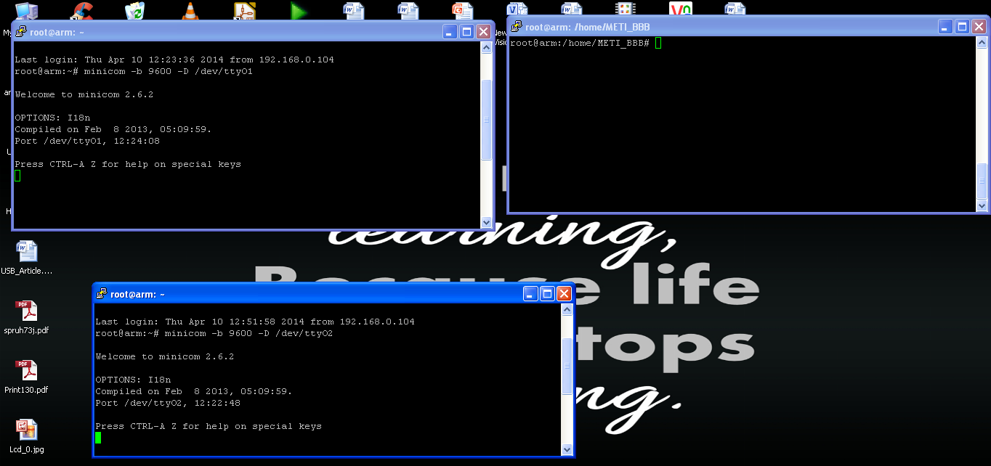

After finishing this run UART_Test.py file

cd /

cd home/METI_BBB

python UART_Test.py

Now you can see “Hello world!”, Prints in ttyO1 port. As shown

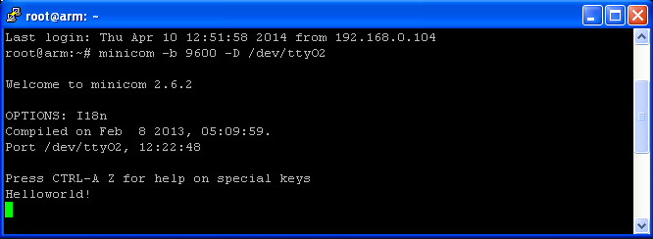

**Project B14- Sending SMS**

Objective:

* Sending SMS using GSM module.

System block diagram:



Wiring:

* Connect RX pin of level converter to RX pin of GSM module.
* Connect TX pin of level converter to TX pin of GSM module.
* Connect RX pin of level converter to P9_24 pin of beaglebone.
* Connect TX pin of level converter to P9_26 pin of beaglebone.
* Connect 5V supply to level converter.
* Made common GND between GSM module, level converter and beaglebone.

Create a new project:

vim METI_Mobile.py

Press *Insert* key in your keyboard and write following code

from flask import Flask

from flask import request

from flask import render_template

import Adafruit_BBIO.UART as UART

import time

import serial

UART.setup("UART1")

Number = 0

Message = ""

Status = 0

ser = serial.Serial(port='/dev/ttyO1',baudrate=9600,timeout=1)

ser.clsoe()

ser.open()

def Send_Message(num,msg):

ser.write("AT+CMGF=1\r\n")

msg_num = 'AT+CMGS="+91'+str(num)+'\r\n'

ser.write(msg_msg)

msg_msg = msg + '\r\n\x1A'

ser.write(msg_msg)

global Status

Status = 0

app = Flask(__name__)

@app.route('/')

def my_form():

return render_template("METI_Mobile.html")

@app.route('/',method=['POST'])

def my_form_post():

global Number

global Message

Number = request.form['number']

Message = request.form['message']

print Number

print Message

global Status

Status = 1

Send_Message(str(Number),str(Message))

return render_template("METI_Mobile.html")

if __name__ == '__main__':

app.run(host='0.0.0.0',port=82,debug=True)

Press ***esc*** write ***:wq*** which is nothing but write and quit

Now you will back to METI_BBB directory

cd templates

vim METI_Mobile.html

Add following code:

<html>

<head>

<link rel="icon" href="http://192.168.0.113:80/images.ico" type="image/x-icon"/>

<title>METI Beaglebone</title>

</head>

<body>

<table>

<tr>

<td>

<img src="http://192.168.0.113:80/yourLogo.png"height="80"width="80">

</td>

<td>

<div>

<h2 style="font-family:Iceland;font-size:40px;line-height:45px;color:#643e08;">METI Beaglebone</h2>

</div>

</td>

</tr>

</table>

<div align="centre">

<table>

<tr>

<td>

<h2>METI Mobile Messenger</h2>

<table>

<tr>

<form method="POST">

<td>

<b>number:</b><input type="text" name="number">

<b></br>message:</b>

</td>

</tr>

<tr>

<td>

<textarea rows="10" cols="40"name="message">

</textarea>

</td>

</tr>

<tr>

<td>

<input type="submit" value="Send">

</td>

</tr>

</form>

</table>

</td>

<td><img src="http://192.168.0.113:80/Mobile.png"></td>

<td>

<p><h3 style="color:blue;">Wiring:</h3><b>1.Connect RX pin of GSM module to RX pin of level converter<b></br>2.Connect TX pin of GSM module to TX pin of level converter</br>3.Connect RX pin of level converter to P9_26 of beaglebone<br>4.CConnect TX pin of level converter to P9_24 of beaglebone</br>5.Connect 5V power supply to level converter.</p>

</td>

</tr>

</table>

</div>

<div>

<div align="center"><h2 style="color:blue;">Note:</h2>

</div>

<div align="center">

<p><b>In this project we are sending message through beaglebone using GSM module.Give 10 digit number.Type the message you want to send </br>and click on send buttonBeaglebone receives this message and sends message using GSM module.Level converters are used to shift the signal level. </p>

</div>

</body>

</html>

Transfer the images to the var/www folder

cd/

cd home

cd METI_BBB

python METI_Mobile.py

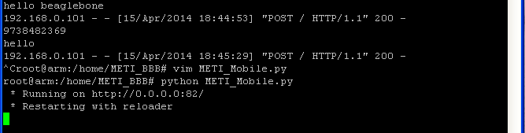

You will get screen as shown.

Go to chrome type you beaglebone IP address in my case 192.168.0.113:80

You will get a screen as shown below send message through it.

